Where In The World Are We? How Will We Get There?
Here, There & Everywhere – Willow Class – Spring 2025
The Willow Class wolf, Winston, is off on his travels. Where has he been and where is he off to next? We’ll travel around the world, visiting continents, listening to music and stories from around the globe. We’ll look at and make maps, local, national and global and write to other schools. We’d like to experience cultures from all over the globe so if you have family anywhere in the world that could write to us please let us know. After half term we will focus on transport.
Key Stories  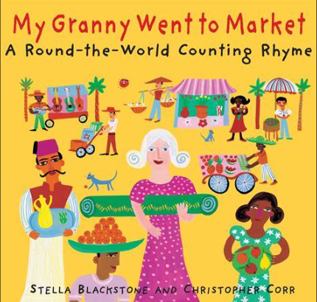  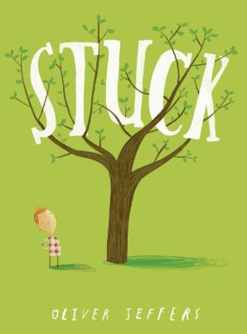  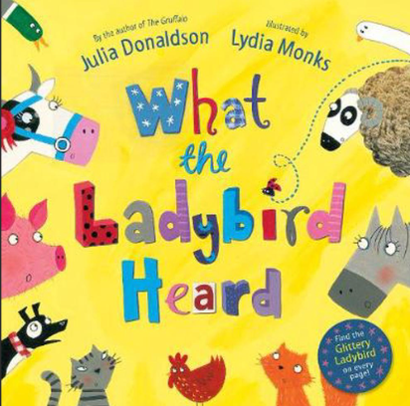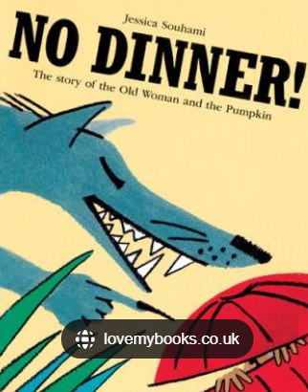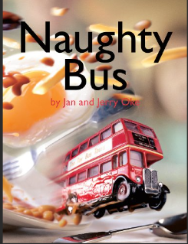  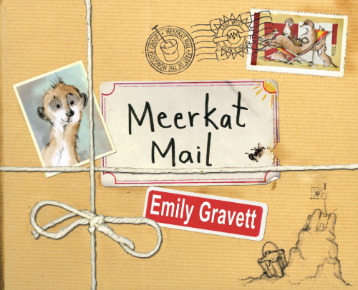 | In Communication, Language and Literacy we will read Stories like …  Stuck  What the Ladybird heard  When Granny Went to Market  The Empty Pot  Masha and the Firebird  No Dinner  Anna Hibiscus Song  Meerkat Mail  Handa’s Surprise  The Naughty Bus  Seasonal Poetry  What we’ll be doing in class  Songs and Rhymes  Talking and listening games  Reading fiction, non fiction and poetry  Reading and writing High Frequency Words  Retelling stories verbally & encouraging independent writing  Non-fiction writing about countries  Writing invitations, postcards, maps and captions  Book of the Week – Talking about our favourite books  You can help at Home:  Reading rhymes and traditional stories.  Reading regularly for fun  Practising keywords | 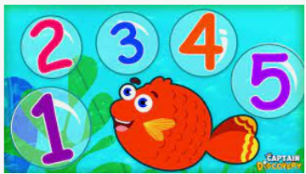  In Maths we will …  What we’ll be doing in class …  Recognising and ordering numbers Sorting Coins  Saying 1 more/1 less than a number  Counting on and counting back Counting, reading & writing numbers to 10, 20 and beyond  Estimate groups of items  Surveys using tally/mark making charts  Using the language of time.  Measuring quantities in cooking and in weight  Patterns and shapes, Spotting shapes in buildings  You can help at Home by  Estimating and counting objects to 10 and beyond  Talk about adding and subtracting  Practise writing numbers at home |  | 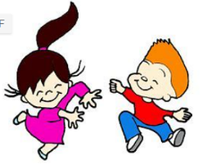  In Physical Development we will …  What we’ll be doing in class …  Self-care; toileting and washing hands  Talking about healthy food choices  Core Strength work  Gymnastics  Mark making using various materials  Noticing the effects of physical activity on our bodies  Practising throwing and catching  Moving to music/linking movements  You can help at Home by  Encourage writing; large, medium and small scale writing  Talking about the need for variety in the food they eat
 |  |   In Personal, Social, Emotional and Health we will …  What we’ll be doing in class …  Staying Safe  Working as part of a team  Taking turns, sharing  Follow rules  What makes each person special and unique.  Acknowledging their own skills and complimenting others  Talking about feelings, good, bad & what makes us grumpy!  Learning to compromise and appreciate others viewpoint  You can help at Home by  Talking about the effect of behaviour & choices on others  Encouraging turn taking and sharing |   In Knowledge and Understanding of the World we will  What we’ll be doing in class …  Noticing Seasonal Changes  Planning a journey  Walk around our school and our village  Maps; local, national, global, drawing our own  Identifying countries and continents  Recognising flags & landmarks, locally & globally  Designing our own flags and currency  Greetings from countries around the world  Using age appropriate software and websites  Using our senses to investigate  Use drawing software to create pictures about themselves  You can help at Home by  Notice seasonal changes  Spotting materials |  |   In Creative and Expressive Arts we will …  What we’ll be doing in class …  Moving to Music  Making Aboriginal patterns  Music from around the world - Investigating musical instruments  Make Japanese folded paper fans  Making Stir-Fry  Mixing colours for a purpose  Home Corner & Travel Agency role play  You can help at Home by  Encouraging mark making and drawing at home
,,

