WILLOW CLASS HOMEWORK GRID FOR TERM 3 and 4
Where In the World Are We? How Will We Get There?
Here is a selection of homework tasks to support the class’s big question this term and its focus characteristics. Choose two tasks a week so that by the end of term, you should have completed all the tasks. Share them with the class by emailing your teacher, bringing your creations into school or by taking photos to share.
  Speaking, listening and writing | 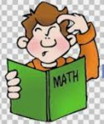  Maths, Science and Problem Solving |   Art and Design | 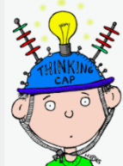  Constructing  and Creating |   Active Body  and Mind
Learn a new nursery rhyme  Choose a nursery rhyme and practice singing it aloud.  https://www.bbc.co.uk/teach/school-radio/nursery-rhymes-a-to-z-index/z4ddgwx | Counting Games to 10 & 20  https://www.topmarks.co.uk/learning-to-count/helicopter-rescue | Nature Dominoes  Collect natural objects to make a set of dominoes. Use cardboard from an old cereal packet and cut it into rectangles. Draw a line in the middle of the card and help stick their finds on each side of the line. | Make a favourite recipe  Try a different breakfast – overnight oats https://www.chopchopfamily.org/recipe/any-berry-overnight-oatmeal/  Or try making Pizza Toast:  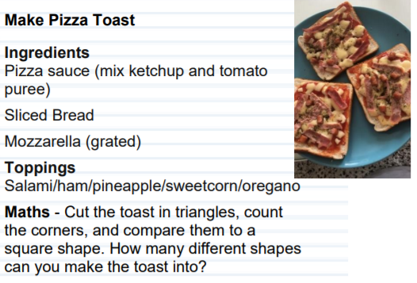 | Spring Walk  Go on a walk.  How many signs of Spring can you see?  Can you talk about the photos?
Sorting  Have a go at sorting toys with your child. You could sort animals by the number of legs they, or cars by their colour. Ask the children to sort their toys and see what they do, can they explain to you how they have sorted them? | Monster Tunnel Maths  Cut tunnel shaped holes in a cardboard box and decorate them to look like monsters. Number each monster. Roll a ball into the monster’s mouth and add up your points.  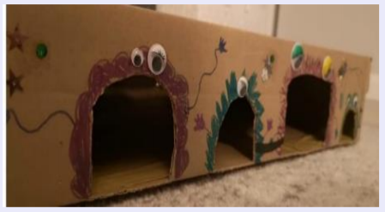 | Spring Wreath  Collect leaves and stick them to make a Spring wreath or make one from cardboard:  https://www.rainbowtrust.org.uk/support-for-families/activities/spring-wreath | Circle Printing  Dip a cardboard tube into some paint and create patterns. Can you squash and fold the tube to make different shapes? What happens if you dip the tube in to different colours of paint? Can you mix a new colour?  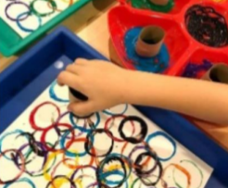 | Threading  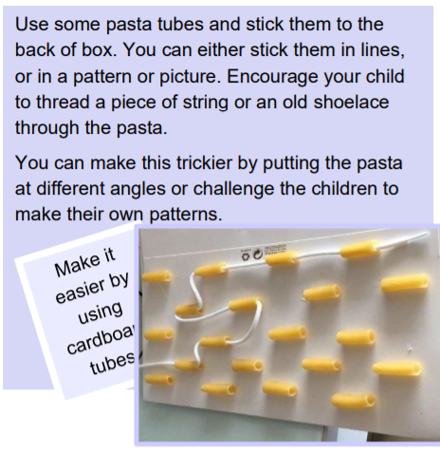
Keywords  Practise reading the keywords.  https://ictgames.com/mobilePage/dinosaurEggsHF/index.html | Measure stuff!  Measure length, height, weight, time, liquids. You can cook, make milkshakes and smoothies, help with jobs that involve counting and measuring. | Recycling Challenge  Help with the recycling!  Look at the different materials. | Writing  Draw and write a shopping list. | Thank Yous  Draw and write 3 things that you want to stay thank you for.
If you are finding it tricky to complete these activities without materials please let us know as we may be able to help.
In addition to tasks on this grid, please support your child with daily reading, using Phonics Shed or Numbots.

