
BOLNEY C.E.P. SCHOOL

Church Lane, Bolney, Haywards Heath, West Sussex RH17 5QP
Tel: 01444-881352 Fax: 01444-881047
E-mail: office@bolneyprimary.school
Web: http://bolneyschool.org.uk/

Headteacher: Ms Emma Lofthouse, BEd Hons

Tuesday, 03 February 2026

Dear Parents & Carers,

Silver Birch Class visit to Newhaven Fort

Silver Birch class will be taking a trip to Newhaven Fort on Thursday 5th March as part of their topic on World War 2.

We will leave Bolney by coach at approximately 9.00am and return in time for school finish.

The children should bring their lunch in a bag they can carry around for the whole day, and wear full school uniform with a coat.

The voluntary donation for this trip will be £7.00 per child, to include insurance, coach travel (kindly paid for by FOB), a workshop and entry into the Fort.

Please complete the slip below and return it to the office, paying your voluntary contribution online through the MCAS app. Once again, many thanks for all the support you give.

Yours sincerely,

Mrs James
Silver Birch Class Teacher

-------------------------------------------------------------------------------------------------------------------------------

Silver Birch Class visit to Newhaven Fort

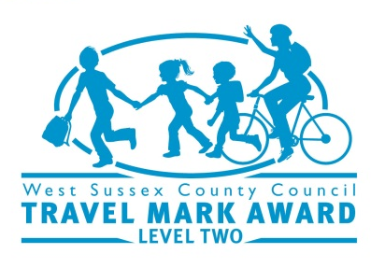


I give permission for my child to take part in the trip to Newhaven Fort on Thursday 5th March

- I will pay my voluntary donation of £7.00 by MCAS

Signed Parent ……………………………………….Child’s Name …………………………………………

