HOLLY CLASS HOMEWORK GRID FOR TERM 1
What have the Romans ever done for me?
Here is a selection of homework tasks to support the class’s big question this term and its focus characteristics. Choose two tasks a week so that by the end of term, you should have completed all the tasks. Share them by emailing work to the class teacher or by taking photos to bring in to school.
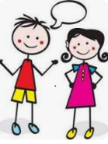  Speaking, listening and writing | 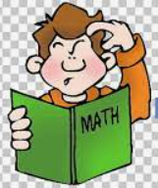  Maths, Science and Problem Solving |   Art and Design | 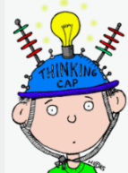  Constructing  and Creating |   Active Body  and Mind
Write down a word related to the Romans for each letter of the alphabet. Then write a sentence about each one to explain it! | Create a maths work sheet for Roman children, making sure you use Roman numerals in your calculations | Mint your own Roman coins | Find a Roman recipe. Create this recipe and take a photo to show your creation. (Write the recipe to go with your photo in case others would like to have a go) | Create an outdoor game for Roman children to play, they played games like backgammon, chess and Tic-Tac-Toe
Research Italy. What Roman buildings, statues, art and cities still remain?  Hints: Rome, Colosseum, Pompeii, Herculaneum | Find as many countries as possible that the Romans invaded. Draw their flags and write a sentence to go with each flag | Research Roman tools/weapons and make a model of one out of whatever medium you would like | Make a 3D model of a Roman Villa and/or a Celtic round house from Britain | Research and learn about the game knucklebones.  Can you make your own set and practise?  Don’t worry – you don’t need real bones! Stones or shells or marbles could be used.
Write a diary entry from someone in a British village which gets taken over by the Romans | Write a secret message in Roman numerals (with an alphabet key) | Design your own mosaic based on the style of a Roman one- check out some videos on YouTube- type in Roman Mosaics into the search engine | Design and make some Roman jewellery | Find out what physical activities the Romans would have done and try to recreate some- record or take a picture to share!

In addition to tasks on this grid, please support your child with daily reading, times tables and spelling.

