Learning for Life (Jigsaw) - As young people, we will be discussing our year ahead, what is meant by being a citizen, responsibilities and leadership roles. We will explore our characteristics of Team Players and Friends but we will start with looking deeper into our Values.

**Silver Birch- Our Autumn Learning Journey- Our theme is The Ancient Egyptians and our big question ‘Is there life after death?’ will look into the concept behind this belief.**

SCIENCE – As scientists, we will be exploring the circulatory system: - describing the function of the blood, heart and blood vessels, the heart & lungs, arteries, veins and capillaries, heart rate & physical fitness. In addition, we will learn about healthy lifestyles – recognising the impact of diet, exercise, drugs and lifestyle on the way our bodies function.

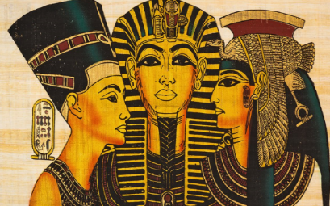

PE-As sportspeople, we will be using our characteristics of Team Players and Values in team games. We will learn the skills to play Hockey. We will also become dancers and perform dances using a range of movement patterns, develop flexibility, strength, technique, control and balance and compare performances with previous ones in the lessons.

ART and DT- As artists, we will be using mixed media to design our Nemes head-dresses and use clay to make our own Sarcophagus.

MATHS- As mathematicians, we will start with place value, swiftly followed by revisiting the four operations. Year 5’s will be revisiting Roman Numerals but now investigating them with numbers up to 1000. Year 6’s will be exploring numbers up to 1,000,000. Finally to finish the autumn term, fractions.

COMPUTING- As programmers, we will firstly remind ourselves how to be safe online by completing a variety of online tasks. Secondly, we will develop our understanding of computer systems and how information is transferred between systems and devices. We will consider small-scale systems as well as large-scale systems. We will be able to explain the input, output, and process aspects of a variety of different real-world systems. Later, we will discover how information is found on the World Wide Web, through learning how search engines work (including how they select and rank results) and what influences searching, and through comparing different search engines.

MUSIC- As musicians, we will explore an artist and their influence on us and the World, learn about posture for singing and evaluate our performance.

HISTORY – As Historians, we will discover what the Egyptians believed about the afterlife and how this contributed to their organisation of civilization and culture. We will try to understand the roles of different Gods in Ancient Egypt. We will learn how the Egyptians used cubits, shadufs, astronomy and maths to build impressive structures e.g. pyramids, cities, farms etc

RE- We will try to answer the questions: ‘Why do Humanists say happiness is the goal of life?’ followed by ‘Was Jesus the Messiah?’

ENGLISH -As writers, we will write character descriptions, informal and formal letters and write in role as one of the characters from the text. We will also write an extract like a diary from the point of view of an Egyptian pyramid builder. As readers, we will listen and focus for extended periods, building reading stamina. We will ask and answer questions arising from plots and characters. We will use inference skills for information and give evidence for opinions, Retrieve information efficiently – by scanning or using features such as subtitles, glossaries and content pages.

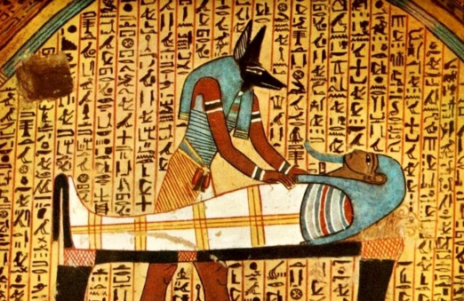

Is there life after death?

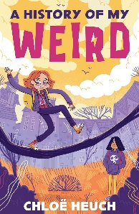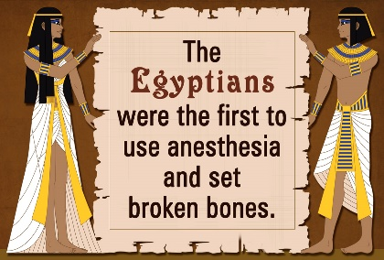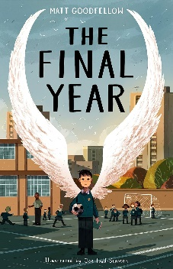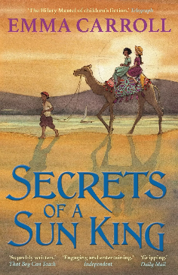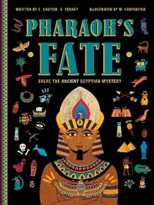

**Key Texts**

Secrets of a Sun King by Emma Carroll

A History of My Weird by Chloe Heuch

The Final Year by Matthew Goodfellow

Pharaoh’s Fate by Camille Gautier

**Key Vocabulary**

Canopic jar

Cartouche

Hieroglyphics

Irrigation

Mummy

Sarcophagus

Scarab

Tomb

Papyrus

Pyramids

Afterlife

Akhet

Dynasty

Egyptologist

Pharaoh

This term, Silver Birch will be exploring the question ‘Is there life after death?’ Our theme is Ancient Egyptians and as Team Players and Friends, we will be learning all about who the Ancient Egyptians were, find out what the Ancient Egyptians believed about the afterlife and the importance of this to their culture. We will explore the roles of some of the Ancient Egyptian gods and investigate some of the rituals involved in the passage from death into the afterlife.

**Key Questions**

Was the social hierarchy of Ancient Egypt fair?

What does it mean by the phrase ‘Walk like an Egyptian’?

What were the Ancient Egyptian Pyramids?