

BOLNEY C.E.P. SCHOOL


Bolney CEP sits in the heart of the Bolney village community and is an inspiring and welcoming school. We have 100 children learning within four different classes: a Reception class, mixed 1/2, 3/4 and 5/6. We have a beautiful learning environment, both inside and out, and our staff and children feel safe and valued.

Wrap-around Childcare Support Assistant

Breakfast Club 7.15 – 8.45am
After School 3.00 – 5.45pm, Monday to Friday, term-time only
Grade 3 point 3 £24,796 (pro-rata 21.25 hours = £11,995)
Applications for either, or both Breakfast club/Afterschool club will be accepted

Job Description
A wrap-around Care assistant will organise activities, prepare snacks and monitor the children’s safety under the guidance of the lead assistant. They may also keep records of children under their care and report to the headteacher about concerns as they arise. Experience of working with children is preferred and basic understanding of childcare practices is an advantage. The support assistant should have caring, kind personalities that help them treat all children fairly and meet each child’s physical, emotional, and social needs.
Duties and Responsibilities
- Supervise and Monitor Children
A wrap-around care support assistant will have a hands-on role in providing a safe childcare environment. Whether the children are playing or eating, the support assistant will keep a close watch to prevent accidents or injuries. Once trained, they may be asked to administer first aid.

- Keep and Update Records
A wrap-around care support assistant may be asked to update daily registers: these logs will include a child’s attendance, allergies and any special accommodations the child may require.

- Prepare Snacks
A wrap-around care support assistant will prepare healthy snacks for children. As new children join the facility, they will need to keep track of allergies or dietary concerns and provide meal alternatives when needed.

- Resolve Conflicts Between Children
A wrap-around care support assistant will observe the children under their watch and may have to mediate conflicts between children, teaching them to compromise and treat each other with respect.

- Maintain a Sanitary Environment
After activities or mealtimes, the wrap-around care support assistant will be responsible for cleaning up messes and clearing the space, making it ready for the next day.
Person Specification: Wrap-Around Care Support Assistant

 | Essential Criteria | Desirable Criteria
Professional Values and Practices | - Willing to support the caring and inclusive ethos of the school  - Ability to use initiative appropriately  - Must be sympathetic to the children’s needs  - To contribute enthusiastically to the staff team, be a good team player and have a very positive attitude  - Willing to take part in professional development activities  - Have an understanding of what is confidential in relation to children  - Have an ability to communicate effectively with pupils and colleagues  - Have good organisation skills | - To contribute to the wider school community
Qualifications, Knowledge and Understanding |  | - First Aid qualification  - Experience working with children is preferred and basic understanding of child care practices
Caring | - Ability to use the required recording and reporting systems and feedback appropriately to the office and headteacher  - Ability to adapt an activity for children experiencing difficulty  - Ability in making the school an attractive and tidy environment  - Ability to carry out interventions and keep accurate records | - Successful experience of working within a school or childcare setting

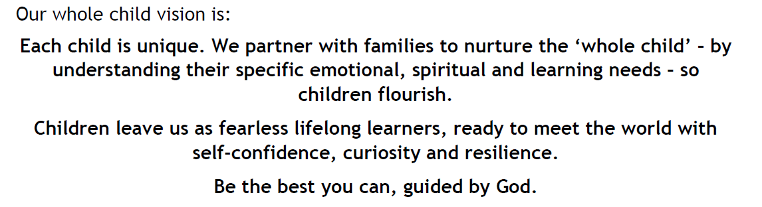

Bolney CE Primary School considers safeguarding to be of paramount importance.

The School is committed to safeguarding and promoting the health, safety and welfare of all children, young people, their families and staff. This means that everything we do is designed to promote the safety and well-being of the children we work with, as well as that of children and young people in general. Any successful applicant will be required to undertake a Disclosure check by the Disclosure and Barring Service at an Enhanced level.
Please send completed applications to the school office.
Vacancy description correct at the time of advertising position.

