As writers and readers we will…   
  
Use the Land of Roar as inspiration when writing our own portal stories and to develop our VIPERS skills in reading lessons.  
Use drama and interplaylands to create our portal stories.  
Develop simple sentences by adding description, phrases and clauses.  
Consider how to create atmosphere and detailed setting descriptions for stories.   
Use paragraphs to show a change of time, subject or place.  
Write poems inspired by chocolate.

**Holly-Our learning journey-Spring ‘25  
  
“Why should we study the Maya?”**

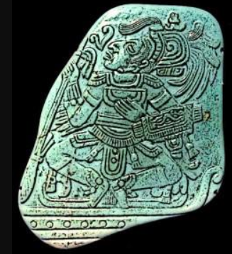

As young people…  
Consider challenges we face in order to be successful in our learning.  
Consider what I want to achieve in life and my ambitions.

As scientists we will…  
  
identify that humans and some other animals have skeletons and muscles for support, protection and movement.  
  
identify that animals, including humans, need the right types and amount of nutrition.

As programmers in computing we will…  
Learn about desktop publishing.

As sportspeople we will…  
Create dance sequences using a range of movement.  
Develop balance and flexibility in gym.  
Develop reactions, hand eye coordination and body positioning in tennis and dodgeball.

As geographers and historians we will…

Compare the jungle and mountainous terrain of Mesoamerica to the UK.

Consider how the Maya were able to overcome difficult conditions in order to build successful cities – transport, food access, water access, irrigation etc.  
Consider why the Maya are worth studying.  
Consider how the Maya civilisation was able to flourish given the challenges – especially climate and terrain. Consider what life was like during the peak of Maya culture. Understand how society was organised and what the culture was like.  
Be reflective and considerate as historians – consider how we can know things about a culture from 1,000 years ago.

Consider why the Maya used human and animal sacrifice and whether they can still be considered civilised.

Wonder why the Maya civilisation faced such a dramatic and drastic decline.

As musicians we will…be learning how to play the   
with a music specialist from the West Sussex Music Service.

As mathematicians we will…

Multiply and divide using formal methods.  
Calculate the perimeter and area of rectilinear shapes.  
Convert between different units of measurement e.g. cm and m  
Find equivalent fractions, add and subtract fractions.  
Find decimal equivalents for common fractions – 1/2 , ¼ ¾ and tenths and hundredths.

In RE we will…  
consider how the Rama and Sita story inspires Hindus to follow their dharma.

and ‘What is the Trinity?’

Big Question?

**Why should we study the Maya?**

This term, Holly will be exploring the question ‘Why should we study the Maya?’ We will be considering the achievements of the Maya civilization, comparing it to others that existed at the same time and looking at how their society was able to develop into a huge empire despite the lack of some technological developments and resources enjoyed by other societies at the time.

Key Vocabulary

Maya  
Civilization  
Mesoamerica  
Hieroglyph  
Jade  
Obsidian  
Quetzal  
Ritual  
Temple  
Stelae  
Cenote

Key Texts  
  
Land of Roar by Jenny McLachlan   
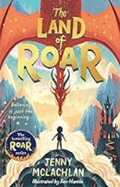

Key Questions  
**What were the achievements of the Maya?**  
**How was chocolate first made and enjoyed?  
  
How did the Maya build their cities and pyramids?  
  
What culture, art and hobbies did the Maya have?**