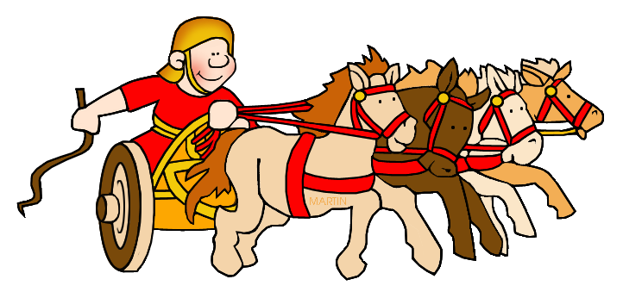
ENGLISH
As writers we will:
read, discuss and write our version of the Escape From Pompeii story as either Livia or Tranio, linking to Drama with Ms Seymour

Research the types of volcanoes (facts in science) and use the facts learned to write a short information page of the types and a little on where they are located, poster, PowerPoint or flip book

If time, write a letter of application to be a soldier in the Roman Army using learned knowledge about them

As readers we will:
read together high quality texts, use VIPERS skills to complete tasks related to the texts

Our big question for this project starts with:
What have the Romans ever done for me?
Then we will look to answer these questions:
Is it important to be true to yourself like Boudica?
Were Roman soldiers treated fairly?
How did the Roman Empire end?
We are Team Players and Friends through learning about the
Romans starting with exploring our Values.

Visitors/Special events
The History Man visit on Tuesday 10th October 2023
Holly Class Autumn Learning Journey
2023

SCIENCE
As scientists we will:
start to recognise that environments can change and that this can sometimes pose dangers to living things (people in the case of Pompeii)
compare and describe different rocks
classify rocks into igneous, metamorphic and sedimentary
recognise that soil is made from rocks and organic matter in differing proportions
understand how different soils are beneficial for different plants and animals
MATHS
As mathematicians we will:
be revisiting place value, becoming confident in methods of calculation in firstly addition and subtraction, leading into multiplication and division

be focusing on times tables each lesson for 10 minutes a day

PE
As sportspeople we will:
learn how to become better team players in team games, working on collaborative skills
design a dance routine based on Testudo and the Roman Army

We are Team Players and Friends through learning about the
Romans starting with exploring our Values.

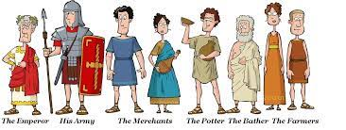
HISTORY/GEOGRAPHY
As historians we will:
consider how the Romans changed life in Celtic Britain and what impact this had on the Celts
we will study Roman life and culture, the impact of Pompeii, the expansion of the Empire and discuss whether it was right for the Romans to invade other places
understand the meaning, size and timescale of the Roman empire by drawing conclusions from maps and timelines
understand at least 2 main reasons, eg: raw materials such as corn, iron, also Claudius’ personal motivation
be able to see why the Roman army was so powerful including organisation, conditions, pay etc

As geographers, we will:
discover where are Volcanoes located around the World and why there is such a place known as The Ring of Fire
ART/DT
As designers we will:
create volcanoes using paper mache

make Honey biscuits just like the Romans ate!

design and make Roman Army shields

COMPUTING
As programmers/technicians we will:
research Volcanoes and the Romans and use Word and PowerPoint to publish our findings
use iPads to record our drama
use the Hour of code Timecraft to go back in time and help learn to code to solve problems

MUSIC
As musicians we will:
learn to play the Djembe drums

R.E
We will be exploring the question: What do Christians learn from the Creation story?

