Holly class home learning grid - Spring
Are some places just too dangerous?
Here is a selection of homework tasks to support the class’s big question this term and its focus characteristics. Choose two tasks a week so that by the end of term, you should have completed all the tasks. Share them by emailing work to the class teacher or by taking photos to bring in to school.
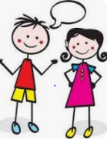  Speaking, listening and writing | 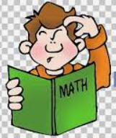  Maths, Science and Problem Solving |   Art and Design | 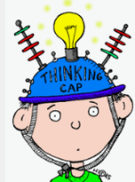  Constructing  and Creating | 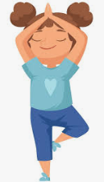  Active Body  and Mind
Write a diary entry recording your experience in an extreme weather event. | Investigate melting, boiling or freezing.  You could see how quickly different liquids boil or how quickly things melt. You could try squash, milk and even water! | Create a rainstorm in a jar  https://arbetterbeginnings.com/parents-families/family-resource-library/science/rainstorm-in-a-jar | Design and make an earthquake proof building – using minecraft, lego, recycled materials etc. | @firefighterfitkids9936/videos  Use the above Youtube channel to find workout routines designed by firefighters – for kids!
Create an extreme weather report. You could write a script and perform it or record it. | Create a weather diary – keep track of the weather – temperature and conditions for two weeks.  You could present as a pictogram with symbols or as a chart to show the temperature each day. | Design clothes suitable for surviving a natural disaster – you could make the clothes for a toy/doll. | Make a map/globe showing natural disasters spots around the world.  You could focus on particular disasters – like volcanoes and the ring of fire. | Make a dance routine inspired by different weathers and climates – rain, wind, storms etc.
Research the mountains across the UK. Where are they? Find out and present facts about them. | Visit ready.gov for games designed around weather and disaster survival. | Make a collage to show different weathers and seasons. | Create a crossword based on natural disasters. Use research to help you decide on the words and the clues. | Can you make a video or a checklist about First Aid for children- why is it so important? How does knowing this help us with our key question?

