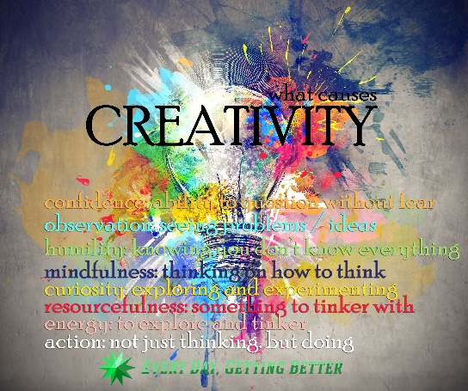

Learning for Life (Jigsaw) - As young people, we will be discussing change and relationships. We will reveal our characteristics of Young Leaders to lead groups within our class in sport and design. We will have to become Problem Solvers in all areas of our learning.

MUSIC- As musicians, we are learning how to play the Ukele and play the music for our catwalk show of football kits/trainers.

GEOGRAPHY – As geographers, we will find out about Africa and its landscape, weather, people and the challenges faced by some people in countries within Africa. We will also research host countries of sports tournaments.

RE- We will try to answer the questions: ‘What kind of world did Jesus want?’ And ‘Why do Muslims call Muhammad the ‘Seal of the Prophets’?’

Why do Muslims call Muhammad the ‘Seal of the Prophets’? We will discuss what is meant by the term Prophet and about how important it is being chosen to be a messenger for God.

**ENGLISH -As writers, we will write a biography of our chosen designer/sportsperson. In addition, we will be writing instructions to mend a puncture on a bicycle tyre and an explanation text about how to survive in the desert.**

**As readers, we will explore picture books, listen to higher level texts, read as groups for pleasure, use books to collect facts about key people in sport and design. We will be practising skimming and scanning skills to obtain information and what to do with this information.**

ART- As artists, we will explore Banksy the artist and try to recreate a piece based on his famous Monkey art work.

D.T- As designers, we will design a football kit or new trainer for the class.

We will use techniques such as tie dying and Batik.

MATHS- As mathematicians, we will continue to learn our times tables to be prepared for the test in June.

We will also continue to look at fractions.

Length, perimeter, statistics, money, shape and time are also in the summer term.

**Holly- Our Summer Learning Journey- we are going to be problem solvers and young leaders. Our theme is creativity and our big question is ‘Am I courageous enough to try something new?’**

COMPUTING- As programmers, we will learn about networks, to appreciate the internet as a network of networks which need to be kept secure. We will learn that the World Wide Web is part of the internet, and will be given opportunities to explore the World Wide Web for ourselves in order to learn about who owns content and what they can access, add, and create. Finally, we will evaluate online content to decide how honest, accurate, or reliable it is, and understand the consequences of false information.

PE-As sportspeople, we will learn all aspects of athletics to provide opportunity to practice for sports day and also skills needed for games like Tennis.

SCIENCE – As scientists, we will be exploring sound and learn to identify how sounds are made and much more. We will also become Electricians, we will identify common appliances that run on electricity. We will construct a simple series electrical circuit and find out about conductors and insulators.

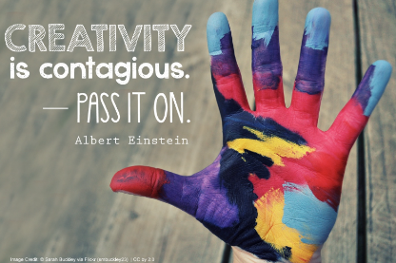

Am I courageous enough to try something new?

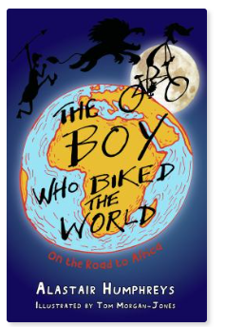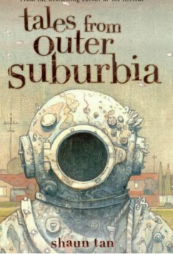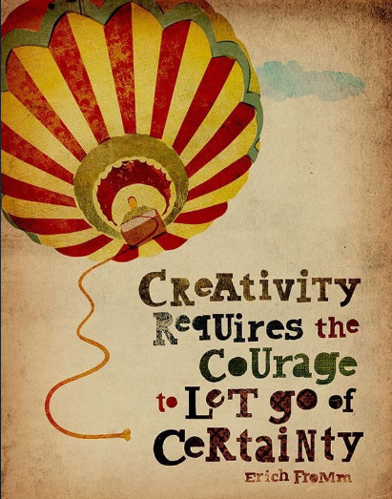

**Key Vocabulary**

Creative, courageous, adventurous, resilient, inspiring, fashion, change, differences, similarities, challenge, accomplishment, achievement, rewarding, talent, innovative, imaginative, original, teamwork, ideas, energy, enthusiasm, growth mind-set, passion, out of the box thinking

**Key Questions**

Can anyone be creative?

Do you have the courage to show your talents?

What is creativity?

Can you learn to be creative?

Why is it so important to make mistakes?

**Key Texts**

The Boy Who Biked the World Part One

The Fastest Boy in The World

Tales from Outer Suburbia

Swimming Against the Storm (continued)

This term, Holly Class will be exploring the question ‘Am I courageous enough to try something new? Our theme is creativity and as Young Leaders and Problem Solvers, we will be trying new things through Art, Music and Sport. There are many quotes from the great inspirational Albert Einstein about creativity and one that stands out to us is *‘Creativity is intelligence having fun’.* During the term, we will be having fun whilst learning about inspirational people in sport, music, art and fashion. As this is an important year in sport, we are starting with the history of football and we will be looking at host countries of sport tournaments.