As writers and readers we will…

Write persuasively and to inform about critical issues. We will use the Greenpeace animations – Rang-Tan and Jag-War to provoke discussion. We will write and design informative presentations and write letters.  
We will write stories inspired by our art and science work on insects and biodiversity. We will imagine what it will be like to be shrunk and coming face to face with our insect creations.

**Holly-Our learning journey-Summer 2023**

**We are Change Makers and Young Leaders in our theme ‘Rainforests’.**

How can we be a friend to nature?

As geographers we will… ask questions like- ‘What will it (the rainforest) be like in the future?’

Understand geographical similarities and differences through the study of human and physical geography of a region (Amazon Rainforest)

Use maps and globes to find the Rainforests of the World.

Describe the layers of the rainforest and the climate of these places.

Focus on fieldwork and examine our local area.

As mathematicians we will… continue to explore fractions. We will be converting between mixed numbers and improper fractions. We will then move on to decimals and focus on recalling useful fraction-decimal equivalents. We will apply our decimal understanding through money problems.  
We will have real life maths opportunities when we look at statistics and surveying in geography, we will also learn to tell the time and convert between digital and analogue.

As artists and designers we will… start with examining insects and biodiversity in the rainforest. We will use this as inspiration to create our own insects.

In RE we will…. explore the question, ‘*When Jesus left, what was the impact of Pentecost?’*

As scientists we will… Start to recognise that environments can change and that this can sometimes pose dangers to living things.

Construct and interpret a variety of food chains, identifying producers, predators and prey.

Identify and describe the functions of different parts of flowering plants: roots, stem/trunk, leaves and flowers.

Explore the requirements of plants for life and growth (air, light, water, nutrients from soil, and room to grow) and how they vary from plant to plant.

**Investigate the way in which water is transported within plants.**

As musicians we will…be learning how to play ukelele building on our note reading last term with a music specialist from the West Sussex Music Service.

As programmers in computing we will…be photo editors. We will learn how digital images can be changed and edited, and how they can then be resaved and reused. We will consider the impact that editing images can have, and evaluate the effectiveness of our choices.

**As sportspeople we will…become athletes and start to practise for our Sports Day.**

As programmers and researchers we will…

Big Question?

**How can we be a friend to nature?**

This term, Holly will asking ‘How can we be a friend to nature?’. Our project will be driven by geography and science as we explore the rainforests. This will lead us to considering the human impact on the natural world. We will consider what changes we can make and how we can solve the problem of climate change and the destruction of the natural world. Our characteristics are Problem Solvers and Young Leaders.

Key Texts  
  
The Wild Robot   
Return to Roar  
The Great Kapok Tree

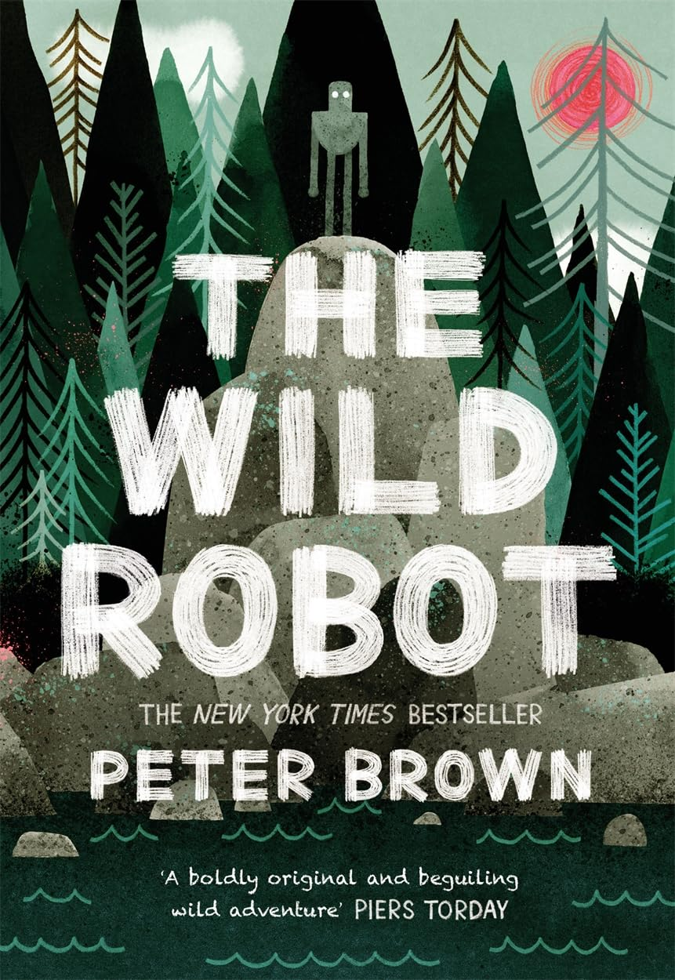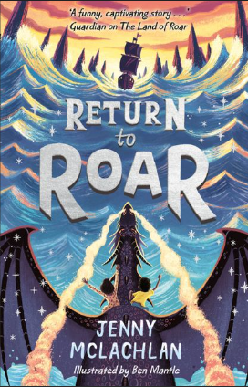

Key Questions

**Why should I care about the rainforests?**

**What are the threats to the rainforest?**

**What might we find in a rainforest?**

**How do humans impact on the environment?**

Key Vocabulary

**Rainforest  
Climate change  
Deforestation   
Biodiversity   
Indigenous   
Canopy  
Emergent  
Understory  
Forest Floor  
Tropical  
Humidity**