Learning for Life (Jigsaw) - As young people, we will be discussing our dreams and goals. We will explore several articles from the UNICEF Rights of the Child through our characteristics of Achievers and Creative Thinkers.
MATHS- As mathematicians, we will start with converting units, looking at solving problems involving the calculation and conversion of units of measure. We will use, read, write and convert between standard units, converting measurements of length, mass, volume and time from a smaller unit of measure to a larger unit. After half term, we will revisit fractions and continue to explore arithmetic and prepare for SATs.
ART and DT- As artists, we will explore a technique called Continuous Line Drawing- several artists used this technique such as Picasso and Glacometti.
Silver Birch- Our Spring Learning Journey- ‘How did WW2 shape the world of today? Our characteristics are Achievers and Creative Thinkers.
As linguists in our French lessons, we will be learning how to describe ourselves.
RE- Firstly, we will try to find answers to this question: ‘What does the Qur’an reveal about Allah and his guidance?’ After half term, we will explore The Psalms through Godly Play.
MUSIC- As musicians, we will perform, compose, and improvise music with accuracy and expression; listen attentively, recall, and evaluate across genres and traditions; use notation; appreciate live and recorded works; and develop historical understanding of music.

COMPUTING- As programmers, we will firstly remind ourselves how to be safe online by completing a variety of online tasks. Secondly, we will be developing our knowledge of ‘selection’ by revisiting how ‘conditions’ can be used in programming, and then learning how the ‘if… then… else...’ structure can be used to select different outcomes depending on whether a condition is ‘true’ or ‘false’. We will represent this understanding in algorithms, and then by constructing programs in the Scratch programming environment. We learn how to write programs that ask questions and use selection to control the outcomes based on the answers given. Then we use this knowledge to design a quiz in response to a given task and implement it as a program. To conclude the unit, we will evaluate our program by identifying how it meets the requirements of the task, the ways we have improved it, and further ways it could be improved.
ENGLISH -As writers, we will start with watching the film, The Forbidden Zone, a film about Dumont who has been surviving in isolation, and living miserably in the remnants of his past. In narratives, we will be describing settings, characters and atmosphere and integrating dialogue to convey character and advance the action. After the film, we will start two texts; The Flamingo Boy and The Lion and the Unicorn for inspiration for our next part of our writing journey.
As readers, we will use the whole class text to build vocabulary, inference, prediction, explaining and summarising, (VIPERS skills).
Throughout the term, we will be reading short texts focusing on comprehension and grammar skills in preparation for SATs.
HISTORY/GEOGRAPHY – As geographers, we will be discovering how can we find out about the location and features of places, find out more about where D-Day took place and learn about the eight points of the compass and how we use a compass.
As historians, we will be retrieving information about important historical events such as WW2. We will suggest accurate and plausible reasons for how/why aspects of the past have been represented and interpreted in different ways. We will know and understand that some evidence is propaganda, opinion or misinformation and that this affects interpretations of history.

Evaluates the usefulness and accurateness of different sources of evidence.

Knows and understands that some evidence is propaganda, opinion or misinformation and that this affects interpretations of history.

Evaluates the usefulness and accurateness of different sources of evidence.
Demonstrating our understanding of historical events through writing, drama and discussions.
PE-As sportspeople, we will be using our characteristics of Creative Thinkers and Achievers to become dancers and gymnasts and perform using a range of movement patterns, develop flexibility, strength, technique, control and balance and compare performances with previous ones in the lessons.
SCIENCE – As scientists, we will be planning investigations, recognising and controlling variables, taking measurements and recording accurately, commenting on findings and summarising results. In our theme of Earth and Space, we will be able to describe movement of: Earth relevant to the Sun; the Moon relevant to Earth. We will describe the Earth, Moon and Sun as approximately spherical bodies. We will explore how the Earth’s rotation explains day/night.
How did WW2 shape the world of today?
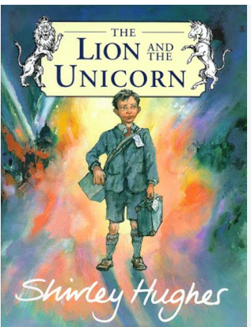
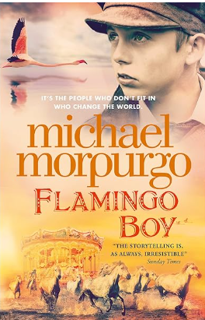
This term, Silver Birch will be exploring the question ‘How did WW2 shape the world of today?’ Our theme is all about WW2 and as Achievers and Creative Thinkers, we will learn why Britain went to war and was threatened with invasion by Hitler’s Germany during the Second World War from 1939-45, just over 20 years since the horrors of the First World War. But most of the time, we will be devoted to working out how the British people managed to cope with life on the Home Front for 6 years, much of that time with rationed food, restricted freedom and the threat of bombing, especially in large cities. We will learn how families were torn apart, with men fighting in all parts of the world, older men preparing to stop any invasion, women working on the land and in factories and children evacuated to the countryside. What kept people going was what came to be known as the 'Blitz spirit', which people sometimes refer to today when times are hard. One of the most important things we will learn about, relates to the world of ‘fake news’ today. To keep up people’s spirits, the government produced a lot of propaganda as well as censorship to put a positive spin on events. We will learn how to spot this - an important skill for life. In terms of the wider world war, you will learn much more about the fighting itself in KS3.
Key Vocabulary
Resilience
Courage
Morale
Adaptability
Endurance
Safety
Risk
Allies
Anderson shelter ARP - Air Raid Patrol warden
Battle of Britain
Germany Billeting
Black market
Blitz
Censorship
Civilian
Dunkirk
Evacuation
Home Guard
Morale
Morrison
shelter
Propaganda
Rationing

Key Texts
The Flamingo Boy by Michael Morpurgo
The Lion and the Unicorn by Shirley Hughes
My Secret War Diary by Marcia Williams

Key Questions
Why did Britain have to go to
war in 1939?

What was VE day really like?

How was Britain able to stand firm against the German threat?
Why is it so difficult to be sure what life was really like on the Home Front?
Which objects explain how Britain coped with the effect of war on the Home Front?

Why was it necessary for children to be evacuated?

