Holly Class – Summer ‘26
Characteristics:
Problem Solvers
Young Leaders

As writers and readers we will…
In VIPERS sessions we will be reading Varjak Paw by SF Said
We will also be using Journey by Aaron Becker as a writing prompt .
Write to persuade – creating adverts based on the short film Cyber Kicks.
Write to entertain – stories and short creative writing based on Journey.
Write to inform – writing biographies about a chosen famous person.

Am I courageous enough to try something new?

As mathematicians we will…
Learn how to find fractions of amounts
Learn decimals through money and real life contexts.
Learn how to tell the time.
Learn how to interpret and gather information from tables and charts.
Learn about angles, shapes and direction.

As geographers/historians we will…
Learn about the history of sports – especially the World Cup.
Learn about famous/influential people in the world of art, fashion, design and sport linking to our English work on biographies.

As artists and designers we will…
Design biscuit themed tie dye cushions.
Study different British artists including Banksy.
In RE we will…. explore the questions
What kind of world did Jesus want?
Why do Muslims call Muhammad the ‘Seal of the Prophets’?

As scientists we will…
Be learning about sound and electricity.
We will be holding our own science fair to share our learning.
As programmers in computing we will…
Become sound engineers. We will learn about recording and editing sound.

As sportspeople we will…
Develop tennis skills
Develop personal best targets in athletics– preparing for sports day

As programmers and researchers we will…

Big Question?
Am I courageous enough to try something new?
This term, Holly will be asking ‘Am I courageous enough to try something new?’ This is an art, sport, science and creativity led project. We will be learning different art techniques from different UK based artists. We will be using creative writing prompts from picture books to inspire writing. We will also be holding our own science fair to share our learning.

Key Texts
Journey & Varjak Paw

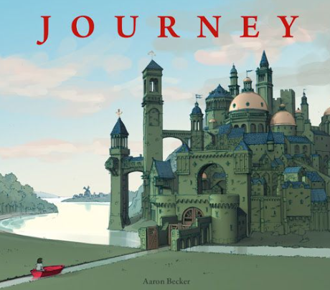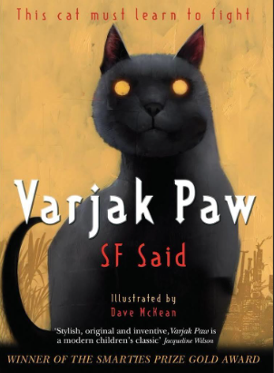

Key Questions
Can anyone be creative?
Do you have the courage to show your talents?
What is creativity?
Can you learn to be creative?
Why is it so important to make mistakes?

Key Vocabulary
Science: Electricity, conductor, insulator, circuit, sound, vibration, soundwaves, volume, pitch, amplitude
Courage, creativity, biography

