Where Does It Come From? What Lives There?
Global Garden Willow Class – Summer 2025 Ocean Deep
This term we will focus on our big questions, Where Does It Come From? and What Lives There? through our topics Global Garden and Ocean Deep we will find out more about where our food comes from and how to best look after our world and our seas. We are focusing on becoming Problem Solvers & Young Leaders and Change Makers & Critical Thinkers as we start our learning journey planning what we want to grow plants we can eat in our growing space outdoors and are looking forward to our caterpillars arriving. After half term we’ll be thinking about Sealife and are off to visit the Sealife Centre.
Key Stories  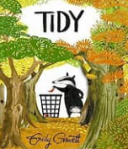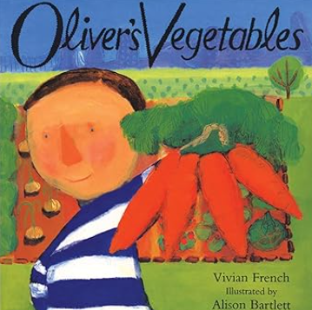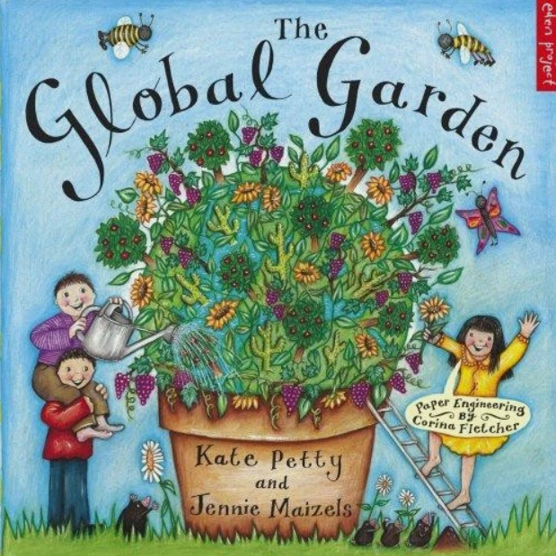  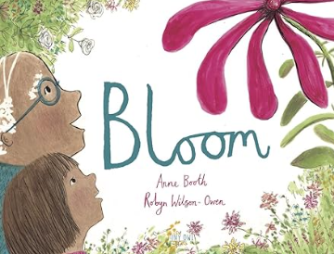  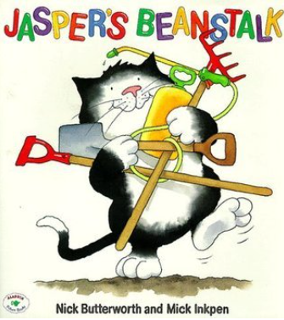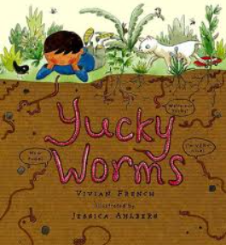 | In Communication, Language and Literacy we will read Stories like …  Seasonal Poetry  What we’ll be doing in class  Songs and Rhymes  Talking and listening games  Reading fiction, non fiction and poetry  Reading and writing High Frequency Words  Retelling stories verbally & encouraging independent writing  Non-fiction writing about sea creatures  Writing invitations, labels, captions and sentences  Book of the Week – Talking about our favourite books  Show And Tell – bring an object from home to talk about or tell us about something they have done.  You can help at Home:  Reading rhymes and traditional stories.  Reading regularly for fun  Practising keywords | 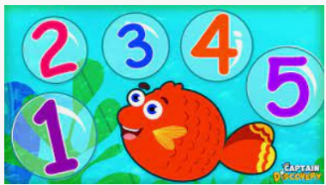  In Maths we will …  What we’ll be doing in class …  Recognising and ordering numbers Counting on and counting back  Addition and Subtraction  Saying 1 more/1 less than a number  Counting, reading & writing numbers to 10, 20 and beyond  Surveys using tally/mark making charts  Using the language of time. Sorting Coins  Measuring quantities in cooking and in weight  2d and 3d shapes and patterns  You can help at Home by  Estimating and counting objects to 10 and beyond  Talk about adding and subtracting  Practise writing numbers at home |  | 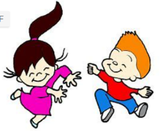  In Physical Development we will …  What we’ll be doing in class …  Self-care; toileting and washing hands  Talking about healthy food choices  Practising throwing and catching  Preparing for Sports Day  Mark making using various materials  Noticing the effects of physical activity on our bodies  Moving to music/linking movements  You can help at Home by  Encourage writing; large, medium and small scale writing  Talking about the need for variety in the food they eat
 |  |   In Personal, Social, Emotional and Health we will …  What we’ll be doing in class …  Taking turns and sharing  Follow rules and staying safe  Working as part of a team  Talking about feelings, good, bad & what makes us grumpy!  Recognising what makes each person special and unique  Acknowledging their skills & complimenting others  Know how to help themselves and others when they feel upset or hurt  Learning to compromise and appreciate others viewpoint  You can help at Home by  Encouraging turn taking and sharing  Talking about the effect of behaviour & choices on others |   In Knowledge and Understanding of the World we will  What we’ll be doing in class …  Noticing Seasonal Changes  Learning about life cycles  Minibeast Hunt  Growing plants  Learning about Sea Creatures  Walk around our school and our village  Maps; local, national, global, drawing our own  Identifying countries and continents  Using age appropriate software and websites  Using our senses to investigate  Use drawing software to create pictures about themselves  You can help at Home by  Notice seasonal changes  Spotting materials |  |   In Creative and Expressive Arts we will …  What we’ll be doing in class …  Moving to Music  Small world play  Mixing colours for a purpose  Investigating musical instruments  Making a structure from recycled materials  Role play in our Home Corner & Garden Centre  You can help at Home by  Encouraging mark making and drawing at home
,,

,,,

