Why Did The Dinosaurs Die Out? Who Lives In A Garden Like This?
Dinosaurs/Minibeasts – Willow Class - Summer 2026
We finish our school year thinking about living things, past and present, from Dinosaurs to Minibeasts.
Key Stories  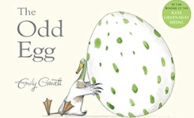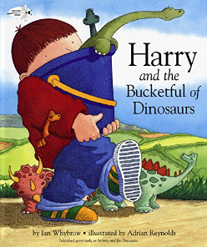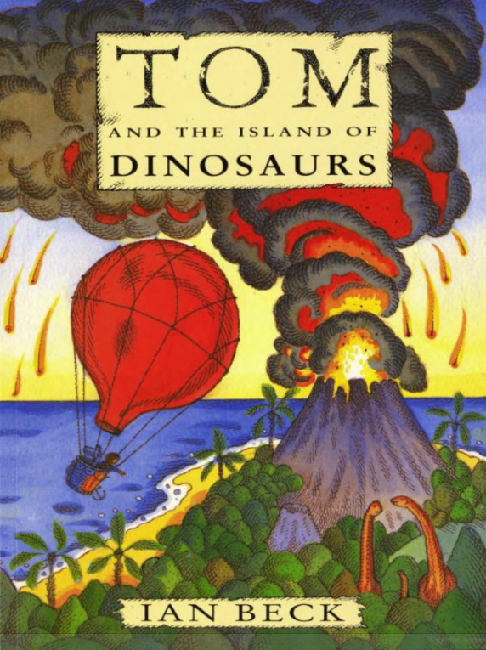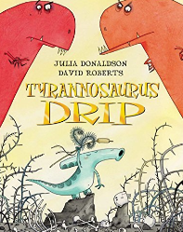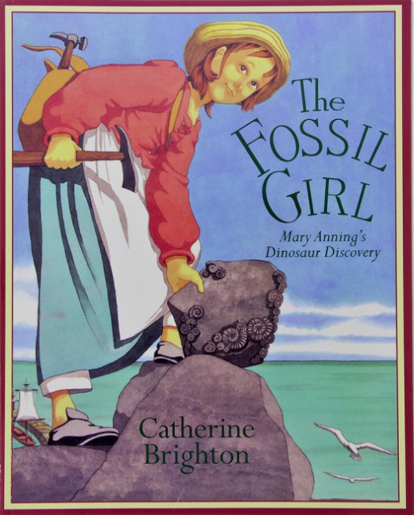  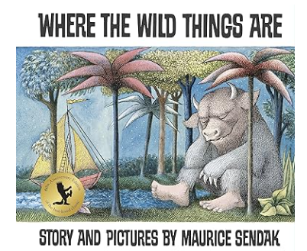 | In Communication, Language and Literacy we will …  Key Texts/Stories  The Odd Egg  The Fossil Girl  Tyrannosaurus Drip  Harry & His Bucketful of Dinosaurs  Tom & The Island of Dinosaurs  Where The Wild Things Are  The Very Hungry Caterpillar  The Bad Tempered Ladybird  The Tiny Seed  What we’ll be doing in class …  Dinosaur Factfiles  Describing characters  Ordering Story events  Writing our own stories  Writing invitations  You can help at Home: Practice keywords  Read for pleasure  Read rhymes and traditional stories | 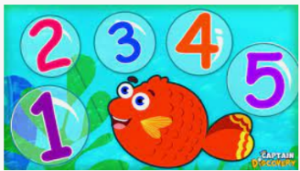  In Maths we will …  What we’ll be doing in class …  Features of 2D and 3d shapes  Doubling and Halving  Saying 1 more and 1 less  Adding and Subtracting  Measures  Counting and ordering numbers to 20 and beyond  Continuing and making repeating patterns  You can help at Home by  Estimating and counting objects to 20 and beyond  Talk about adding and subtracting |  | 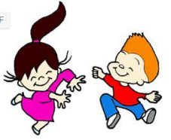  In Physical Development we will …  What we’ll be doing in class …  Negotiating play space safely  Mark making using various materials  Developing fine and gross motor skills  Throwing, catching, running, jumping and preparing for Sports Day  Talking about growing and developing  Noticing the effects of physical activity on our bodies  You can help at Home by  Encourage writing; large, medium and small scale writing  Encourage independence in dressing
 |  |   In Personal, Social, Emotional and Health we will …  What we’ll be doing in class …  Making hard decisions  Talking about what makes a good friend  Thinking about “everyday superheroes”  Acknowledging that we are all precious and unique  You can help at Home by  discussing right from wrong | 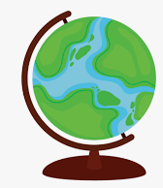  In Knowledge and Understanding of the World we will  What we’ll be doing in class …  Investigate fossils  Learning about habitats  Using maps and globes to see where dinosaurs have been found  Finding out what Earth looked like millions of years ago  Use the Internet to research dinosaurs  Dinosaur similarities and differences;  Key skills in computing; typing, printing and saving work  You can help at Home by  Notice seasonal changes |  | 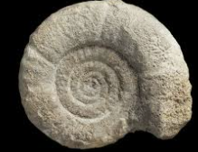  In Creative and Expressive Arts we will …  What we’ll be doing in class …  Make fossils by printing in clay  Make collages and pictures using natural materials  Listening to music and thinking how it makes us feel  Making up our own stories  Use drawing software to create pictures  You can help at Home by  Talk about materials
,,,

