What are Reading Vipers?
These are the key reading skills for children to be able read and comprehend a wide range of literary texts.
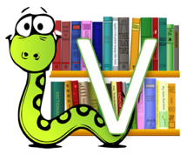 | Vocabulary  Looking at the choice of words that an author uses in a text.
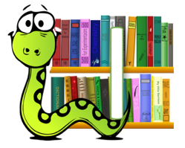 | Infer  What is suggested but not said in the text? Read between the lines and find the ‘hidden’ meaning.
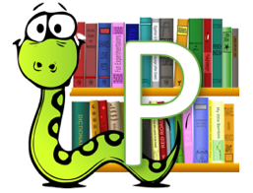 | Predict  What might happen next based on what has happened in the text?
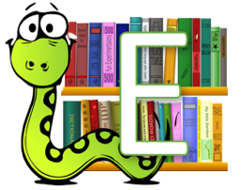 | Explain  Explain their thoughts and opinions about a text.
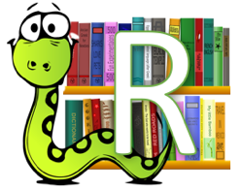 | Retrieve  Retrieve information from the text to answer questions.
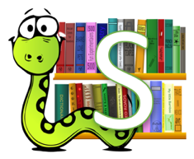 | Sequence  Putting the key events in order.

How can I support my child with their
reading comprehension at home?
You could try one or more of these activities at home with your child when you hear them read at home.
Vocabulary
Pick out two or three words from the text they have read and use the passage to discuss their meaning.
Talk about other words that have the same meaning.
Infer
Discuss a character’s personality or feelings – ask your child “how do you know this?” See if they can spot something that is suggested but not said e.g. “the boy’s hands were trembling” – we can infer that he might be nervous.
Predict
At a relevant part, stop and encourage your child to make a prediction about what might happen next, based on what they know.
Explain
Ask your child whether they liked the book and why. What was their favourite part, or character and were there any parts they didn’t like?
Retrieve
See if your child can retrieve key information from the chapter you’ve read with them e.g. names/ details/ events.
Sequence
Can your child retell the story in order? See if they explain what happened at the beginning or end?

