If you have any queries regarding forest school please contact Bolney school office on 01444881352

More information regarding our forest school sessions and the forest school handbook can be viewed on the Bolney school website under the curriculum tab.

www.bolneyschool.org.uk
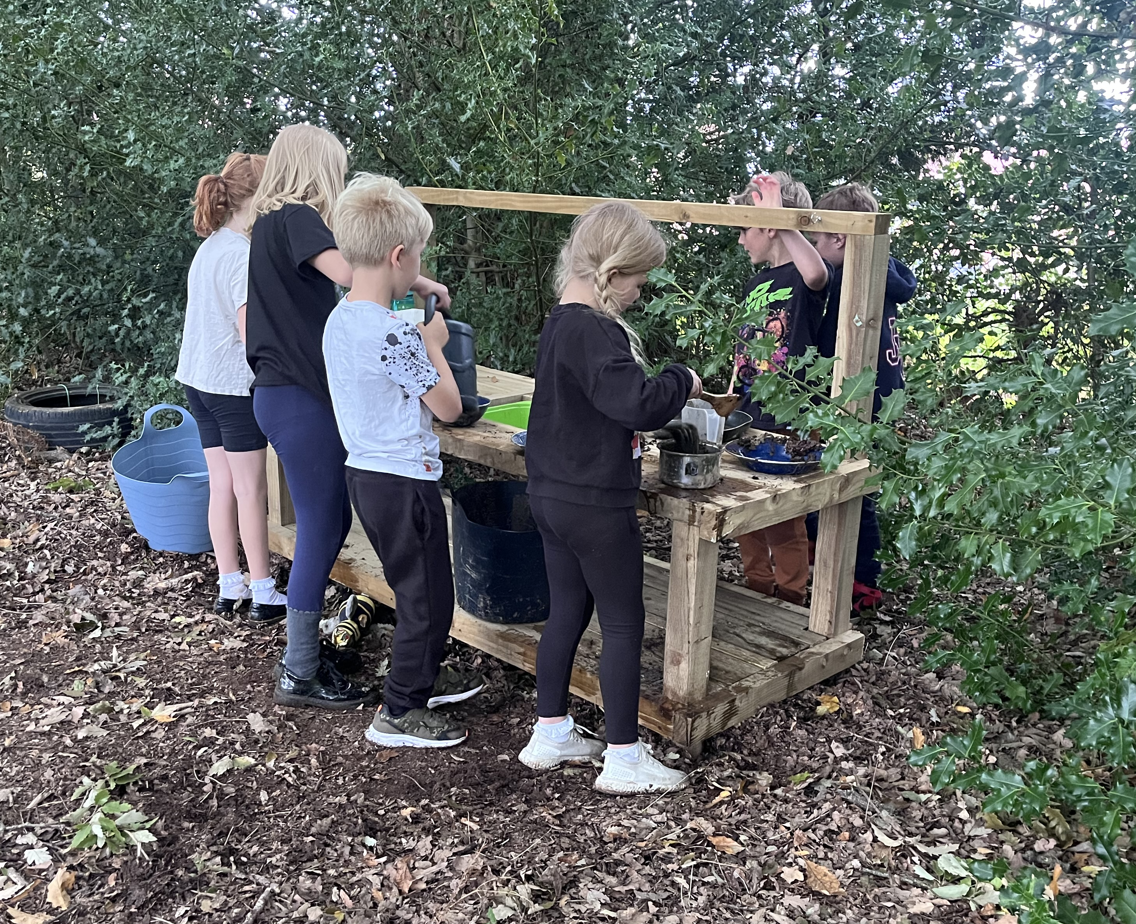
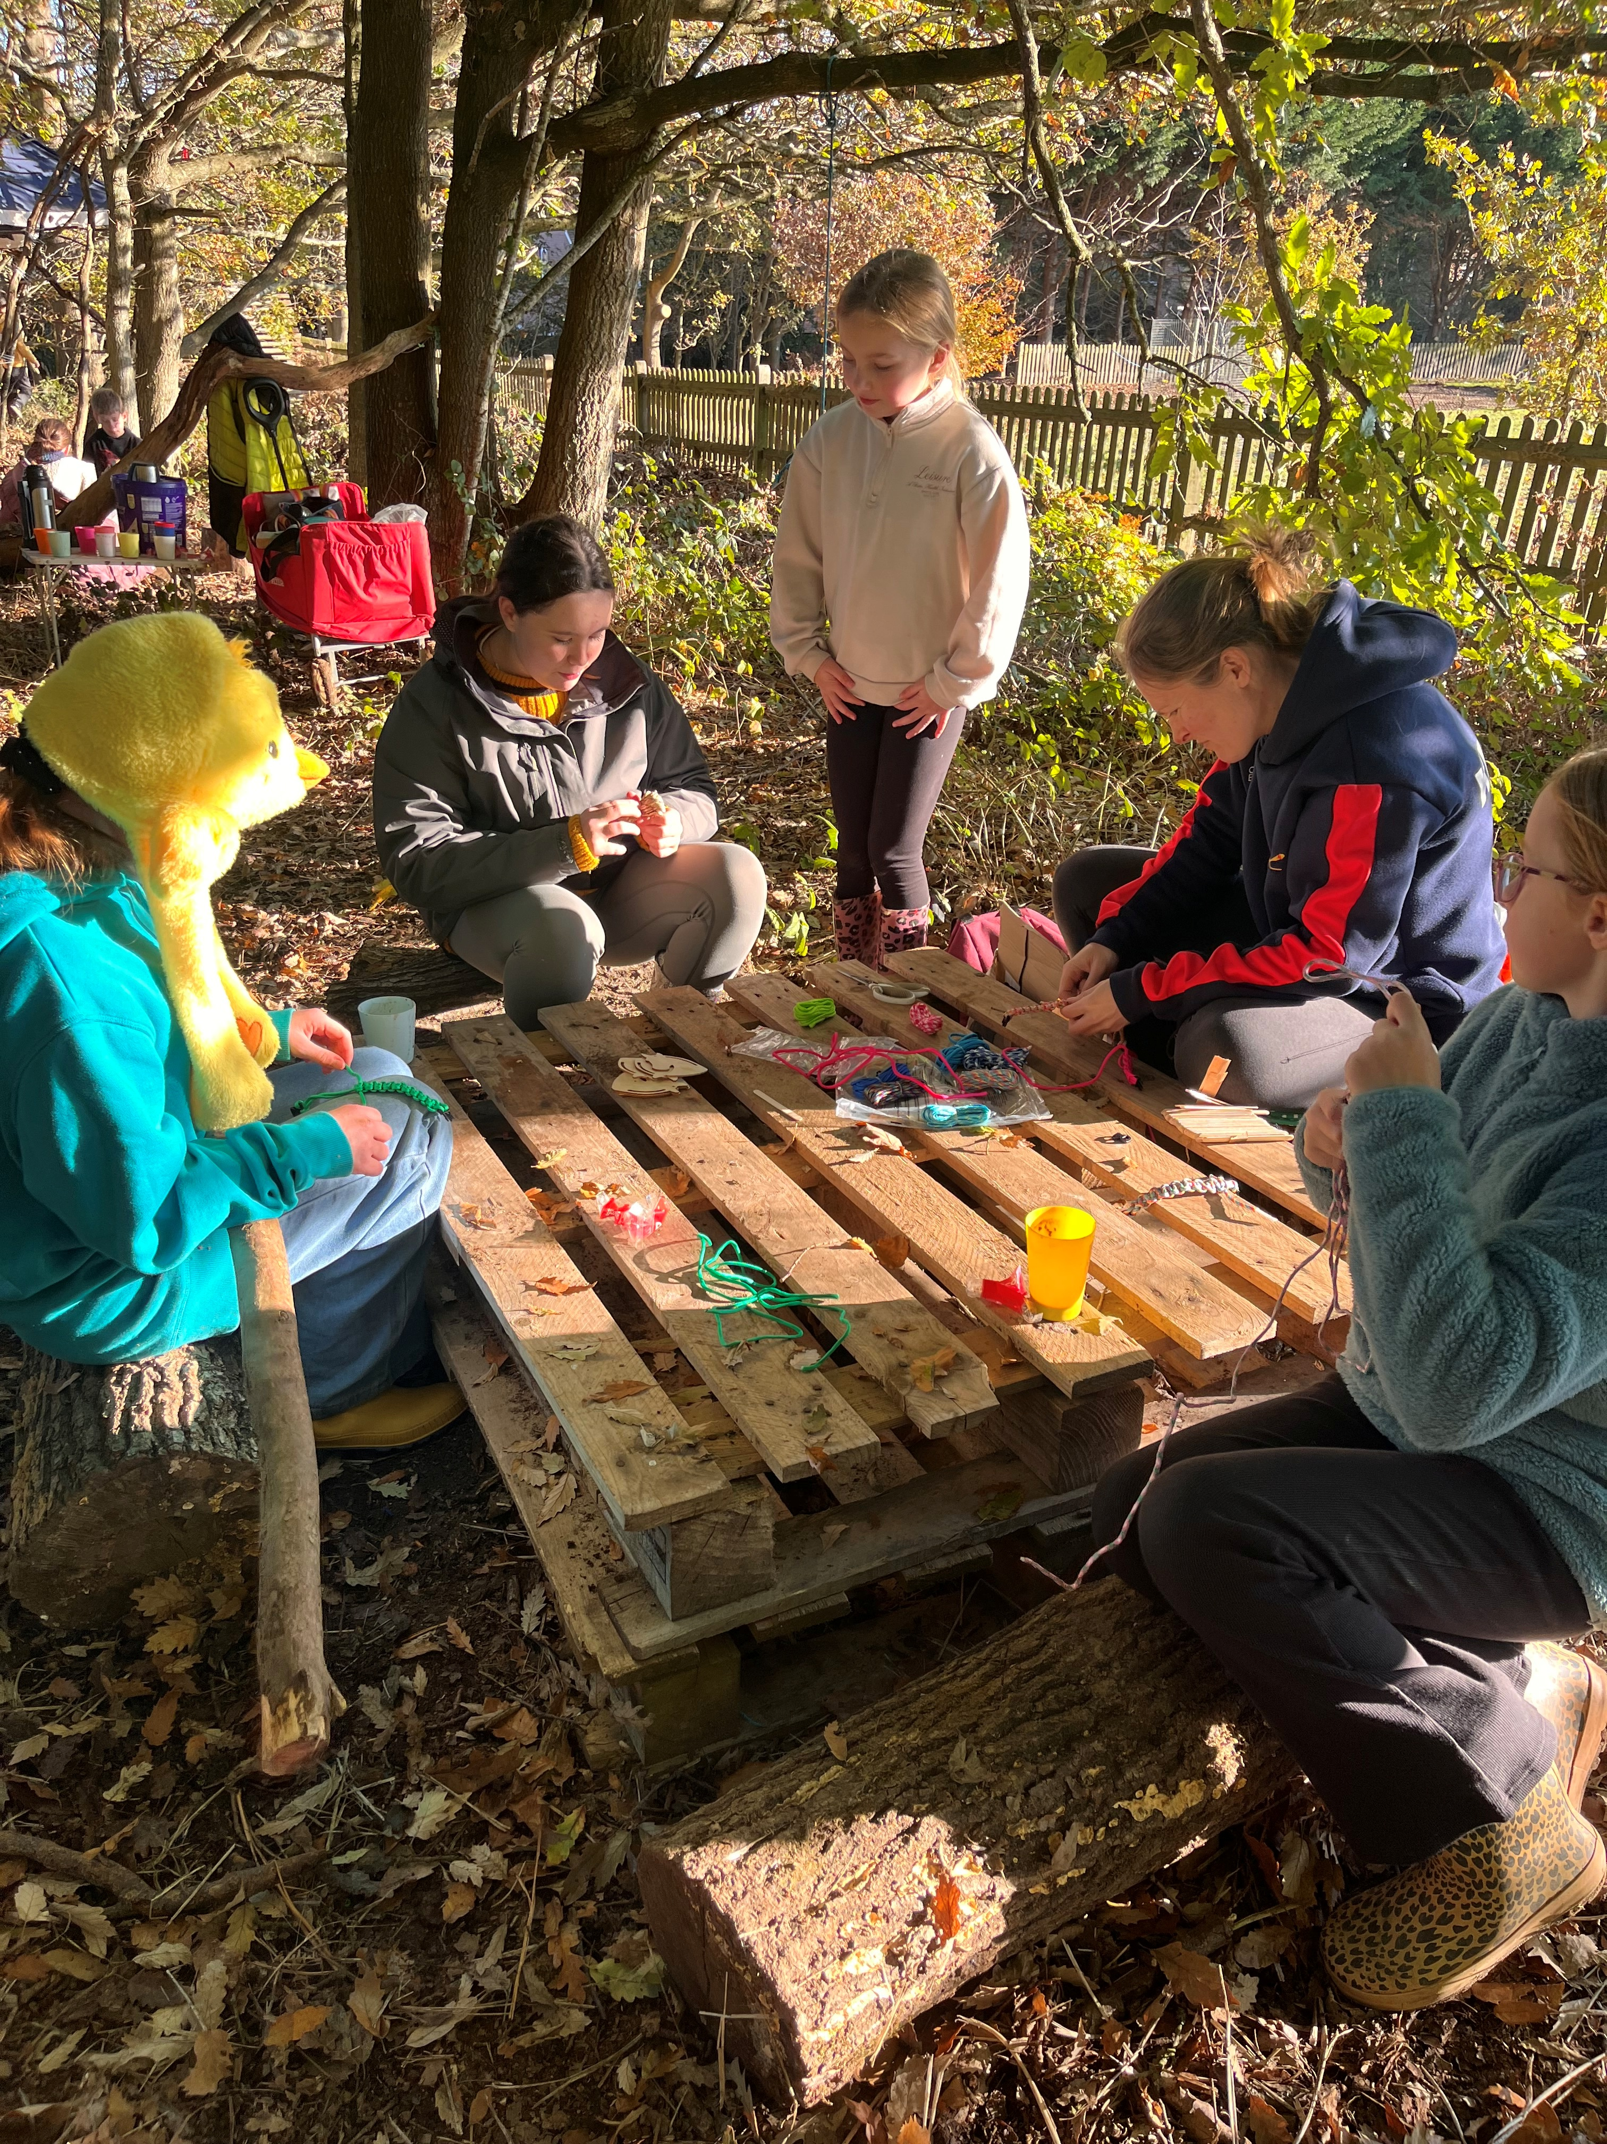

Extreme or bad weather
Our Forest School promotes an all-weather, all-seasons approach to outdoor learning. There may be occasions when it is unsafe or impractical for sessions to proceed due to adverse or extreme weather conditions and they will be cancelled.

Weather Assessment
- Weather conditions will be reviewed on the morning of each planned session using the Met Office. The Forest School Leader will determine whether the session can proceed safely.
- If a session proceeds, it is on the condition that participants are appropriately dressed for the weather and the relevant risk assessments have been completed.
- The Forest School Leader may suspend or terminate a session at any time if changing conditions present safety concerns.
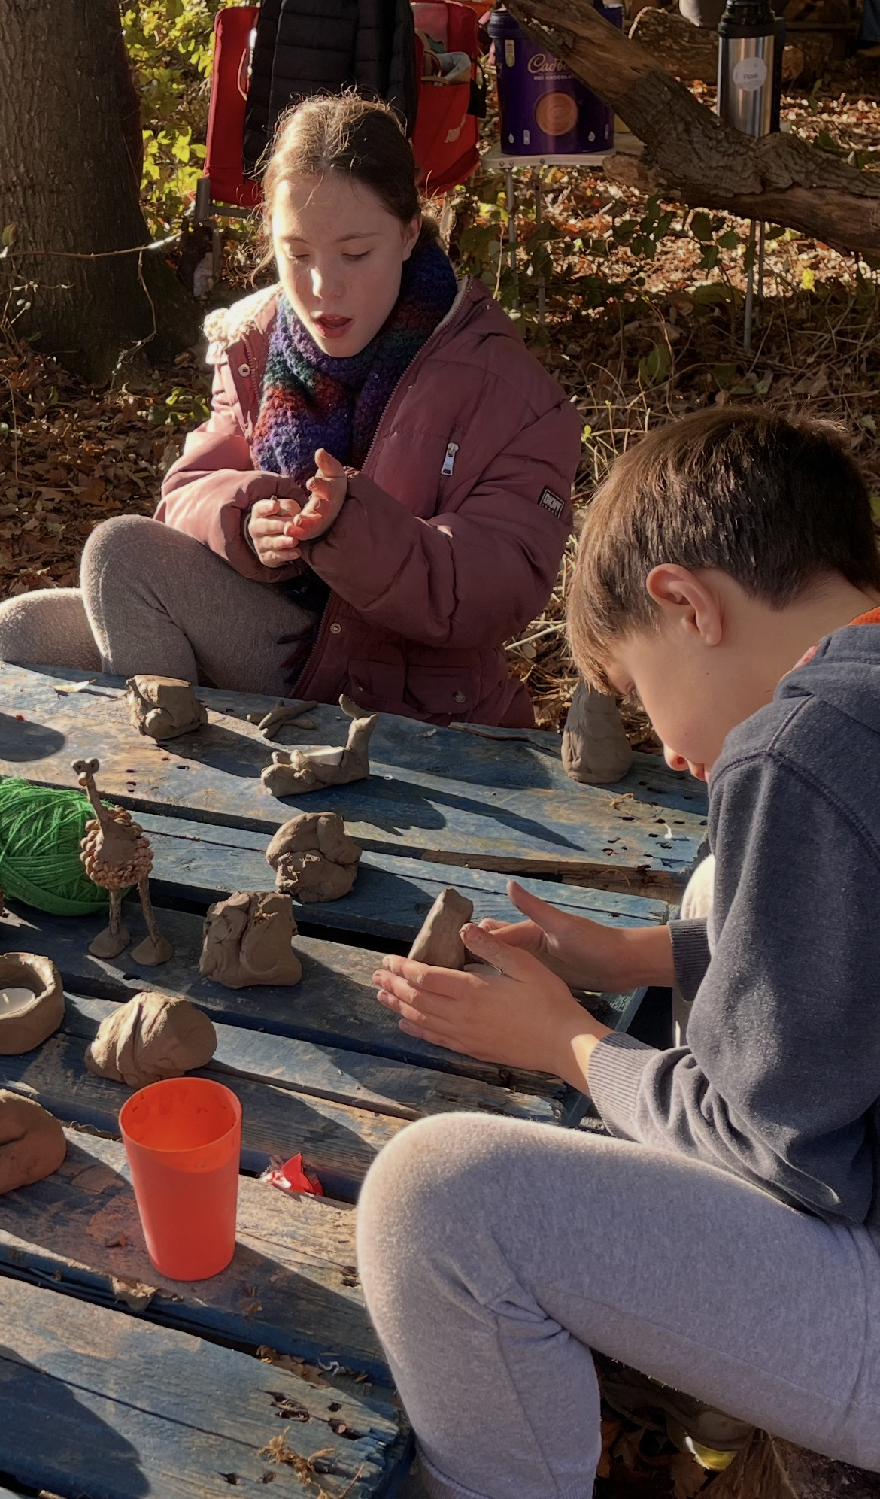

Clothing

The children are required to wear differing clothes dependent on the seasons.

Summer – 2 layers on top (t-shirt & thin jumper), legs covered, hats and sunblock
Autumn – 3 layers on top (t-shirt, jumper & light weight jacket), legs covered.
Winter – 4 layers on top (vest, t-shirt, jumper & warm jacket), legs covered, hats and gloves

- Arms and legs should be covered at all times to avoid tick bites, scratches and stings.
- Appropriate footwear such as strong boots, children will not be permitted to climb trees in wellington boots and will not be able to participate in the session if they are wearing crocs or sandals.
- Natural fibres such as cotton or wool are desirable and less likely to melt if exposed to sparks.
- Hair should be tied up if below shoulder length.
- No loose clothing, toggles or cords to be worn or they will not be able to participate with the camp fire.
- The clothes need to be durable and suitable to get wet or muddy.
- A waterproof jacket must be provided in wet conditions

Inappropriate clothing may result in a participant being unable to join certain activities for safety reasons.

Our forest school vision statement

“We are each unique but together we flourish”

Our Forest school sessions will take place in a dedicated woodland every Friday afternoon between 1-3pm, each class will receive a 6 weekly group session at Forest school, rotating between the year groups throughout the school year. This ensures that each year group experiences forest school in all of the seasons and can observe the changes in nature.
Activities will be planned dependent on age and interests, considering each unique child in the group and the group dynamic as a whole.
We have a ‘Big Project’ for each class, ranging from building shelters to creating homes for wildlife and preserving the beauty of the fascinating woodland around us.
There are opportunities for children to independently explore with curiosity, where they can take risks and learn from their experiences, gaining confidence through mastering practical skills and achieving goals in a supportive environment, fostering social, emotional, and physical growth.
Observations will be made throughout the sessions and reviews will frequently happen amongst forest school staff.



Bolney bushcraft

Our sessions take place in a beautiful woodland a short walk from the school. There are a variety of trees as well as an ancient oak tree which provides shade, shelter and encourages an appreciation for the incredible nature surrounding us. Frequent interaction with nature fosters a sense of respect and responsibility for the natural world. The health and safety of all participants is paramount, we have a qualified forest school leader running each session, we conduct daily and seasonal risk assessments, activities like fire lighting and tool use are carefully supervised with clear safety rules and appropriate supervision. The children are taught boundaries and safety rules and are expected to follow them.
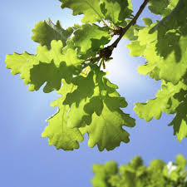

Key criteria and principles of a Forest school

The Long-Term Principle
Forest School is a long-term process of frequent and regular sessions in a woodland or natural environment, rather than a one-off visit. Planning, adaptation, observations and reviewing are integral elements of Forest School.

The Nature Principle Forest School takes place in a woodland or natural wooded environment to support the development of a relationship between the learner and the natural world.

The Risk Principle Forest School offers learners the opportunity to take supported risks appropriate to the environment.

The Holistic Learning Principle Forest School aims to promote the holistic development of all those involved, fostering resilient, confident, independent and creative learners.

The Leadership Principle Forest School is run by qualified Practitioners who continuously maintain and develop their professional Practice.

The Community Principle Forest School uses a range of learner-centred processes to create a community for development and learning.

