HOLLY CLASS HOMEWORK GRID FOR TERM 4
Why should we study the Maya?
Here is a selection of homework tasks to support the class’s big question this term and its focus characteristics. Choose two tasks a week so that by the end of term, you should have completed all the tasks. Share them by emailing work to the class teacher or by taking photos to bring in to school. There is a whole school homework display board in the library we shall be sharing all the home learning across the school towards the end of term.
  Speaking, listening and writing | 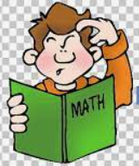  Maths, Science and Problem Solving |   Art and Design | 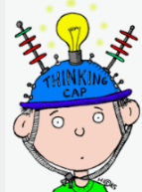  Constructing  and Creating |   Active Body  and Mind
Imagine you are a Maya arriving in modern Britain for the first time. Write a letter or orally report your first impressions. | Write a secret message using Maya hieroglyphs. | Design some art using the Maya style.  Look at Dan Fenelon’s art for inspiration | Research a Mayan temple and using whatever materials you would like, create a model. | Create a ball game you think Maya people would enjoy. Look at Pok a Tok for ideas.
Research Maya cities. Write a fact file about them including information about population, buildings and location. | Choose an area of the body e.g. hand, leg, finger – find out what bones are there. Draw a diagram and label it. | Draw and label a Maya house- what materials did they use? How do these houses compare with the Stone Age era? | Make up a design for a new chocolate bar. Can you think of a name for it? Can you design the packaging? | Create a dance routine inspired by animals the Maya lived alongside – jaguars, snakes, monkeys, parrots
Write a short story using as many different chocolate names and words as possible. | Keep a food diary for a week. Have you had your 5 fruit and vegetables each day?  Write down how you have been healthy during the week. | Create a map to show where the Maya were located. | Design a recipe for a Maya family meal. What ingredients were available? | Make up a 60 second sports challenge for your family. Compete to find the winning family member.

In addition to tasks on this grid, please support your child with daily reading, using numbots/TTrockstars and the weekly spelling task (set on Friday).

