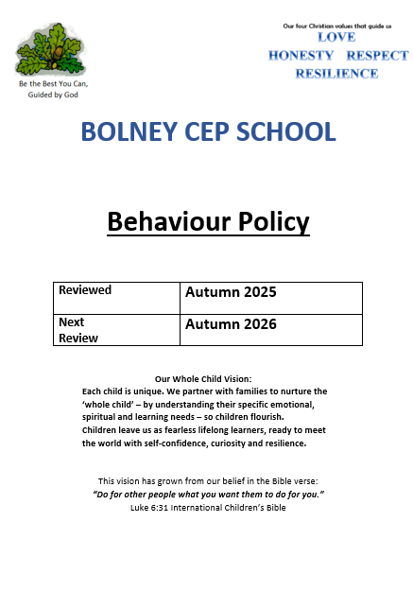

Bolney CE Primary School Behaviour Policy
Our Behaviour Policy at Bolney is based around consistent practice, positive encouragement and polite, respectful and thoughtful behaviour.
It is underpinned by both our vision and our key Christian values of Love, Respect, Honesty and Resilience.
This policy supports the school’s Anti-Bullying Policy.

What is Behaviour?
Behaviour is the way members of the school community interact with and respond to different people and situations.

Principles
- All pupils, staff and visitors have the right to feel happy, safe, valued and respected at all times, and able to learn free from the disruption of others;
- Respect is shown to all members of the school community, to property and to the environment;
- Positive behaviour is recognised and encouraged;
- As an inclusive school, all members of the community should be free from any form of discrimination;
- The school rules should be built around our school values, displayed around the school, consistently modelled and applied by all staff and volunteers at all times;
- Rewards, sanctions and the use of reasonable force are known and understood by children and applied fairly and consistently by staff, taking into account SEND, disability and the needs of vulnerable children and offering support as necessary;
- Suspensions and exclusions are used appropriately and in line with DfE Guidance.
- A positive home-school relationship is promoted with the objective of pupils and parents cooperating to maintain an orderly climate for learning and so all stakeholders are actively involved in addressing any behaviour incidents;
- The governing body also wishes to emphasise that violence, threatening behaviour or abuse by pupils or parents will not be tolerated in any circumstances.

Aims
To create an environment in which:
- children feel valued and safe
- children have a strong positive respect for themselves and others
- successful teaching and learning takes place
- appropriate behaviour contributes to the well being of the school community
- PACE (Playfulness, Acceptance, Curiosity and Empathy) is used to engage with children on a deeper level and establish secure relationships.
To fulfil these aims staff:
- are consistent in their management of behaviour
- use positive language
- emphasise politeness, kindness and mutual respect
- recognise and value individual achievements and contributions

- encourage children to be responsible for their own personal conduct
- liaise with parents/carers regarding their child’s behaviour
- use the terminology of ‘over and above’

This policy outlines the strategies we use to ensure the aims are met.

What is unacceptable behaviour?
This may occur in a variety of forms:

Not following rules set by the school
Emotional – being deliberately unfriendly, excluding, tormenting, intimidation
Physical – pushing, kicking, hitting, punching or any use of violence
Verbal – name calling, malicious sarcasm, spreading rumours, malicious teasing. It may be directed towards gender, ethnic origin, physical / social disability, or personality, etc.
Racist – racial taunts, graffiti, gestures
Sexual – unwanted physical contact or sexually abusive comments
Damage to property or theft – taking personal property or coercing a pupil to hand over property to them
Cyber – email, social media or messaging misuse, telephone calls or misuse of associated technology such as camera or video facilities

Our School Rules
The whole school community was involved in creating and agreeing these rules. They are based on our Christian values of love, respect, honesty and resilience and refer to our vision: ‘Be the best you can, guided by God. Every child and adult is to commit to these rules which will guide all of us in our daily lives:
- Be Ready
- Be Respectful
- Be Safe

Positive reinforcement strategies
Pupils who follow the rules will be acknowledged wherever possible through immediate, verbal praise specific to the acknowledged behaviour (“Thank you for putting your chair under the desk, James, you have gone over and above”). This style of over and above recognition is the keystone to our classroom and school behaviour policy.

- Classes may choose to have additional class rules or ‘Over and Above’ goals that they are
working towards.
- In class, time is made for children to show particular achievements from a lesson or home learning and praise is given.

- Team points are awarded for acts that are over and above. These are given as tokens to add to a whole house team tube and once the tube is full, the whole house team have a treat. Each team has the opportunity to fill their tube and receive a treat from a list of choices available to them.
- Oak leaves are awarded in Celebration Assembly for effort and positive attitudes to learning, the children may show work they have been awarded an oak leaf for and talk about it to the rest of the class/school, showing the value placed on it.

- Christian values are awarded each week – one child across the school per value, nominated by the
- staff or children.
- Outside successes such as sporting achievements can be shared and celebrated in Celebration assembly.

- Certificates for weekly sports stars are awarded in Celebration assembly.
- Other class rewards may also be used such as: Marble in the jar or Golden time at the end of the week.

- Positive contact to parents – messages sent home, speaking with parents, bi weekly newsletters and work sharing sessions.
- Headteacher’s award stickers and sharing learning with the headteacher.
Rewards are not to be taken away once awarded.

Minimising and responding to unacceptable behaviour
Adults in the school seek to minimise the opportunity for pupils to misbehave through:
  - Engagement through an exciting and challenging curriculum;
  - Early establishment of their authority in a secure, confident but relaxed manner;
  - Establishment and maintenance of shared expectations of behaviour, routines and structure;
  - Considered, sensitive and skilled early intervention, this may include directed choice, e.g. you can stay in your seat and work quietly or move to the table over there and work on your own.
  - Using the PACE approach where appropriate

Consequences
Pupils who choose not to follow the rules are subject to the following set of consequences. These consequences are consistent in all classrooms/playgrounds and are in an order of hierarchy. However in extreme cases of inappropriate behaviour it may be necessary to go straight to a specific sanction, like losing time or class exclusion. When giving the sanction, after a polite reminder, the consequence of continuing the action should be made clear. The consequences are:

Polite Reminder
Using a principle of least intrusive response, pupils are reminded that they are not adhering to a class/ playground rule. They are calmly told the rule they are infringing and asked to comply.

Reflection Time
A child failing to comply with a polite reminder will be asked to reflect on their behaviour. This is designed to highlight the fact that they are displaying undesired behaviour and that further sanctions will follow if the child continues to misbehave. This is shared verbally with the child and they may have time out or be asked to work on a table on their own within the classroom environment or stand to the side of the playground to restore good behaviour.

Lose time
Continued misbehaviour, or a concerning behaviour that does not follow our principles outlined at the start of this policy, will result in the child losing some time from their next play time. A reflective discussion should take place during this time which could incorporate elements of the PACE model. If this is during playtime, this may be after first aid has been administered which should be explained to the child. The class teacher is to be informed of this at the end of play and loss of next playtime or

Golden Time should be left to the discretion of the teacher.

CPOMs is used to log the behaviour and should include any discussions or follow up that was carried out. These should be recorded under ‘playground incident’.

Headteacher involvement
Continued misbehaviour or a serious, isolated incident can result in the headteacher meeting with a child to discuss their behaviour. This is recorded on CPOMS. If the headteacher or the teacher deems it necessary, parents will be called in to have a wider discussion about the child’s behaviour.

Time in (reflection time)
Continued poor behaviour or a serious, isolated incident will result in the child being removed from the classroom/ playground environment to work in one of the safe spaces. If the child is removed near the end of a session they will be expected to remain there for the next session for a reasonable length of time. The child’s return to class/play will be decided based on their readiness to return to learning with their peers.
The child will be removed to an area as decided by the Headteacher or SLT in their absence. A member of staff can escort the child to the Headteacher. If there is not a member of staff available to do this a request can be made for assistance using the two-way radio or sending a red card to the office.

Once out of class the child will continue with their work and discuss the incident with the adult when calm enough to do so. This will be recorded on CPOMS. If the time out occurs over a break-time the child may have a supervised break at an alternative time to the other children. Good practice would be to discuss incident with all children involved and eye witnesses.

Loss of privilege / responsibility
If a child persists in making poor choices, the class teacher may recommend to the Headteacher that a privilege (such as sports crew) or representing the school at a sporting fixture for example, be withdrawn. This decision would be made in consultation with parent/carer.

Parental Involvement
This is at the discretion of the class teacher for any of the sanctions given after the sanction of losing time. Parents will be informed of a class exclusion on the day it has occurred wherever possible. The teacher / Head / SLT (depending on the situation) should seek to meet with parents or make a phone call home to discuss the issues. It is important to keep parents informed of their child’s behaviour and to foster as much support from home as possible.

A formal record of meetings with parents should be put on CPOMS.

Fixed-term and permanent exclusions
Only the Headteacher (or the Acting Headteacher) has the power to exclude a pupil from school. The Headteacher may exclude a pupil for one or more fixed periods for up to 45 days in any one school year. The Headteacher may also exclude a pupil permanently. It is also possible for the Headteacher to convert a fixed-term exclusion into a permanent exclusion, if the circumstances warrant this.

If the Headteacher excludes a pupil, they must inform the parents/carers immediately, giving reasons for the exclusion. At the same time, the Headteacher makes it clear to the parents/carers that they can, if they wish, appeal against the decision to the Governing Body. The school informs the

parents/carers how to make any such appeal.

The Headteacher informs the LA and the Governing Body about any permanent exclusion, and about any fixed-term exclusions.

If permanent exclusion is becoming a distinct possibility, then efforts will be made to organise a multi- agency meeting for the benefit of the child. Advice is sought by the West Sussex Fair Access Team.
Attendees may include parents/carers, teachers, teaching assistants, and other professionals. A pastoral support plan will be agreed which aims to reinstate positive behaviours.

The Governing Body itself cannot either exclude a pupil or extend the exclusion period made by the Headteacher. The Governing Body has a discipline committee, which is made up of between three and five members. This committee considers any exclusion appeals on behalf of the Governors.
When an appeals panel meets to consider exclusion, the panel consider the circumstances in which the pupil was excluded, consider any representation by parents/carers and the LEA, and consider whether the pupil should be reinstated.

If the Governors’ appeals panel decides that a pupil should be reinstated, the Headteacher must
comply with this ruling.

PACE
For children with more complex needs, the PACE (Playfulness, Acceptance, Curiosity and Empathy) model should be used. This model is used to build meaningful connections with children on a deeper level which will help them to feel a secure trust towards adults. It provides a non-judgemental approach that requires an adult to understand the reasons and emotions behind a child’s behaviour. All staff have received training on this model. For more information, please see our website page dedicated to PACE.

Behaviour Support Plan or other plans
For children who find following the school’s rules and expectations a challenge a behaviour support plan is to be implemented. This will support a child with their behaviour and ensure there is a consistent approach when supporting a child.
A behaviour support plan will be agreed by the SENDCo with the child’s class teacher, the child and the child’s parents/carers.
All staff and the parents/carers will be aware of the plan and be consistent in its implementation. A review of the plan is to take place as circumstances change.
The involvement of outside agencies is to be considered and staff are to engage with the agency involved.

Use of force
All members of staff are aware of the regulations regarding the use of force by teachers, as set out in DfEE Circular 10/98, relating to section 550A of the Education Act 1996: The Use of Force to Control or Restrain Pupils. Staff only intervene physically to restrain children to prevent injury to a child. The actions that we take are in line with government guidelines on the restraint of children.
Members of staff who are involved with physically restraining a child will have received Team Teach training

Bullying
Any incidents of bullying will be dealt with firmly, fairly, promptly and confidentially. The child-friendly Steps to Success will be used. Please see the Anti-bullying Policy.

The role of the class teacher and support staff:
It is the responsibility of the teaching team to engage the children in an exciting and challenging curriculum. They are to ensure that positive behaviour is promoted in their class, and that the class behaves in a responsible manner. The teaching teams in our school have high expectations of the children in terms of behaviour, and they strive to ensure that all children work to the best of their ability.
The teaching teams treat each child fairly and enforce the classroom code consistently. The teaching teams treat all children in their class with respect and understanding.

The class teacher reports to parents/carers about the progress of each child in their class, in line with the whole-school policy. The class teacher may also contact a parent/carer if there are concerns about the behaviour or welfare of a child. If the class teacher needs support and guidance in managing a child’s behaviour they will liaise with the school’s SENDCo. This may lead to further guidance from outside agencies.

The role of the Headteacher:
It is the responsibility of the Headteacher, under the School Standards and Framework Act 1998, to implement the school behaviour policy consistently throughout the school, and to report to governors, when requested, on the effectiveness of the policy. It is also the responsibility of the Headteacher to ensure the health, safety and welfare of all children in the school.

The Headteacher supports the staff by implementing the policy, by setting the standards of behaviour, and by supporting staff in the implementation of the policy. The Headteacher keeps records of all reported serious incidents of misbehaviour.
The Headteacher has the responsibility for giving fixed-term exclusions to individual children for serious acts of misbehaviour. For repeated or very serious acts of anti-social behaviour, the Headteacher may permanently exclude a child. Both these actions are only taken after the school governors have been notified.

The role of parents/carers:
The school works collaboratively with parents/carers, so children receive consistent messages about how to behave at home and at school. Our expectations for good behaviour are outlined in the School Prospectus and on the school website. We expect parents/carers to read these and support them.

We expect parents/carers to support their child’s learning, and to co-operate with the school, as set out in the home-school agreement. We try to build a supportive dialogue between the home and the school, and we inform parents/carers if we have concerns about their child’s welfare or behaviour.

If the school has to use reasonable sanctions to discipline a child, parents/carers should support the actions of the school. If parents/carers have any concern about the way that their child has been treated, they should initially contact the class teacher. If the concern remains, they should contact the Headteacher. If this discussion cannot resolve the problem the parents/carers can follow the Complaints procedure. (See Complaints Policy on our website.)

The role of governors:
The Governing Body has the responsibility of setting down these general guidelines on standards of discipline and behaviour, and of reviewing their effectiveness. The governors support the

Headteacher in carrying out these guidelines.

The Headteacher has the day-to-day authority to implement the school behaviour policy, but governors may give advice to the Headteacher about particular disciplinary issues. The Headteacher must take this into account when making decisions about matters of behaviour.

Monitoring
The Headteacher monitors the effectiveness of this policy on a regular basis. The Headteacher also reports to the Governing Body on the effectiveness of the policy and, if necessary, makes recommendations for further improvements.

The Headteacher keeps a record of any pupil who is suspended for a fixed term, or who is permanently excluded. The Headteacher completes the relevant documentation and shares it with the Local Authority. It is the responsibility of the Governing Body to monitor the rate of suspensions and exclusions and to ensure that the school policy is administered fairly and consistently.

~~~~~~~~~~~~

This policy applies to all areas outlined in the DfE document ‘Behaviour and discipline in schools’
Advice for headteachers and school staff January 2016 which includes:
- Pupils’ conduct outside the school gates – teachers’ powers
- Detention
- Confiscation of inappropriate items
- Power to use reasonable force

APPENDIX 1

There are various safe spaces within classrooms and in the wider school:

The Headteacher’s Office
Outside the library
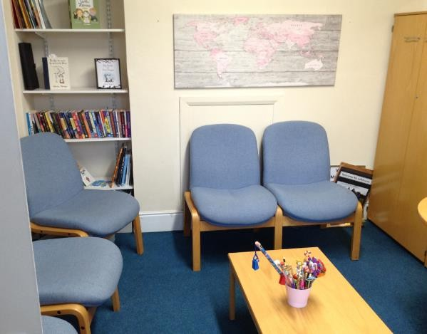
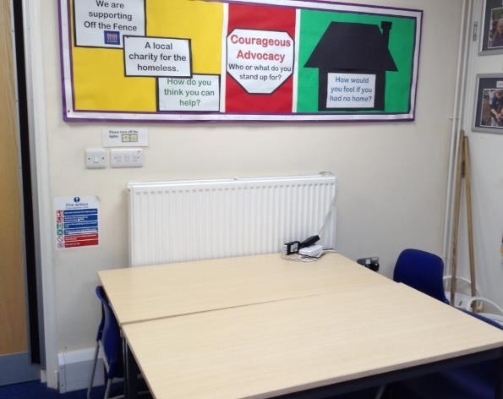
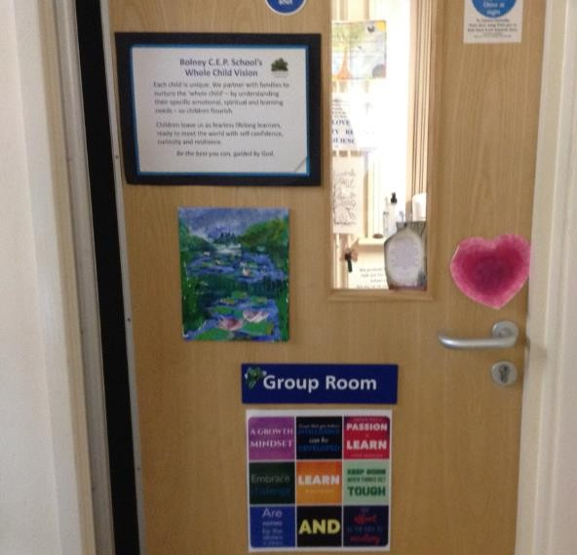
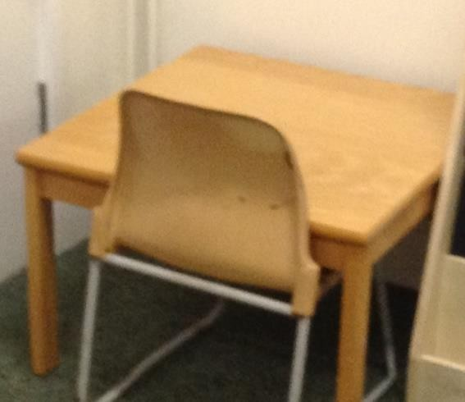
The SENDCos Office
A workspace within a classroom

APPENDIX 2

Warm Demanders

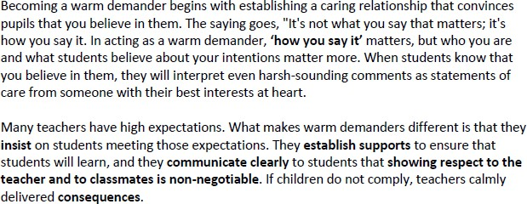

Catch them doing something good

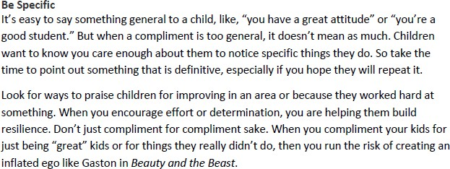

Positive Phrases

You have really improved your... Thank you for…..
I like the way you . . . I can tell how hard you worked…
I noticed how you . . . Well done for…

APPENDIX 3 PACE
