How Have Toys Changed Over Time? How Will The Story End?
Toys and Traditional Tales – Willow Class – Autumn 2024
We start the school year with our Toys topic, thinking about our favourite toys and how toys have changed over time, what toys are made out of
and what toys are like around the world. After half term we will focus on Traditional Tales, retelling stories and changing them.
Key Stories  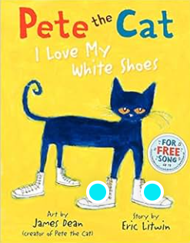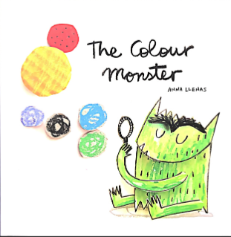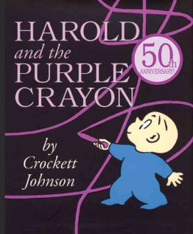  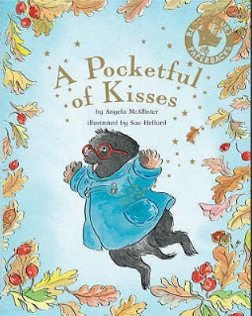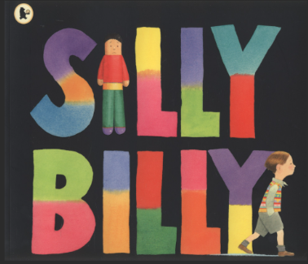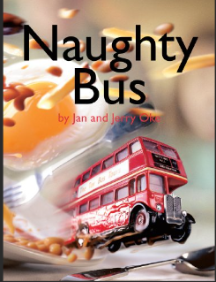 | In Communication, Language and Literacy we will read Stories like …  Pete The Cat  The Colour Monster  Pocketful of Kisses  Harold And The Purple Crayon  Silly Billy  The Naughty Bus  Monkey And Me  Seasonal Poetry  What we’ll be doing in class  Getting to know our new classmates and teachers  Showing awareness of listeners  Explore sounds  Talking about our favourite toys  Book of the Week – Talking about our favourite books  You can help at Home: Reading rhymes and traditional stories.  Reading regularly for fun  Favourite Toys  We would love children to bring a favourite toy to school to show, draw and write about in the first 3 weeks. | 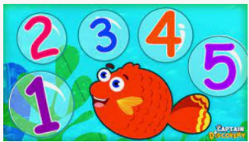  In Maths we will …  What we’ll be doing in class …  Use number names in order  Recognising numbers  Estimate groups of items  Compare quantities  Counting objects to 10 and 20 and beyond  Comparing heights/size and solve measures problems  Saying 1 more and 1 less  Continuing and making repeating patterns  Features of 2D and 3d shapes  You can help at Home by  Estimating and counting objects to 10 and beyond  Talk about adding and subtracting |  | 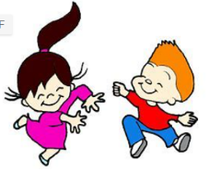  In Physical Development we will …  What we’ll be doing in class …  Self-care; toileting and washing hands  Talking about healthy food choices  Negotiating play space safely  Mark making using various materials  Noticing the effects of physical activity on our bodies  Practising throwing and catching  Dressing and undressing  Moving to music/linking movements  You can help at Home by  Encourage writing; large, medium and small scale writing  Encourage independence in dressing
 |  |   In Personal, Social, Emotional and Health we will …  What we’ll be doing in class …  Forming relationships  Staying Safe  Discuss our favourite toys from home  Awareness of own and other’s needs  Being sensitive to needs and feelings of others  Taking turns, sharing  Follow rules  You can help at Home by  Encouraging turn taking and sharing  Join us for  Year R Meet the Teacher  2:30pm Thursday 18th September  in Willow Class. |   In Knowledge and Understanding of the World we will  What we’ll be doing in class …  Noticing Seasonal Changes  Using simple age appropriate software and websites  Using our senses to investigate  Being able to talk about past and present  Sorting old and new toys; grouping, comparing and thinking about how toys work  Investigate how toys move; pushes and pulls  Experiment with cars on ramps and different surfaces  You can help at Home by  Notice seasonal changes  Spotting materials |  | 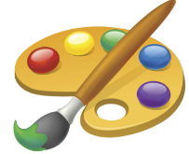  In Creative and Expressive Arts we will …  What we’ll be doing in class …   Colour Mixing  Explore sounds and sing songs  Observational drawings of old toys  Collaging and pastel pictures of bonfires and fireworks  Listening to special music;  Make sock puppets & Worry Dolls and acting out stories  Home Corner & Toy Shop role play  Making Diva Lamps  Making Christmas wrapping paper  You can help at Home by  Talk about materials
,,

