SCIENCE –we will be continuing to learn about forces (gravity), friction, air and wind resistance.  
We will also be learning about levers and pulleys.

Learning for Life (Jigsaw) - As young people, we will explore the characteristics of Achievers and Creative Thinkers. Our film unit starts with a real-life achiever and then we delve into the famous achievers in our Saxon and Viking times, including Saint Frideswide who founded the first church in Oxford.

Our Jigsaw lessons start with Dreams and Goals.

**Silver Birch- Our Spring Learning Journey- Our theme is The Anglo Saxons and Vikings and our big question ‘What makes someone British?’**

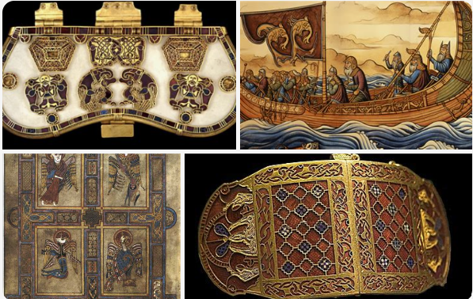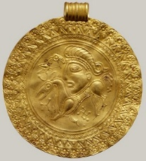As scientists,

RE- We will try to answer the questions: ‘**What is holiness for Jewish people, a place, a time, an object or something else?’** followed by, ‘**What difference does the resurrection make to Christians?’**

MATHS- As mathematicians, we will continue with Fractions. The Year 6’s will move into decimals and percentages before exploring ratio, algebra and geometry.

Year 5 will be focusing on fractions and decimals before moving on to data handling, area, perimeter, volume and geometry.

PE-As sportspeople, we will start with a dance unit based around Alfred the Great using BBC Radio.

Our specialist teacher will move onto gymnastics.

COMPUTING- As programmers, we will look at the creation of websites for a chosen purpose. We will identify what makes a good web page and use this information to design and evaluate our own website using Google Sites. Throughout the process, we will pay specific attention to copyright and fair use of media, the aesthetics of the site, and navigation paths.

HISTORY/GEOGRAPHY – As Historians, we will be discussing how different groups arrived, settled and invaded in order to establish themselves in Britain. We will look at the reasons for groups relocating and discussing ‘push’ and ‘pull’ factors.

As Geographers, we travel back to the time of the early village settlers and discover how towns and villages got their names and why certain areas were chosen as settlements. Then return to the present day and look at settlements and explore maps of surrounding areas.

ART and DT- As artists, we will use scraper boards to design and make our own ‘Sutton Hoo’ hoard. We will research Viking jewellery and explore what was found in the actual ‘Sutton Hoo’ hoard. After half term, we will design a purse fit for a Viking. Children may make two different designs that incorporate different skills such as sewing, cutting and measuring.

ENGLISH -As writers, firstly, we will watch the film called The Ridge and write setting descriptions, narratives, and learn how to create atmosphere and poetry. We will then start our text The London Eye Mystery and explore speech as conversation, writing a recount as a character and a police report.

In history, we will write historical short stories as well as newspaper reports on Viking invasions.

MUSIC- As musicians, we Learn the song Living on a Prayer for our school pantomime, play instruments and explore composition.

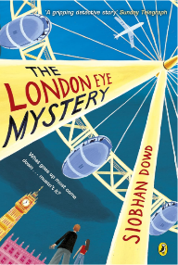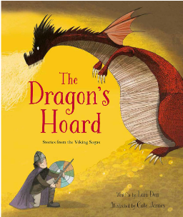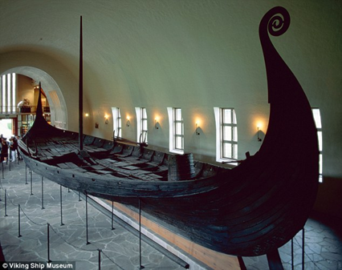

What makes someone British?

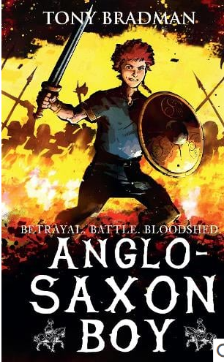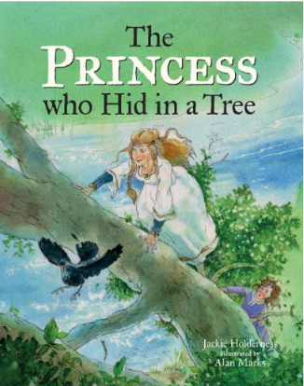

**Key Vocabulary**

Cemetery Sutton Hoo

Cenotaph Treaty

Christianity Turning Point

Danelaw Um

Hoard Viking

Hypothesis Wergild

Monastery

Pagan

Picts

Sceptre

Settlement

**Key Questions**

Were Saxon times really ‘Dark’ Ages?

How did the Vikings try to

take over the country and how close did they get?

Alfred the Great. How great was he?

Raiders or settlers: how should we remember the Vikings?

What image do we have of the Vikings?

**Key Texts**

The London Eye Mystery by Siobhan Dowd

Anglo Saxon Boy by Tony Bradman

The Princess who Hid in a Tree by Jackie Holderness

The Dragon’s Hoard by Lari Don

This term, Silver Birch will be exploring the question ‘What makes someone British?’ Our theme is Anglo Saxons and the Vikings. As Achievers and Creative Thinkers, we will be discussing how different groups arrived, settled and invaded in order to establish themselves in Britain. We will look at the reasons for groups relocating and discussing ‘push’ and ‘pull’ factors. We will also look at what can be learned about history and geography from place names. In addition, we will be considering these points; was Alfred really great and were the Dark Ages in Anglo-Saxon Britain really that dark?