Silver Birch HOMEWORK GRID FOR TERM 3 and 4
How did WW2 shape the world of today?
Here is a selection of homework tasks to support the class’s big question this term and its focus characteristics. Choose two tasks a week so that by the end of term, you should have completed all the tasks. Share them by emailing work to the class teacher or by taking photos to bring in to school. There is a whole school homework display board in the library we shall be sharing all the home learning across the school towards the end of term.
  Speaking, listening and writing | 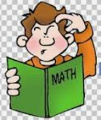  Maths, Science and Problem Solving |   Art and Design |   Constructing  and Creating |   Active Body  and Mind
Listen to Churchill’s famous speeches from WW2. Consider how he encouraged, inspired and informed the country.  Write your own inspirational speech to lift the moods of the population during wartime. | Create a scale model/diagram of the solar system.  Can you work out the distances between planets and how to show this to scale?  Can you choose appropriately sized objects? | Create some VE Day bunting to celebrate the end of the war. | Create a small cardboard replica of a bomb shelter:  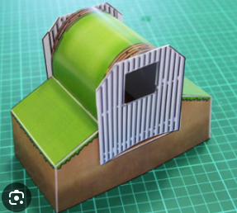 | Create an exercise routine for a soldiers to stay in shape.  Consider what strength activities you might need as well as fitness/cardio ones.
Write a diary entry from the point of view of an evacuee.  Are you staying with a kind family? Is it different from what you are used to? Are you missing home? | Blackout blinds were used to keep light from escaping houses, enabling enemy bombers to see where to go.  Investigate household fabrics and materials to see what would make the best blackout blinds. | Create a piece of art inspired by the night sky.  You could research constellations and use this to create an image. | Make a map/globe showing some of the key countries/cities and battles of WW2 | Create a WW2/1940s dance routine.  Think about the Charleston, Jive, Lambeth Walk that we have learned in school.  How can you make your own?
Research key countries involved in WW2 – UK, USA, Russia, Germany, Italy, Japan, France, Australia/New Zealand.  Can you find out key facts and statistics about e.g size of army etc.  Create a fact page to show what you have found out. | Create a code using the phonetic alphabet, which was used by the RAF in the war:  You could also research Morse code and use that instead. | Research 1940s fashion. Can you design a fashionable outfit that someone could have worn. | Create a war time meal – make sure you consider rationing and the restrictions in place that people had to work around! | Air raids could last hours. Can you pick a skill such as juggling or stacking cups that you could try and improve on while you imagine being in an air raid shelter. Can you improve over the course of a week?

