Big question: How should society be organised?
Here is a selection of homework tasks to support the class’s big question this term and its focus characteristics. Choose two tasks a week so that by the end of term, you should have completed all the tasks. Share them by emailing work to the class teacher or by taking photos to bring in to school. There is a whole school homework display board in the library; we shall be sharing all the home learning across the school towards the end of term.
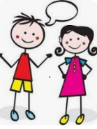  Speaking, listening and writing | 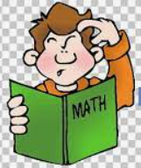  Maths, Science and Problem Solving | Art and Design | 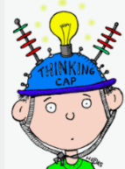  Constructing  and Creating | Active Body  and Mind
Learn a short Greek story or myth (Aesop’s fables) to recite or perform aloud. | Who was Pythagoras? Can you research and find out how Pythagoras’ theory helps us in maths? | Create some artwork inspired by your star sign. | Design and make your own labyrinth. You could draw, use string, use card etc. | Create a mini Olympics of events you can compete in at home (keepy uppies, laps round the garden, target throwing)  Can you round up some family members to compete against?
Research and write about life for children in Ancient Greece. | Create a timeline of the Ancient Greek | Find out about Greek architecture. Make a poster showing types of Greek columns or Greek patterns. | Prepare some Greek food – Delian sweets and sesame and honey pancakes might be a good choice! | Make a gymnastics routine inspired by the constellations. What shapes can you make?
Find out about the Greek alphabet & language.  Can you write some phrases or words in Greek? | Find out how many medals the USA, China, Great Britain, Australia and other countries won at the last Olympics. Present your findings in a table or bar chart. | Ancient Greek vases were very detailed and often told stories.  Draw your own design based on a God or story. | Make a Spartan helmet or shield | Create a fitness plan for a Spartan soldier to stay strong and fit.
In addition to tasks on this grid, please support your child with daily reading, using Spelling Frame, TTRS (or Numbots).

