BEECH CLASS HOMEWORK GRID FOR TERM 1
What is in my Toybox?
Here is a selection of homework tasks to support the class’s big question this term and its focus characteristics. Choose two tasks a week so that by the end of term, you should have completed all the tasks. Share them with the class by emailing your teacher, bringing your creations into school or by taking photos to share.
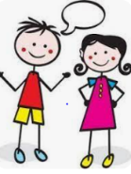  Speaking, listening and writing | 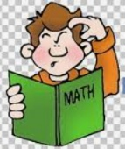  Maths, Science and Problem Solving |   Art and Design | 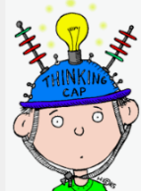  Constructing  and Creating |   Active Body  and Mind
Active Listeners  Interview your parents, grandparents, relatives or friend about toys they played with when they were younger. What toys did they play with? What materials were they made from? Write and draw about them. | Sort out the toys  Sort your toys into groups, deciding how to sort them; new and old, wheels and no wheels, materials they are made from. Add labels to your groups. Take a photo of your sorting or write your results in a diagram. | Ramps  Make ramps from cardboard or books. Test which toy travels furthest. Does changing the height affect the result. | Materials Detective  Pick several toys and identify the materials they are made fron. Why do you think the materials were chosen. | Recycle  Do you have any books or toys you haven’t played with for a while? Can you swap with with a friend or take them to a charity shop?
Old and new  Choose an old toy and a new toy and write about the similarities/ differences between them | Toy Shop  Set up your own toy shop, giving each toy a price. Get a family member to pretend buying them, work out what coins you need and work out change. | Toy Map  Create a map of an imaginary town where the toys can live, including roads, a school, shops, a park and landmarks. | Build Challenge  Can you build a bridge that will hold 5 toy cars? Can you build a bridge that you can sit under? | Toy Photography#  Create a scene with toys and take photographs from different angles. Talk about foreground, background and perspective.
Tell Me  Write the instructions of how to play a favourite game and introduce the game to our class. | Measure  Measure the length or height of different toys, using a ruler or tape measure and put them in order. | Toy Theatre  Use toys as actors and make your own short play. Make tickets and a poster for the performance. | Guess the rule  Ask a family member to arrange toyus according to a secret rule, like wheels, colour, how many doors. Can you guess the rule. | Rescue Me!  Can you set a problem, like rescuing your toy from the other side of the room without touching the floor. Draw a map.
If you are finding it tricky to complete these activities without materials please let us know as we may be able to help.
In addition to tasks on this grid, please support your child with daily reading, using Spelling Frame, TTRS (or Numbots).

