WILLOW CLASS HOMEWORK GRID FOR AUTUMN TERM 2023
Big Question: Who Lives There?
Here is a selection of homework tasks to support the class’s Homes and Castles topic. Choose two tasks a week so that by the end of term, you should have completed all the tasks. Share them with the class by emailing your teacher, bringing your creations into school or by taking photos to share. We will celebrate work in class and display items on the whole school homework display board in the library.
  Speaking, listening and writing |   Maths, Science and Problem Solving |   Art and Design | Constructing  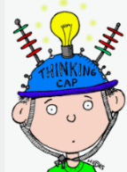  and Creating |   Active Body  and Mind
Memory Game  Collect 10 small objects and put them on a tray. Cover them. Ask a friend or parent to look away and take away 1 item. See if they can guess which is missing. | Sweetie Sort  Empty a packet of jelly beans, jelly babies, smarties or similar coloured sweets. Sort the sweets into colours and draw a picture of how many of each colour. | Recycling Challenge  Help with the recycling!  Look at the different materials and sort them into different materials. | Make a favourite recipe  Try making Pizza Toast:  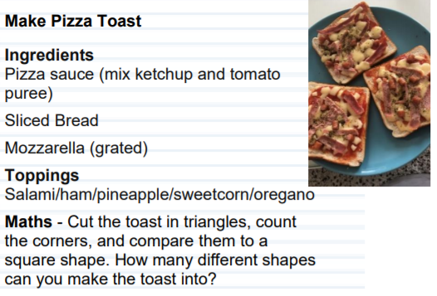 | Keep Fit!  Set up a circuit of 3 different exercises. a jumping station, a running station and a stretching station.
Learn a new nursery rhyme  Choose a nursery rhyme and practice singing it aloud.  https://www.bbc.co.uk/teach/school-radio/nursery-rhymes-a-to-z-index/z4ddgwx | Conker Collecting  Can you collect conkers and arrange them in order of size? | Autumn Painting  Keep a weather diary foe a week, Draw the weather for each day. | Writing  Draw and write a shopping list. | Thank Yous  Draw and write 3 things that you want to stay thank you for.
Sorting  Have a go at sorting toys with your child. You could sort animals by the number of legs they, or cars by their colour. Ask the children to sort their toys and see what they do, can they explain to you how they have sorted them? | Autumn Weather Diary  Keep a weather diary foe a week, Draw the weather for each day. | Circle Printing  Dip a cardboard tube into some paint and create patterns. Can you use Autumn colours? What happens if you dip the tube in to different colours of paint? Can you mix a new colour?  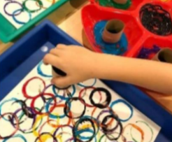 | Threading  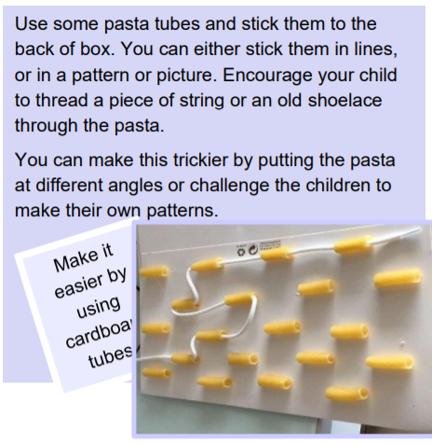 | Autumn Sensory Walk  Go for an Autumn walk. How many signs of Autumn can you see? What can you see, hear and smell and touch and taste? Take photos.
If you are finding it tricky to complete these activities without materials please let us know as we may be able to help.
In addition to tasks on this grid, please support your child with daily reading.

