

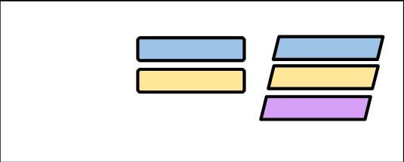

Key

:

Teacher

SENDCO

Teacher and SENDCO

Bolney CEP SEND Flow Chart

If the school feel it is appropriate, evidence is gathered for at least two terms and an application for an Education & Health Care Plan (EHCP) is made. If agreed, the targets will be reviewed through the annual review process.

**START:** Area of need observed in pupil by the class teacher

*If a pupil is making appropriate progress, then new targets are continued for three terms. If the pupils continues to make good progress, then eventually they can be removed from the SEND register if agreed by parents/carers, teaching team and SENDCO

No

No

No

Yes*

Yes*

Yes

Is the pupil making progress?

Teachers to fill out a **First Observation Form (FOF)** and share with the SENDCO

Meeting with parents/carers to discuss the possible need to refer to external agencies.

Is the pupil making progress?

Is the pupil making progress?

Pupil’s progress is monitored by class teacher and SENDCO over three terms through the Graduated Approach Form.

Pupil’s progress is monitored termly through assessments and Pupil Progress Meetings.

Pupil removed from SEND monitoring. Process to start again if required.

Individual Learning Plan (ILP) created with parents/carers, teaching team and SENDCO. Pupil moved to SEND register.

Pupil’s progress is monitored by class teacher, SENDCO and SLT through Pupil Progress Meetings and shared with parent/carers.

Pupil Added to SEND monitoring.

Pupil’s progress is monitored and reviewed by class teacher and SENDCO

Referral to external agencies completed and submitted.

Adjustments are made to in-class provision using the **Ordinarily Available Inclusive Practice (OAIP).** This is recorded on the **Graduated Approach forms**. These are to be shared with parents.