As writers and readers we will:
Write descriptively to describe the lives and experiences of Stone Age people.
Use emotive language to demonstrate the difficulty of day-to-day life through stories and diaries.
Write entertaining poems about life in the Stone Age.
Write to inform – creating information pages about aspects of life in the Stone Age. Develop VIPERS (reading and comprehension) skills through our class novel ‘The Wild Way Home’.
Holly
Autumn
What tools do we need to survive?
Team Players
Friends
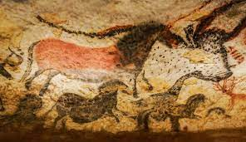
As musicians we will:
Be listening and appraising music.
As young people we will:
think about our rights, roles and responsibilities in school and in life.
We will consider what helps us learn and what we want our school and classroom to be like.
As linguists we will:
Introduce Spanish with greetings and counting to 10.
As artists and designers we will:
Develop sculpture skills through clay.
Develop cutting, cooking and weaving skills – taking inspiration from Stone Age techniques.
As sportspeople we will:
Develop teamwork skills through OAA
Apply teamwork skills in invasion games like netball and hockey.
Develop strength, flexibility and sequences in dance.
In RE we will:
explore the questions ‘What symbols and stories help Jewish people remember their covenant with God?’ and ‘What is the Trinity?’

and ‘What is the Trinity?’
As scientists we will….
Learn how the digestive system functions.
Identify different teeth and their function.
Understand the importance of healthy choices and nutrition.
As mathematicians we will:
Recognise place value and partition numbers flexibly.
Develop fluency in addition and subtraction.
Recognise inverse relationship between addition and subtraction.
Use formal written methods for addition and subtraction.
Recognise commutativity in multiplication.
As geographers and historians we will:
Consider the question – ‘is it true to say that Stone Age man was just a simple hunter gatherer only interested in food and shelter?’
Analyse ‘Stone Age poo’ to discover information about Stone Age diets and resources.
Use drama/storytelling to take on the role of Stone Age villagers and make a series of decisions and debates to ensure our survival.
Compare settlements from different regions of the UK and consider how climate and access to resources influenced decisions.
As programmers in computing we will:
Discuss the importance of being safe online.
Learn how computers are connected through networks.
Big Question?
What tools do we need to survive?

This term, Holly will be exploring the question ‘What tools do we need to survive?’ Our theme is the Stone Age to Iron Age and as Team Players and Friends, we will be learning all about the technological advancements made over the time period, how communities lived and worked together, what culture and lives they led and what it took to survive in difficult times.

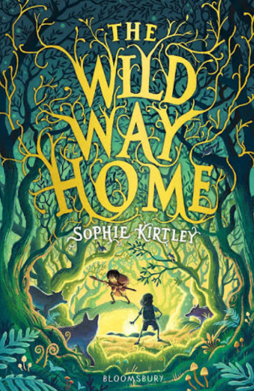
Key Texts
The Wild Way Home – Sophie Kirtley
Stone Age Boy – Satoshi Kitamura
Woolly Mammoth – Mick Manning/Brita Granstorm
Key Vocabulary
Stone Age,
Iron Age,
Bronze Age,
Ice Age,
Neolithic,
Mesolithic,
Paleolithic,
Prehistoric,
hunter-gather,
farmer, tribe, archaeologist, artefact
Key Questions
How do we need to support each other when building a home?
How have humans been able to survive?
What was life like for Stone Age children?
Is it true to say that Stone Age man was just a simple hunter gatherer only interested in food and shelter?

