SILVER BIRCH CLASS HOMEWORK GRID FOR TERMS 1 and 2
Is there life after death?
Here is a selection of homework tasks to support the class’s big question this term and its focus characteristics. Choose two tasks a week so that by the end of term, you should have completed all the tasks. Share them by emailing work to the class teacher or by taking photos to bring in to school. There is a whole school homework display board in the library we shall be sharing all the home learning across the school towards the end of term.
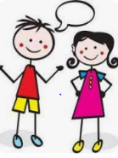  Speaking, listening and writing | 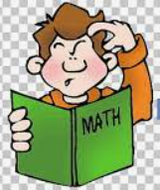  Maths, Science and Problem Solving | 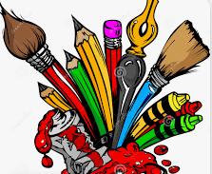  Art and Design | 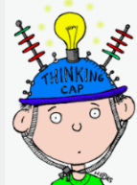  Constructing  and Creating | 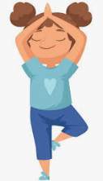  Active Body  and Mind
Life in ancient Egypt was very different to life in modern-day Egypt. Use the  questions to help you research some information about the culture and life in Egypt today. What traditional Egyptian foods can you find out about? Can you find out what the weather is like through the year in Egypt? What can you find out about traditional clothes that are worn, such as the galabiya and the shemagh? How do people get from one place to another? You can decide how to present this work. | Try to mummify some fruit. Take some photos and write down what you did to help other have a go. Use an apple and cut a face shape in it. You could turn it into a body! | Make your own version of papyrus using brown paper, water and glue. Using your papyrus to draw on, design an Egyptian God. | Design and make an Egyptian reed boat, these instructions will help you: https://www.teachingideas.co.uk/history/how-to-make-an-egyptian-boat/ | Create your own dance to Egyptian music.
Make a fact file about the Egyptian gods. | Design an information poster all about the Circulatory System- use the BBC Bitesize website to help you. | Make a 3D pyramid from any materials you would like. | Farmers in Ancient Egypt used a shaduf to lift water from the canals. They could then use this on their fields and crops. Try to make a shaduf using lego. You might need to find out what this looks like! | Research a musician or a music artist that has influenced you. Consider how to share what you have found out- could you teach a dance or a song?
On a map, mark the important landmarks of Egypt. | Write a maths problem using Hieroglyphics. | Design and make an Egyptian mask. | Make some Egyptian bread. Share the recipe. | Make up a game or a challenge to help with fitness.

