How Would You Change The World?
Superheroes – Willow Class - Spring 2024
We refocus our Superheroes topic, thinking of everyday superheroes that we couldn’t do without, like nurses, doctors, vets, police, firecrews, RNLI, builders, plumbers, Mum’s and Dad’s. We’ll be inventing our own characters and villains. We will think of how we can
Key Stories  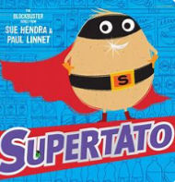  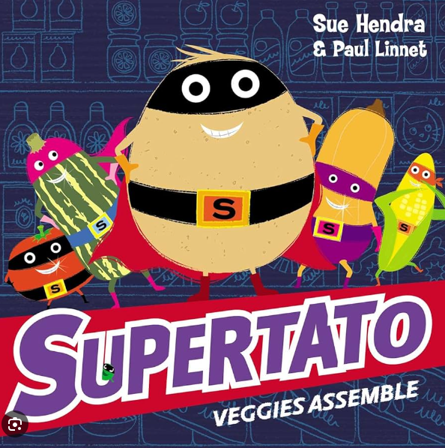  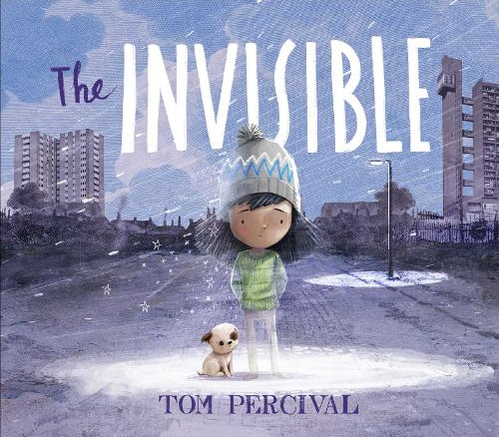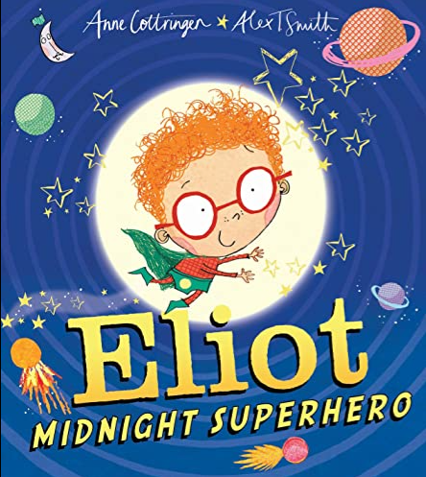 | In Communication, Language and Literacy we will …  Key Texts/Stories  If I Was a Superhero  The Invisible  Supertato  Supertato: Vegetables Assemble  Elliot Jones Midnight  What we’ll be doing in class …  Describing characters  Explaining our superpowers  Ordering Story events  You can help at Home: Reading rhymes and traditional stories.  Practising high frequency words  Reading regularly for fun | 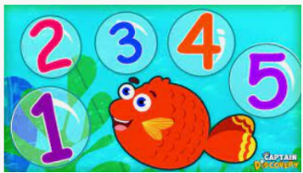  In Maths we will …  What we’ll be doing in class …  Doubling and Pairs  Saying 1 more and 1 less  Adding and Subtracting  Measures  Ordering numbers to 10 and beyond  Continuing and making repeating patterns  Features of 2D and 3d shapes  You can help at Home by  Estimating and counting objects to 10 and beyond  Talk about adding and subtracting |  | In Physical Development we will …  What we’ll be doing in class …  Negotiating play space safely  Mark making using various materials  Developing fine and gross motor skills  Practising throwing and catching  Talking about healthy food choices  Cooking Stir-Fry  Noticing the effects of physical activity on our bodies  You can help at Home by  Encourage writing; large, medium and small scale writing  Encourage independence in dressing
 |  | In Personal, Social, Emotional and Health we will …  What we’ll be doing in class …  Making hard decisions  Talking about what makes a good friend  Thinking about “everyday superheroes”  Acknowledging that we are all precious and unique  You can help at Home by  talk about real life superheroes  discussing right from wrong | In Knowledge and Understanding of the World we will  What we’ll be doing in class …  Choosing suitable materials for superhero puppets  Noticing Seasonal Changes  Using simple age appropriate software and websites  Talking about Easter  Superhero Day Part 2  Dress like a Superhero again  Wednesday Thursday 21st March  You can help at Home by  Notice seasonal changes  Spotting materials |  | In Creative and Expressive Arts we will …  What we’ll be doing in class …  Superhero role play  Superhero dance  Decorating Eggs and our garden for Easter  You can help at Home by  Talk about materials
,,,
British Science Week
w/c Monday 11th March – fun experiments in school and to try at home.

