Holly Class – Spring ‘26
Characteristics:
Achievers
Creative Thinkers

Are some places just too dangerous?
As writers and readers we will…
In VIPERS sessions we will be reading Kensuke’s Kingdom by Michael Morpurgo.
Write to inform – about extreme climates, weather and locations.
Write to entertain – stories inspired by our Kensuke’s Kingdom and our learning in geography and science lessons..
Write to inform – news reports about extreme weather events.

As mathematicians we will…
Measure in mm, cm and m
Convert between measures.
Find the area and perimeter of rectilinear shapes.
Represent fractions, find tenths and tenths as decimals, add and subtract fractions, order and compare fractions

As artists and designers we will…
Design disaster proof buildings – considering materials, design and potential flaws before testing out their effectiveness!

As geographers/historians we will…
Find out about natural disasters, different climates and weather events. Where they occur and why they are more likely in some places.
Learn how humans have responded to these challenges, how buildings disaster responses are affected by these challenges.

As musicians we will…
Learning to play the glockenspiel!

In RE we will…. explore the questions
How does a Muslim show their submission and obedience to Allah?
Why does a Hindu want to collect good karma?

As scientists we will…
Understand how the Earth is made of layers and be able to describe them.
Learn about the water cycle.
As programmers in computing we will…
Use scratch to code. We will learn how to create and change characters, use sounds and create animated sequences.

As sportspeople we will…
Develop strength, flexibility, balance and coordination in gymnastics and dance.

As programmers and researchers we will…

Big Question?
Are some places just too dangerous?
This term, Holly will be asking ‘Are some places just too dangerous?’. This is a geography and science led project. We will be learning about different climates and climate zones. We will see where and why natural disasters occur and discuss how humans have responded to this. In science we will be learning about the structure of the Earth and the water cycle.

Key Texts
Kensuke’s Kingdom by Michael Morpurgo
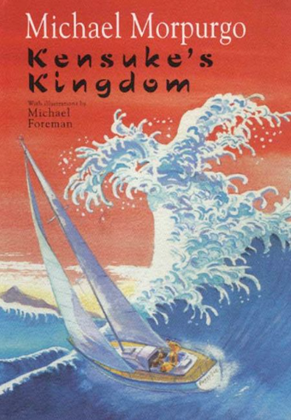

Key Questions
What can humans do to overcome challenging climates and natural disasters?
Key Vocabulary
Climate, Weather,
Disaster, Human, Natural
Physical, Pollution, Deforestation
Industrial, Nuclear, Radiation
Earthquake, Tsunami
Magma, Tectonic Plates
Volcanoes, Lava
Hurricane, Tornado
Drought
Flooding

