17th July 2026
Dear Parents and Carers
I am really looking forward to working with your children in September and starting our first project all about the Ancient Egyptians. We will be exploring the characteristics of our Values and Team Players.
We will be discussing big questions such as Was the social hierarchy of Ancient Egypt fair? What does it mean by the phrase ‘Walk like an Egyptian’? What were the Ancient Egyptian Pyramids? What is the concept behind life after death in Ancient Egypt?
In English and VIPERS, we will be using the brilliant book, ‘Secrets of a Sun King’ by Emma Carroll. Following ‘Secrets of a Sun King’, we will read the book, ‘Pharaoh’s Fate’ by Camille Gautier.
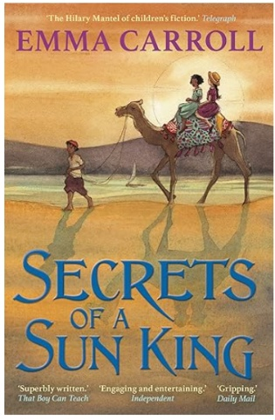
It would be great for each child to have access to Secrets of a Sun King for the start of the term in September because we will be using it for narrative writing in the first half term.
As you are already aware, having copies of the text enables each child to not only follow the story being read aloud, but to be able to go back, re read, look deeper into the illustrations and highlight words they liked.
It can be found on Amazon from £3.81 for a used like new copy or from £5.71 for a new copy. If you have any questions or need support with this, please email me cjames@bolneyprimary.school
Regards, Mrs James

