Beech Class | What Is In My Toy Box? | Autumn 2026
We will learn about the history of toys and games, exploring how toys have changed over time and talk to family members about toys they played with. We will compare toys from around the world and past and present, investigating the use of materials and using our toys as inspiration in Art, constructing simple vehicles. We will be concentrating on the school values of Love, Honesty, Respect & Resilience.
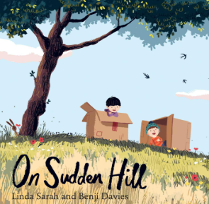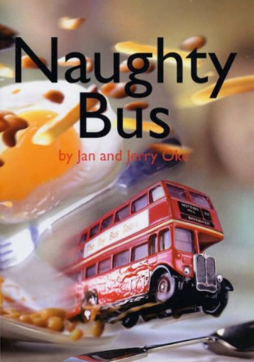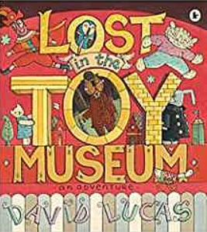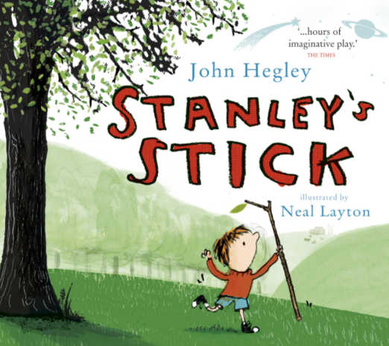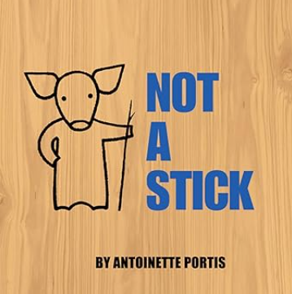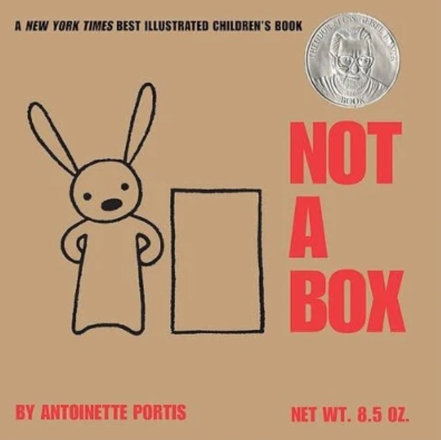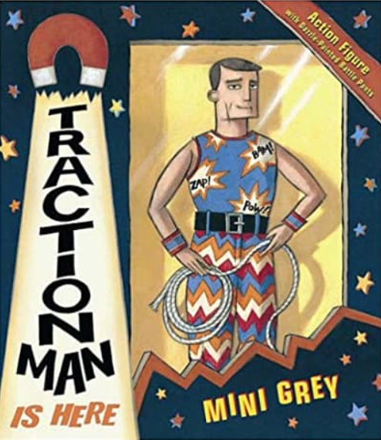

In English we writing stories staring our own toys, designing wanted posters and writing invitations. We will imagine letters that characters might write to each other and write and produce our own version of Naughty Bus. |  |  | In Maths we will practising place value to 100, calculations for numbers within 20, building fluency of addition and subtraction within 10 then with 2 digit numbers. We will introduce multiplication and division.
In Music, we will be singing together, learning singing games keeping a steady pulse, performing as whole class and in smaller groups. | In Geography we will learn about toys and games from different countries, locate the UK on a world map, identifying the countries and capital cities of the UK and developing e map and atlas skills. | In Art we will use toys as inspiration for painting and drawing, observing and drawing toys carefully, exploring line, shape, colour, pattern and texture. |  | In DT we will design, make and evaluate our own vehicles, investigating wheels, axles and moving parts and constructing a simple vehicle. | In Science we will investigate what materials toys are made from, identifying materials, considering why particular materials are suitable for different toys.
In RE we will learning about the importance of good deeds in Jewish families. | In Learning For Life we will talk about hopes and fears and rights and responsibilities. | In History we will be learning about how toys have changed over time. |  | In PE we will be moving, dodging, balancing and developing balance and agility. | In Computing we will be learning about technology around us and staying safe.

