**Back to School for Holly Class – September 2024**

When I go back to school some things will be the same and some things may be different.

**Things that will be the same –**

The way I travel to school will probably be the same.

The school building will be the same.



The adults who work at school will be there to help me. Ms Lofthouse will be my headteacher and Zoe will be in the office.

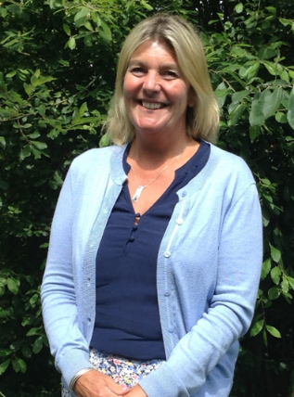

I will eat my lunch in the hall with the children in Holly and Silver Birch class and we will all play together. This will be the same as Year 3 if I am going into Year 4.

**Things that will be different –**

My classroom: You will be in Holly class and it will be in a different room.

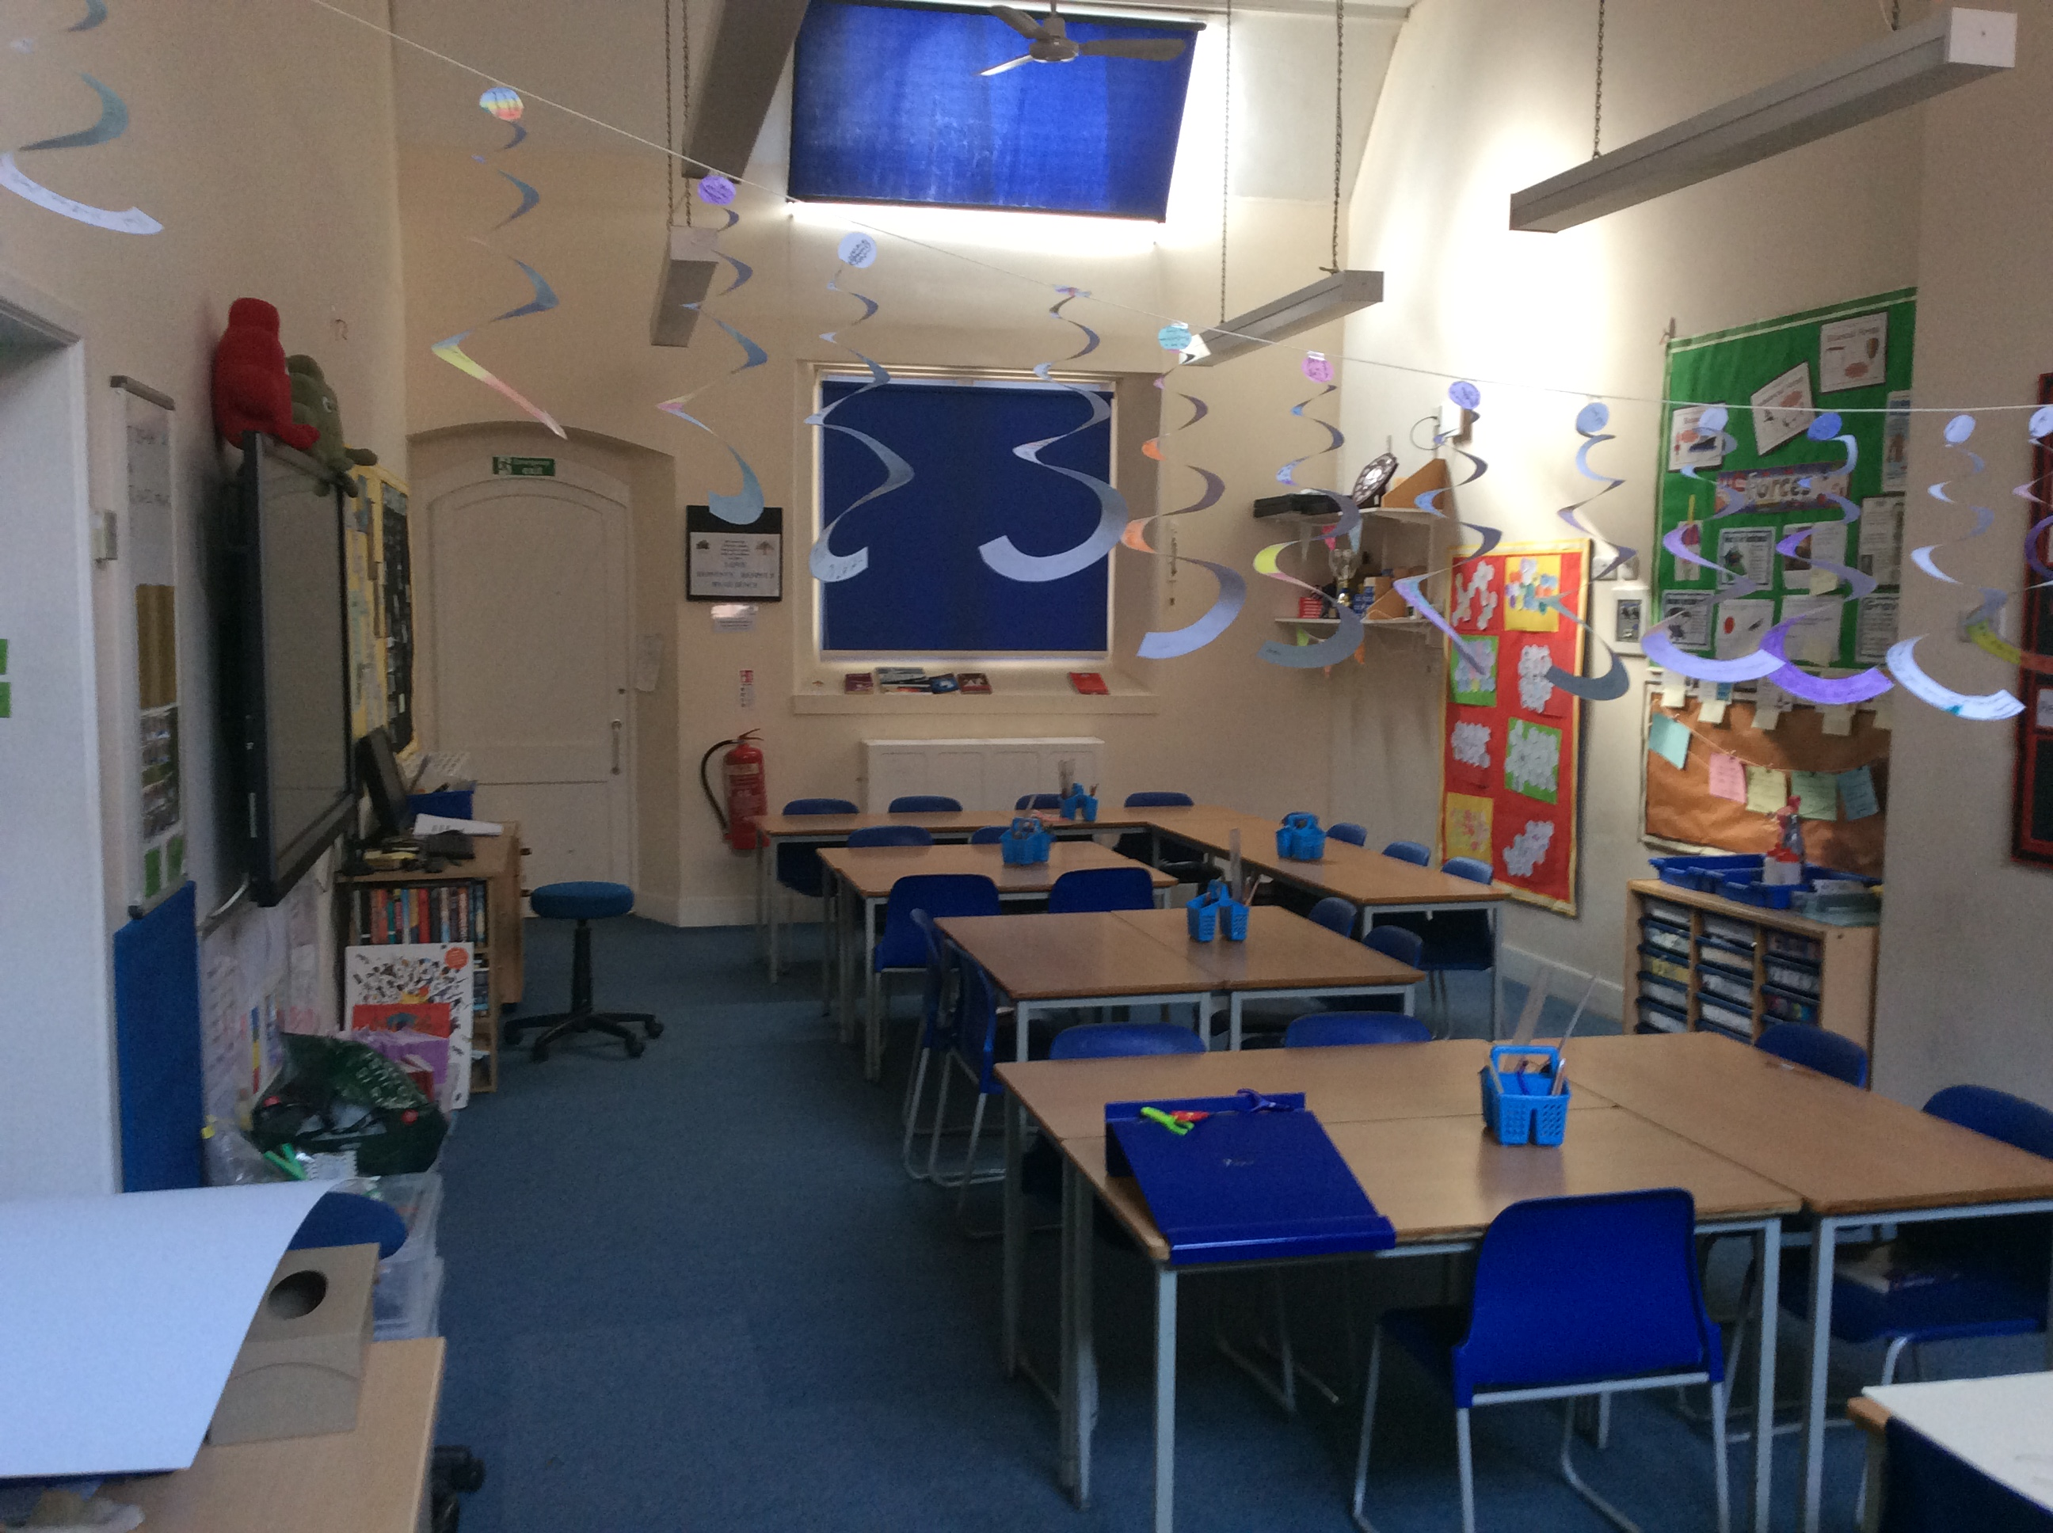

I will sit in a different seat. Mr Pitt will show me where to sit. This is okay. 

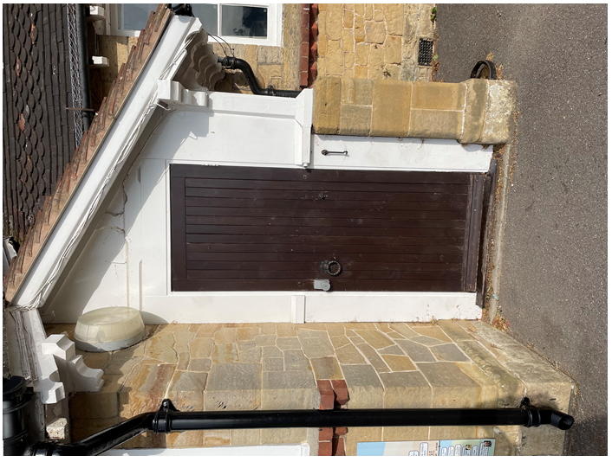

I will go through Holly class door in the mornings and afternoons.

I will put my lunch bag on the trolley near the door and I will have a peg to put my things on.

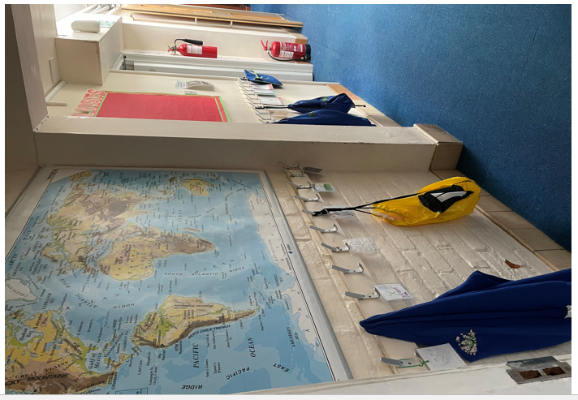

I will use the same toilets

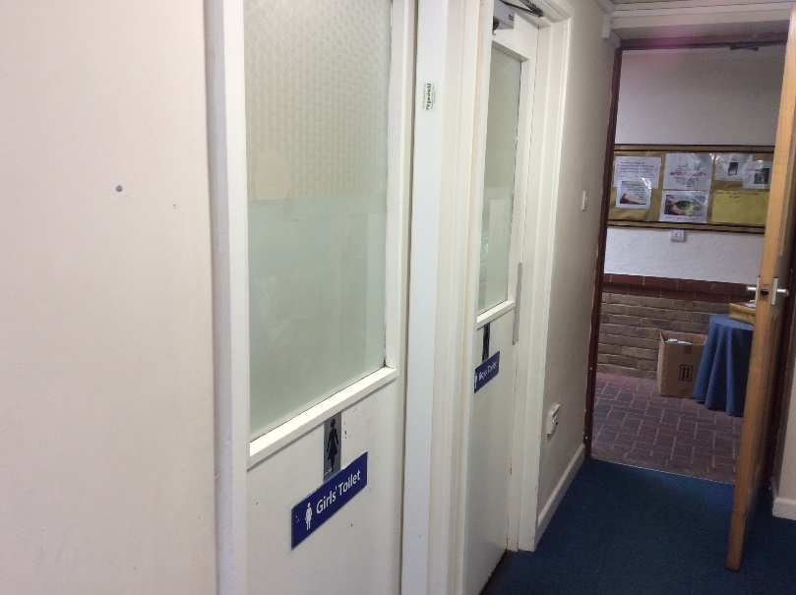

I will have 19 children in my class and we will be Year 3 and Year 4 together.   
I will eat my lunch in the hall with the children in Holly and Silver Birch class and we will all play together. First we will go out to play, then eat our lunch. This is different from Year 2.

My timetable will be different each day, especially for the first two weeks. I will be playing games with my friends and working together.

Mr Pitt will be my teacher.

Mrs Booty, Miss Goad and Mrs Browning will also be in my class.





Sometimes change makes me feel worried or sad, that’s okay. 

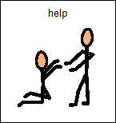Everyone feels sad sometimes.

If I am sad or worried I can tell someone who cares for me. Mr Pitt and the other adults will help me. They will listen to me and help me to be less worried. My family can help me too.

If someone does something I do not like I will say “STOP! Please don’t do that, I don’t like it”.

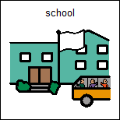All children need to go to school to learn and practise new things.

It is good to go to school.

I will look forward to going back to school on Tuesday September 3rd 2024.

