BOLNEY C.E.P. SCHOOL 



***Bolney CEP sits in the heart of the Bolney village community and is an inspiring and welcoming school. We have 100 children learning within four different classes: a Reception class, mixed 1/2, 3/4 and 5/6. We have a beautiful learning environment, both inside and out, and our staff and children feel safe and valued.***

**Wrap-around Childcare Staff**

Breakfast Club 7.15 – 8.45am

After School 3.00 – 5.45pm, Monday to Friday, term-time only

Grade 3 point 3 £24027 (pro-rata)

Applications for either, or both Breakfast club/Afterschool club will be accepted

**Job Description**

Wrap-around Care assistants will organise activities, prepare snacks and monitor the children’s safety. They may also keep records of children under their care and report to the headteacher about concerns as they arise. Experience working with children is preferred and basic understanding of childcare practices is an advantage. The assistants should have caring, kind personalities that help them treat all children fairly and meet each child’s physical, emotional, and social needs.

**Duties and Responsibilities**

* **Supervise and Monitor Children**

Wrap-around care assistants will have a hands-on role in providing a safe childcare environment. Whether the children are playing or eating, the care assistant will keep a close watch to prevent accidents or injuries. They may have to administer First aid in case emergencies arise while on the job.

* **Keep and Update Records**

Wrap-around care assistants will update daily registers, these logs may include a child’s attendance, allergies and any special accommodations the child may require.

* **Prepare Snacks**

Wrap-around care assistants will prepare healthy snacks for children. As new kids join the facility, they keep track of allergies or dietary concerns and provide meal alternatives when needed.

* **Resolve Conflicts Between Children**

Wrap-around care assistant will observe the children under their watch and may have to mediate conflicts between children, teaching them to compromise and treat each other with respect.

* **Maintain a Sanitary Environment**

After activities or mealtimes, the wrap-around care assistants will be responsible for cleaning up messes and clearing the hall, making it ready for the next day.

|  |  |  |
| --- | --- | --- |
| Person Specification: **Wrap-Around Care Assistant** | | |
|  | **Essential Criteria** | **Desirable Criteria** |
| **Professional Values and Practices** | * Willing to support the caring and inclusive ethos of the school * Ability to use initiative appropriately * Must be sympathetic to the children’s needs * To contribute enthusiastically to the staff team, be a good team player and have **a very positive attitude** * Willing to take part in professional development activities * Have an understanding of what is confidential in relation to children * Have an ability to communicate effectively with pupils and colleagues * Have good organisation skills | * To contribute to the wider school community |
| **Qualifications, Knowledge and Understanding** |  | * First Aid qualification * Experience working with children is preferred and basic understanding of child care practices |
| **Caring** | * Ability to use the required recording and reporting systems and feedback appropriately to the office and headteacher * Ability to adapt an activity for children experiencing difficulty * Ability in making the school an attractive and tidy environment * Ability to carry out interventions and keep accurate records | * Successful experience of working within a school or childcare setting |

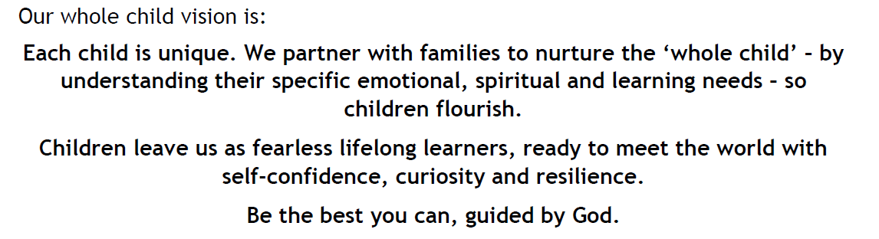

**Bolney CE Primary School considers safeguarding to be of paramount importance.**

The School is committed to safeguarding and promoting the health, safety and welfare of all children, young people, their families and staff.  This means that everything we do is designed to promote the safety and well-being of the children we work with, as well as that of children and young people in general. Any successful applicant will be required to undertake a Disclosure check by the Disclosure and Barring Service at an Enhanced level.

**Closing date for applications – Please send completed applications to the school office by midday, Friday 4th July 2025**

**Interviews – Monday 7th July 2025**

**Vacancy description correct at the time of advertising positions**