**Holly Class – Autumn ‘25**

**Characteristics:  
Values  
Team Players  
Friends**

What have the Romans ever done for us?

As writers and readers we will…   
  
Write a guide for new Roman soldiers – inspired by the Roman Soldiers Handbook.  
  
Write diary entries in role – inspired by drama (mantle of the expert situations) and VIPERS text.

Write short stories inspired by Escape from Pompeii.

As geographers/historians we will…

Consider how the Romans changed life in Britain.

Understand the meaning, size and timescale of the Roman empire by drawing conclusions from maps and timelines

Consider the motivations for Roman expansion and what attracted them to Britain/

Be able to see why the Roman army was so powerful including organisation, conditions, pay etc

As mathematicians we will…

Learn about Roman Numerals and compare to our number system.  
Focus on place value – learning how to represent numbers in different ways, partition into hundreds, tens and ones and partition flexibly to help with calculating. Find 10,100 more or less in efficient ways.  
Order and estimate numbers on a number line.  
Round numbers to the nearest 1,000, 100, 10.  
Add and subtract using mental strategies and formal column methods.

As artists and designers we will…

Create volcano models using different materials and designs – to test effectiveness

As musicians we will…  
Play and perform in solo and ensemble contexts, using voices and instruments.  
Listen with attention to detail and recall sound. Use and understand staff and other notations. Appreciate and understand music from a wide range of traditions and great composers.

In RE we will…. explore the questions, ‘Why do Jewish families talk about repentance at New Year?

‘Why does Christmas matter to Christians?’

As scientists we will…

Compare, order and classify rocks (igneous, sedimentary, metamorphic).  
  
Understand how soil is made and what it is composed of.

Understand how the Earth is made of layers and be able to describe them.

As programmers in computing we will…  
  
Learn about computer systems  
Learn about digital devices and design our own using input, process and output language.

As sportspeople we will…

Learn how to become better team players in team games, working on collaborative skills.

As programmers and researchers we will…

Big Question?

What have the Romans ever done for us?

This term, Holly will be asking ‘What have the Romans ever done for us?’ In history we will be learning about the expansion and advancements of the Roman Empire. We will look at the culture, religion, art and life in the Roman era and then look at the impact this had on Britain. We will consider how and why the Romans wanted to settle in Britain and what implications this had for the people already living here. We will also think about what remnants there are and signs of Roman influence in this country today.

Key Texts  
Escape from Pompeii  
A Gladiator Stole My Lunchbox  
The Roman Soldier’s Handbook  
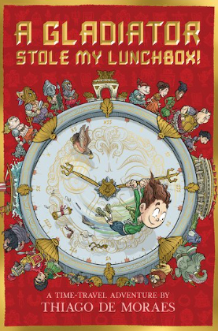 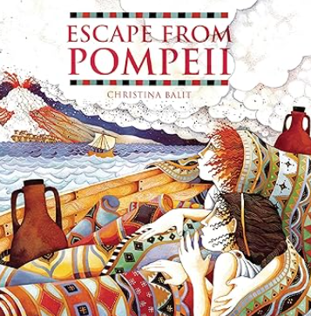

Key Questions

**How did the Romans change Britain?**

**Why did the Romans want to come to Britain?**

**Can we still see Roman influence today?**

Key Vocabulary

**Colosseum,  
 amphitheatre,   
aqueduct,   
bath house,  
 mosaic,  
 temple,**

**villa,**

**centurion,**

**chariot,**

**barbarian,**

**gladiator,**

**Boudicca,**

**toga,**

**Julius Caesar,**

**emperor,**

**Roman numerals,**

**invade, settle, Briton**