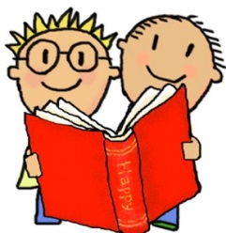
Asking questions about a book…
Choosing a book:
• Why did you choose this book?
• Have you read other books by this author?
• What could this book be about?
Before reading the book:
• What do you think this story will be about? Why do you think that?
• Talk about the different parts of the book (eg. Front cover, back cover, title, author, illustrator, blurb, ISBN number, bar code, publisher marks)
• If it is an information book ask them where you will find out about something specific (ie. can the child use the Contents page or Index to locate information?)
During the reading of the book:
• Tell me what is happening in the pictures.
• What has happened so far? Is it what you expected to happen?
• What might happen next? How do you think the story might end?
• Ask children about events in the story: How would you feel if you had been that character? • Has anything like that happened to you? Would you like that to happen to you?
• If reading an information book: What facts have you read?
• Have you learnt anything new? What does this page tell you about? Is there anything that interests you on this page?
• Where would you go to find information about….?
At the end of the book:
• What was the most interesting/ exciting part of the book? Can you find it?
• What sort of character is….? Is he/she friendly/ mean/ nice…?
• Why did that character do … (give a situation/ event from the story)?
• Are there any words or phrases that you enjoyed?
• Are there any parts of the book that are repeated? Why do you think that the author did that?
• Who are the main characters in the story? What character would you like to be?
• Why are some words written in capital letters? Italics? Bold print? Different colour?
• Would you like to read another story by this author or illustrator?
• Have you read any other books like this one? Is it happy/ sad/ scary/ exciting? Why do you think this?
• Does this book remind you of any other stories, or TV programmes/ DVDs?
• Does this story remind you of anything that has happened to you?
• Did you like this book? Why? (Encourage children to develop their opinion about books by encouraging them to explain their reasons)

