4th October 2024

Dear Parents and Carers

This week’s spelling task can be found on spelling frame or spelling shed, <https://play.edshed.com/en-gb/spelling> Stage 5 if using spelling shed. Please find rule number 62 on Years 5 and 6 if using spelling frame. We have been looking at Challenge Words and revisited ‘ious’ words. If you would rather do a paper-based task, please see the crosswords attached. These crosswords incorporate some of the spellings, not necessarily all but please use this list for the next few home learning sessions.

Choose five to work on at a time.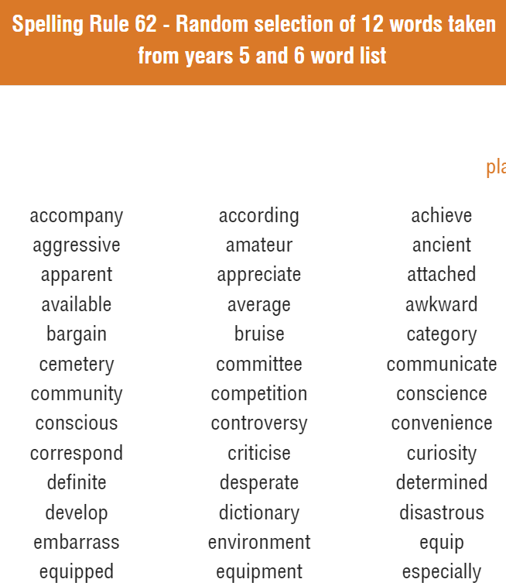

Please let me know if you have any difficulties with completing home learning whether you are logging into spelling frame, spelling shed or completing a paper copy. I do have to ask children to miss break times if they do not complete home learning.

Regards, Mrs James

