ART and DT- As artists, our theme is ‘Looking through the porthole’, as we explore different types of printmaking.

MATHS- As mathematicians, we will start with place value, swiftly followed by revisiting the four operations. Year 5’s will be revisiting Roman Numerals but now investigating them with numbers up to 1000. Year 6’s will be exploring numbers up to 1,000,000. Finally, to finish the autumn term, lots and lots of fractions, decimals and percentages.

**Silver Birch- Our Autumn Learning Journey- ‘What makes a good friend?’ Our characteristics are Team Players and Friends.**

Learning for Life (Jigsaw) - As young people, we will be discussing our year ahead, what is meant by being a citizen, responsibilities and leadership roles. We will explore our characteristics of Team Players and Friends but we will start with looking deeper into our Values.

PE-As sportspeople, we will be using our characteristics of Team Players and Values in team games. We will learn the skills to play Hockey and Netball. We will also become dancers and gymnasts to perform using a range of movement patterns, develop flexibility, strength, technique, control and balance and compare performances with previous ones in the lessons.

As linguists in our French lessons, we will be learning about greetings, family members and the verbs ‘to be’ and ‘to have’.

MUSIC- As musicians, we will perform, compose, and improvise music with accuracy and expression; listen attentively, recall, and evaluate across genres and traditions; use notation; appreciate live and recorded works; and develop historical understanding of music.

RE- Firstly, we will try to find answers to this statement: Creation and Science: conflicting or complementary? After half term, we will explore this question: How can following God bring freedom and Justice?

COMPUTING- As programmers, we will firstly remind ourselves how to be safe online by completing a variety of online tasks. Secondly, we develop our understanding of computer systems and how information is transferred between systems and devices. We consider small-scale systems as well as large-scale systems. We explain the input, output, and process aspects of a variety of different real-world systems. We discover how information is found on the World Wide Web, through learning how search engines work (including how they select and rank results) and what influences searching, and through comparing different search engines.

After half term, we will learn how to create short videos by working in pairs or groups. As we progress through this unit, we will be exposed to topic-based language and develop the skills of capturing, editing, and manipulating video. We are guided with step-by-step support to take our idea from conception to completion. At the conclusion of the unit, we have the opportunity to reflect on and assess our progress in creating a video.

HISTORY/GEOGRAPHY – As geographers, we will be comparing conditions in Antarctica to other regions of the world, considering the impact of climate change on Antarctica. As historians, we will be retrieving information about important historical events, interpreting information on and discussing the cultural impact of the age of exploration.

Demonstrating our understanding of historical events through writing, drama and discussions.

ENGLISH -As writers, we will start with watching the film, ‘The Dreadful Menace’. We will explore figurative language; personification, metaphors, similes and other poetic devices to write our own poem. We will move onto reading Shackleton’s Journey and writing persuasively to apply for Shackleton’s crew. We will write in character about experiences during Shackleton’s journey to Antarctica. In this, we will show an awareness of historical context and use appropriate formality and vocabulary. We will also consider how to present information in order to inform and entertain readers.

As readers, we will use the whole class text ‘Holes’ to build vocabulary, inference, prediction, explaining and summarising, (VIPERS skills)

Throughout the term, we will be reading short texts focusing on comprehension and grammar skills in preparation for SATs.

SCIENCE – As scientists, we will be planning investigations, recognising and controlling variables, taking measurements and recording accurately, commenting on findings and summarising results. We will be comparing and grouping materials, demonstrating changes in states and exploring insulation.

What makes a good friend?

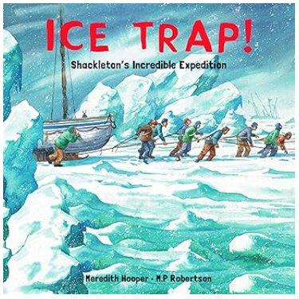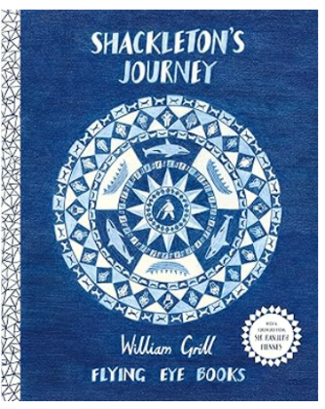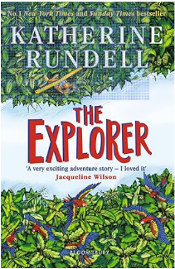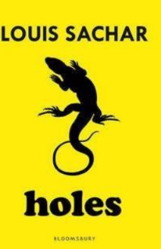

**Key Vocabulary**

Resilience

Strength

Courage

Friendship

Morale

Adaptability

Endurance

Perseverance

Safety

Risk

Expedition

Polar

Pioneering

**Key Questions**

Why is friendship important?

Why are differences useful?

What qualities do you value most in a friend?

What is the difference between a friend and an acquaintance?

**Key Texts**

Holes, by Louis Sachar

Shackleton’s Journey by William Grill

The Explorer by Katherine Rundell

Ice Trap by Meredith Hooper

Women who led the way; Great Explorers and Adventurers by Mick Manning

This term, Silver Birch will be exploring the question ‘What makes a good friend?’ Our theme is all about Explorers and as Team Players and Friends, we will be learning to understand how different skills, personalities and people contribute to successful groups and tasks. Researching Explorers such as Shackleton will enable us to look more into human resilience and leadership skills, something that we remember Shackleton for- prioritising the safety and morale of his crew over his primary goal of reaching the South Pole.