HOLLY CLASS HOMEWORK GRID FOR TERM 4
Does the use of human sacrifice prove that the Mayans were a cruel people?
Here is a selection of homework tasks to support the class’s big question this term and its focus characteristics. Choose two tasks a week so that by the end of term, you should have completed all the tasks. Share them by emailing work to the class teacher or by taking photos to bring in to school. There will be a homework sharing noticeboard in the hall for work and on Thursday 30th March, please bring in any bigger creations as we shall be sharing all the home learning across the school.
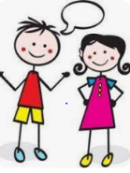  Speaking, listening and writing | 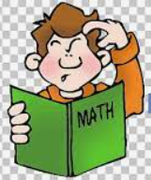  Maths, Science and Problem Solving |   Art and Design | 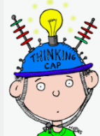  Constructing  and Creating |   Active Body  and Mind
Imagine you are a Mayan arrived in Britain for the first time. Write a letter or orally report your first impressions. | Write a secret message using Mayan numbers and letters. | Design an item of clothing that the Maya may have worn- use Dan Fenelon’s style. | Research a Mayan temple and using whatever materials you would like, create a model. | Create a poster using collage identifying activities/techniques to help you relax- avoiding tech!
Research a Mayan God then design your own God. | Choose a muscle or a bone from the body, draw it, label it and explain why you chose to research it. | Draw and label a Maya house- what materials did they use? How do these houses compare with the Stone Age era? | Make up your own recipe for a new chocolate bar. Can you think of a name for it? | Take a visit to your local swimming pool and show off your new skills you have learned in the lessons.
Explore the word ‘sacrifice’. What does it mean to sacrifice? Write down yours or someone in your family’s experience of sacrifice. | Keep a food diary for a week. Have you had your 5 fruit and vegetables each day?  Write down how you have been healthy during the week. | Create some wild art outdoors – have a look at 50 things to do before you’re 11 ¾ on the National Trust website | Design a recipe for a Maya family meal. What ingredients were available?  Look on BBC Bitesize What did the Maya eat? | Make up a 60 second sports challenge for your family. Compete to find the winning family member.

In addition to tasks on this grid, please support your child with daily reading, using Spelling Frame / TTRS.

