WILLOW CLASS HOMEWORK GRID FOR SUMMER TERM 2026
Why Did The Dinosaurs Die Out? Who Lives In A Garden Like This?
Here is a selection of homework tasks to support our Dinosaurs and Minibeasts topics and its focus characteristics, Young Leaders & Problem Solvers and Change Makers & Critical Thinkers. Choose two tasks a week and share them with me by email or through the home learning books, bringing your creations into school or by taking photos to share. We will share them in class and in the library.
  Speaking, listening and writing | 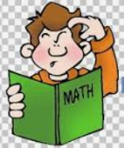  Maths, Science and Problem Solving |   Art and Design | 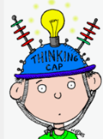  Constructing  and Creating |   Active Body  and Mind
Dinophonics 1  Can you think of some more words that start with the sound ‘d’? Try to write a list of 8.  Can you think of some words that rhyme with dinosaur. Try to write a list of 8. | Dinoprints  Cut out some dinosaur footprints from paper. Jump along the footprints counting them. Count forwards and backwards in steps of 1. Write numbers on the footprints. Use objects such as pasta shells to measure the dinosaur footprints.   | Dinomodel  Use recycled materials, playdoh or construction equipment such as lego to create some model dinosaurs.  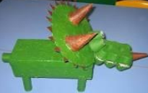 | Design-a-Dino  Create your own dinosaur. Draw a picture then write its name underneath. You could ask a grown-up to help you write some adjectives to describe your new dinosaur. Is it scary or friendly? Is it large, long or scaly? | Make Ice Lollies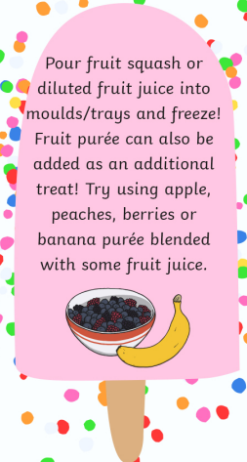
Learn a new nursery rhyme  Choose a nursery rhyme and practice singing it aloud.  https://www.bbc.co.uk/teach/school-radio/nursery-rhymes-a-to-z-index/z4ddgwx | Dinoproblems  If there are 10 dinosaurs in the forest and 4 get lost, how many are left? Use your fingers to help you. Can you draw it?  If there are 8 dinosaurs in the forest and 4 join them for a tea-party how many are there now? Can you draw it? | Make-a-bug  Collect some natural materials, such as leaves, pebbles and sticks. Can you make a minibeast using the natural materials? You could take a photo to share with your friends. Can they guess what minibeast you created? | Following Shadows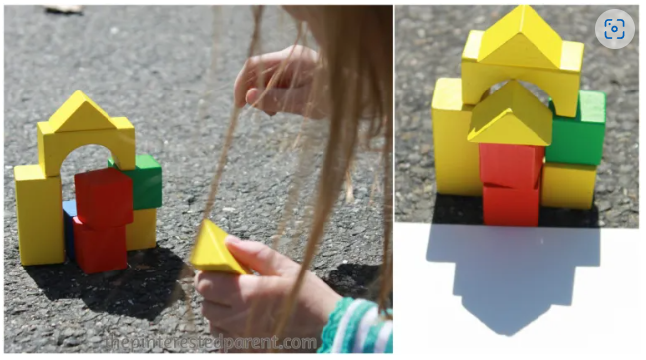 Make a structure from blocks outside. Draw round the shadow with chalk. Repeat 3 more times the same day and see how theb shadows change. | Memory Game  Collect up to 10 items on a tray and cover it with a tea towel. Uncover for 10 seconds then recover. How many can your child remember?
Describe-a-Dino  Describe a dinosaur to a friend or family member and ask them to guess which dinosaur you are! Remember to use adjectives, like “I am big. I have a long neck and a long tail. I like to eat the leaves in the trees.” | Bingo  Draw a 5 x 2 grid on recycled cardboard. Write numbers between 1 and 20 in the squares. Randomly call out the numbers and encourage your child to cross out that number. First one with all numbers coverd is the winner. | Shelter building  Can you make a den? If it’s a rainy day, you could make one using chairs and blankets. If it’s nice weather, you could make one outside, maybe in the park or woods, using sticks and branches. | Make a Mini-Bug Hotel  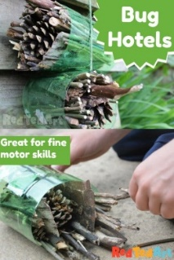  Cut the top and bottom off the bottle. Collect twigs into a bundle and tie together with string and stuff it into the bottle. Tie string round the outside the bottle and hang it in your garden. | Plant Hunt  Go on a plant hunt and photograph what you find. How many flowering plabnts can you find?
If you are finding it tricky to complete these activities without materials please let us know as we may be able to help.
In addition to tasks on this grid, please support your child with daily reading and Numbots.

