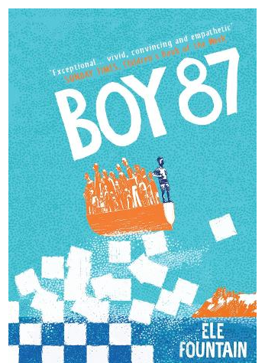4th April 2025

Dear Parents and Carers,

This term, our project will be focusing on refugees, displacement and the key question “Can we make a difference to others?” We will be discussing how our actions can affect others and we will be considering what we can do to make the world around us a better place.  
  
We will be reading ‘Boy 87’ by Ele Fountain as our Vipers text. This is a powerful, sometimes sad but age appropriate introduction to some challenging topics like asylum, corruption, government, survival and safety.   
  
It would be great for each child to have a copy of this book for the start of term (22nd April) so we can read along together in class. As previously mentioned, the engagement, enjoyment and comprehension from the children was boosted by so many of them having access to the books. It will also be helpful when discussing vocabulary and will allow the children to reread chapters and remind themselves of the plot and characters.   
  
There are copies on Amazon for around £7 for a new copy but from £0.70 for a used one. It is also widely available in Waterstones etc. Please let me know if you have any trouble finding it or need some support with this.

Thank you in advance,

Mrs James