Who Lives There? Who Has Been Eating My Porridge?
Homes and Castles and Traditional Tales – Willow Class – Autumn 2025
We start the school year with our Homes and Castles topic, settling into school life, building relationships, thinking about where we live and learning about Castles. After half term we will focus on Traditional Tales, enjoying stories, retelling them and changing them.
Key Stories  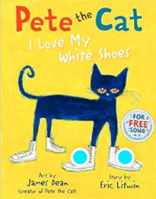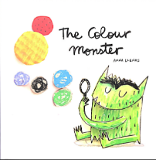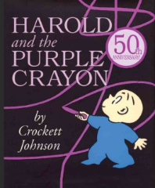  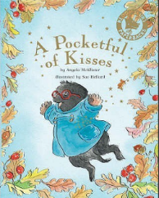  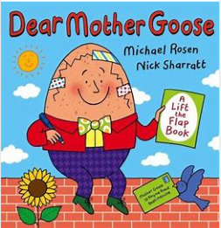 | In Communication, Language and Literacy we will read Stories like …  Pete The Cat  The Colour Monster  Pocketful of Kisses  Harold And The Purple Crayon  Dear Mother Goose  Small Knight & George  Dear Zoo  The Kiss That Missed  Good Night Sleep Tight  Seasonal Poetry  What we’ll be doing in class  Getting to know our new classmates and teachers  Showing awareness of listeners  Explore sounds  Writing non-fiction labels about castles  Labelling castle pictures  Book of the Week – Talking about our favourite books  You can help at Home: Reading rhymes and traditional stories.  Reading regularly for fun | 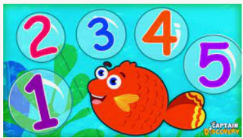  In Maths we will …  What we’ll be doing in class …  Use number names in order  Recognising numbers  Estimate groups of items  Compare quantities  Counting objects to 10 and 20 and beyond  Comparing heights/size and solve measures problems  Saying 1 more and 1 less  Continuing and making repeating patterns  Features of 2D and 3d shapes  You can help at Home by  Estimating and counting objects to 10 and beyond  Talk about adding and subtracting |  | 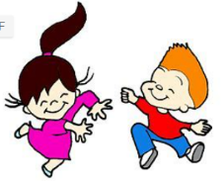  In Physical Development we will …  What we’ll be doing in class …  Getting to know you games  Self-care; toileting and washing hands  Talking about healthy food choices  Negotiating play space safely  Practising throwing and catching  Talking about healthy food choices  Noticing the effects of physical activity on our bodies  Mark making using various materials Dressing and undressing  Moving to music/linking movements  You can help at Home by  Encourage writing; large, medium and small scale writing  Encourage independence in dressing
 |  |   In Personal, Social, Emotional and Health we will …  What we’ll be doing in class …  Forming relationships  Staying Safe  Discuss our favourite toys from home  Awareness of own and other’s needs  Being sensitive to needs and feelings of others  Taking turns, sharing  Follow rules  You can help at Home by  Encouraging turn taking and sharing  Homes  We would love children to bring in a photo of themselves stood by their front door. |   In Knowledge and Understanding of the World we will  What we’ll be doing in class …  Noticing Seasonal Changes  Using simple age appropriate software and websites  Using our senses to investigate  Being able to talk about past and present  You can help at Home by  Notice seasonal changes  Spotting materials  Join us for  Year R Meet the Teacher  2:30pm in Willow Class,  Wednesday 22 September |  |   In Creative and Expressive Arts we will …  What we’ll be doing in class …  Colour Mixing  Explore sounds and sing songs  Castle role play  Design and make shields  Collaging and pastel pictures of bonfires and fireworks  Listening to special music;  Making Diva Lamps  Art; Paul Klee ‘Castle and sun’  Design and build large cardboard box castles  You can help at Home by  Talk about materials
,,

