SCIENCE –As scientists, we will learn about the process of reproduction and the life cycles of plants, mammals, amphibians, insects and birds. We will explore reproduction in different plants, including different methods of pollination and asexual reproduction.

Learning for Life (Jigsaw) - As young people, we will explore the characteristics of Young Leaders and Problem Solvers in the first half term. Our film unit starts with a young person left alone after a war and shows a real-life problem solver in his survival story. In the second half term, we will move onto Change Makers and Critical Thinkers. We will look at famous refugees and organisations such as Amnesty International and Unicef who have/made/are making a difference to others through change and attitudes.

**Silver Birch- Our Summer Learning Journey- Our theme is displacement and our big question is ‘Can we make a difference to others?’**

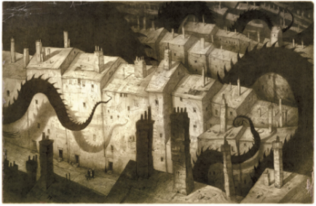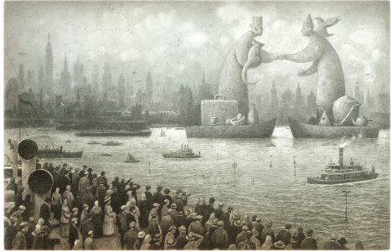

ART and DT- As artists, we will create a virtual work of art using digital photography. We will use Photoshop Express Photo Editor, an art program to edit and produce our desired outcome. We will take and assemble a sequence of photos to make a flick book to give the impression of movement.

MATHS- As mathematicians, the Year 6’s will continue with SATs revision spending time on fractions and decimals before exploring geometry, perimeter and statistics. Boy 87 will influence many of our maths problems and data tasks.

Year 5 will be exploring data handling, area, perimeter, volume and geometry. We will then revisit percentages and decimals.

REAL LIFE MATHS- using data from charities to input in our spreadsheets. Use percentages.to identify patterns in data.

COMPUTING- As programmers, we are introduced to spreadsheets. We will be supported in organising data into columns and rows to create our own data set. We will be taught the importance of formatting data to support calculations, while also being introduced to formulas and will begin to understand how they can be used to produce calculated data. We will be taught how to apply formulas that include a range of cells, and apply formulas to multiple cells by duplicating them. Next, we will use spreadsheets to plan an event and answer questions. Finally, we will create charts, and evaluate results in comparison to questions asked.

ENGLISH -As writers, firstly, we will watch the film called Birthday Boy and write setting descriptions, character descriptions and monologues. We will then start our wordless book, The Arrival. This text offers many writing opportunities. We start with a prediction followed by a narrative incorporating a flashback as well as journal entries and emotional letters as a character in the book. Boy 87 will act as a starting point for our geography and some writing tasks too.

RE- We will try to answer the questions: ‘***How do questions about Brahman and atman influence the way a Hindu lives?’***  Followed by ‘***How do the ‘Heroes of Faith’ encourage Christians today?’***

PE-As sportspeople, we will start to practice for sports day and focus on athletics.

Our specialist teacher will teach cricket.

MUSIC- As musicians, we will start auditions for our end of term production Joseph and his Technicolour Dreamcoat and start to learn the songs.

HISTORY/GEOGRAPHY – As Geographers, we will focus on considering whether our actions can help others. We will look at the refugee crisis and look at the geographical reasons for displacement. Our focus will be on the horn of Africa and this will lead into work on biomes and climate zones. We will consider the distribution of natural resources and how this affects human geography. We will also take part in a Take One Geography Day later in the term.

As Historians, we will use our previous knowledge of the Anglo-Saxons and Vikings to debate why people flee their homes. We will consider the work of Amnesty International and UNICEF.

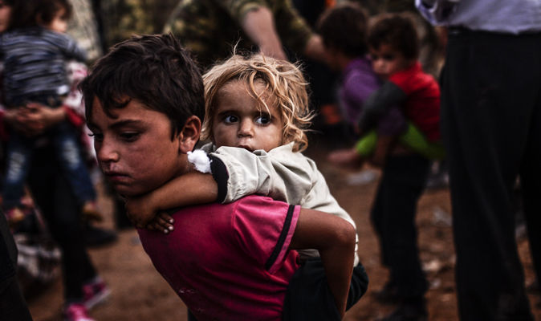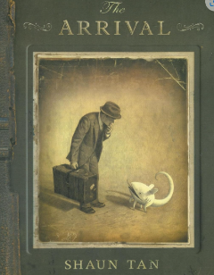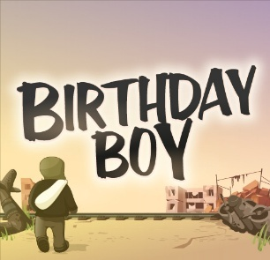

Can we make a difference to others?

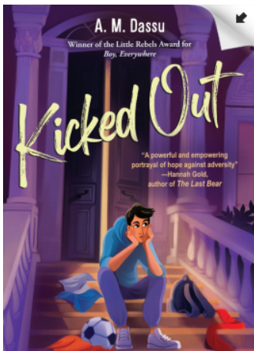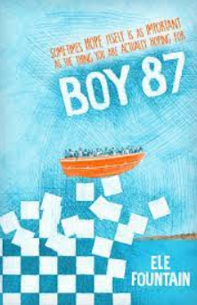

**Key Texts**

Boy 87 by Ele Fountain

The Arrival by Shaun Tan

Who are Refugees and Migrants? What Makes People Leave their Homes? And Other Big Questions by Michael Rosen and Anne Marie Young

Kicked Out by A.M. Dassu

The Watertower by

This term, Silver Birch will be exploring the question ‘Can we make a difference to others?’ Our theme is Displacement and as Young Leaders and Problem Solvers, we will be discussing how people are being forced to leave their homes due to conflict, violence, persecution, or natural disasters. We will start with our film unit, ‘Birthday Boy’ which is a short film about a Korean boy left alone after the war in 1951. We will then explore the wordless text, The Arrival. This book tells the emotional story of an immigrant without friends or family arriving into a new nameless country. We will follow this by reading Boy 87, a story about refugees, friendships, and survival. Through out the term, we will look at famous refugees and how these people have influenced change and what we can all do to make a difference.

**Key Vocabulary**

immigration

flee

migration

displaced

emigrate

citizenship

humanitarian

war

residence

asylum seeker

**Key Questions**

How do pictures evoke images?

Can you interpret a story without words?

How do pictures tell a story?

How do refuges cope with new lives/homes?

Can you put yourself in someone else’s shoes?

Could you live without home comforts?

Can our actions help others?

How does displacement affectpeople?