WILLOW CLASS HOMEWORK GRID FOR TERM 3
What’s Your Superpower?
Here is a selection of homework tasks to support our Superheroes project topic and its focus characteristics, Achievers and Team Players. Choose two tasks a week and share them with me by email or through the home learning books, bringing your creations into school or by taking photos to share. We will share them in class and in the library.
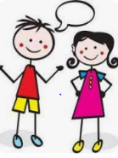  Speaking, listening and writing | 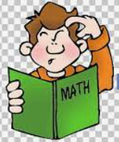  Maths, Science and Problem Solving | Art and Design | 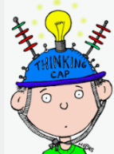  Constructing  and Creating | Active Body  and Mind
Interview With a Superhero Who’s Your Real Life Superhero? It could be a friend or family member. Draw a picture of your special superhero. | Winter Maths  Sammy squirrel hid 3 nuts for the winter. He has already eaten 2 of them. How many nuts has he got left? You could draw a picture or use your fingers to help you work out the answer | Superhero Costume  Draw a costume or accessory, like a cape for a superhero. | Superhero Vehicles  Make a vehicle for a superhero from recycled materials. Remember to give it special features. | Growing  Do you have any photos of when you were a baby? Are there photos of when your grown-ups were babies? Talk about what they looked like and what kind of things they did when they were babies. How have they changed?
Winter Woolies  Draw a picture of someone dressed for a cold winter day and then label the clothes they are wearing to keep them warm and dry. | Weather Diary  Draw pictures or take photos of what the weather is like each day. What season is it? What do you think the weather will be like during the next season? Will you need to wear different clothes? | Superhero Stories  Read a superhero story with a family member. Can you think of a different ending. Draw it. | Festivals  Talk about any festivals you celebrate with your family. What do you do to celebrate? Are there other festivals that you have talked about at school? | Superhero Challenge  How many star jumps can you do in a minute? Challenge a family member. How many can they do?
What would you do?  Ask your family what superpower they would want and why. | Winter Walking  Go on a winter walk with a grown-up and look around to see the things that have changed since the summer. | Superhero Villain  Draw a Wanted poster for a Superhero villain. | Cooking  Talk to a grown-up about the changes that happen during cooking. How does bread change when it’s toasted? What about cake mixture when it’s baked or spaghetti when it’s boiled? Can you describe what happens? Why do you think these changes happen? | Jobs  Talk to someone in your family about the kinds of jobs people do. Have you seen a bus driver, a shop assistant or a doctor? What do you know about their jobs and what would you like to find out? You could draw a picture of what job you would like to do when you are older.
If you are finding it tricky to complete these activities without materials please let us know as we may be able to help.
In addition to tasks on this grid, please support your child with daily reading and Numbots.

