Traditional Tales – Who’s Been Eating My Porridge?
Willow Class Autumn 2 2023

We will be sharing traditional stories, recognising and joining in with repeated phrases.
We will be acting these stories out, drawing story maps and using our phonics to add keywords. We will finish by writing our own traditional story.
We will learn about Diwali, Bonfire Night and the Nativity.
Key Stories  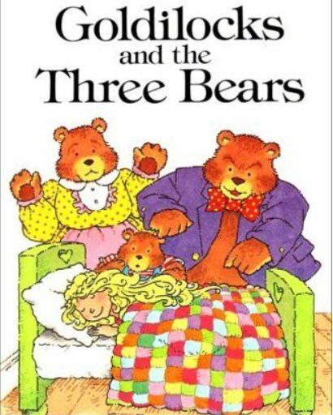  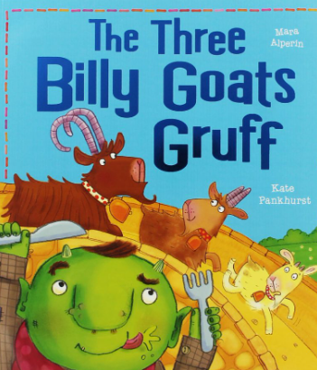  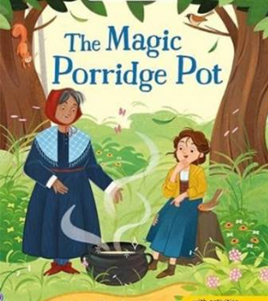  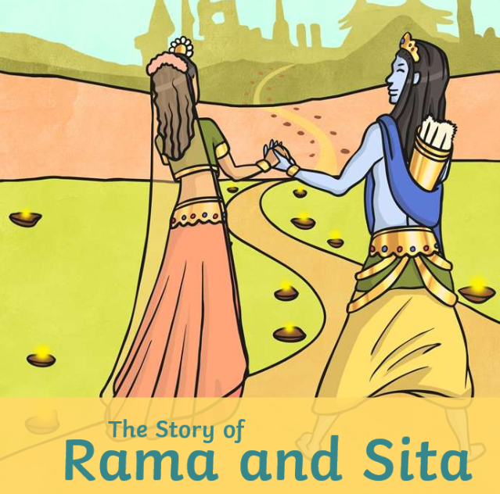  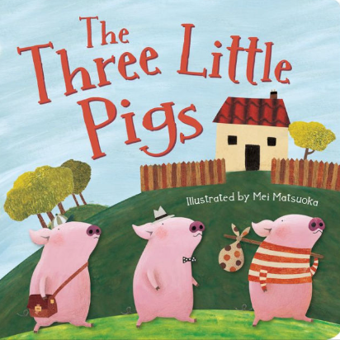 | In Communication, Language and Literacy we will …  Key Texts/Stories  The Magic Porridge Pot  Goldilocks & the 3 Bears  The 3 Billy Goats Gruff  Rama and Sita – The Story of Diwali  The 3 Little Pigs  The Ugly Duckling  What we’ll be doing in class …  Reading rhymes and traditional stories.  Noticing and joining in with repeated language  Drawing Story Maps and adding keywords  Writing labels about Autumn  Instructions – recipes  Learning new sounds and practising blending  You can help at Home by  Reading rhymes and traditional stories.  Practising high frequency words  Reading regularly for fun | 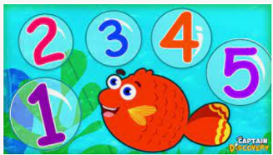  In Maths we will …  What we’ll be doing in class …  Estimating and counting numbers  Saying 1 more and 1 less  Ordering numbers to 10 and beyond  Continuing and making repeating patterns  Features of 2D shapes especially circles and triangles  Adding and Subtracting  Measures; heights of goats, length of beds, capacity of diva lamps  You can help at Home by  Estimating, counting objects  Spotting shapes |  | In Physical Development we will …  What we’ll be doing in class …  Negotiating play space safely  Mark making using various materials  Developing for and gross motor skills  Practising throwing and catching  Talking about healthy food choices  Noticing the effects of physical activity on our bodies  You can help at Home by  Encourage writing; large, medium and small scale writing  Talking about the importance of variety in the food we eat
 |  | In Personal, Social, Emotional and Health we will …  What we’ll be doing in class …  Celebrating Differences and Similarities  Making hard decisions  Talking about what makes a good friend  You can help at Home by  discussing right from wrong | In Knowledge and Understanding of the World we will  What we’ll be doing in class …  Sorting materials  Properties of materials for pigs houses  Noticing Seasonal Changes  Using simple age appropriate software and websites  Talking about the Nativity  Talking about Diwali  You can help at Home by  Noticing changes in the season  Discuss seasonal foods  Spotting different materials around us |  | 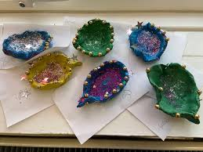  In Creative and Expressive Arts we will …  What we’ll be doing in class …  Home role play  DT; making masks for characters  Design and build own houses  Making and Painting Diva lamps  You can help at Home by  Talk about materials
,,,

