Silver Birch HOMEWORK GRID FOR TERM 5 and 6
How should society be organised?
Here is a selection of homework tasks to support the class’s big question this term and its focus characteristics. Choose two tasks a week so that by the end of term, you should have completed all the tasks. Share them by emailing work to the class teacher or by taking photos to bring in to school. There is a whole school homework display board in the library we shall be sharing all the home learning across the school towards the end of term.
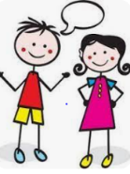  Speaking, listening and writing | 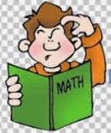  Maths, Science and Problem Solving |   Art and Design | 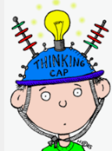  Constructing  and Creating |   Active Body  and Mind
Find out some simple Greek  phrases. E.g Hello, how are you?  What’s your name? etc. Can you  make a poster to display them in  Greek and English?  If you can learn the pronunciation,  can you try and teach us at  school? | Who was Pythagoras? How is he linked to maths? What is  Pythagoras’ theory? Present your findings – use diagrams to explain what you have learnt. | Make a collage using pictures from holiday brochures or the internet showing ancient buildings and interesting places to visit in Greece. | Cook some Greek food or a meal. Write up the recipes. Can you include a photo of your creation too? | Devise an event based on the Olympics that we could try out in school.
Write an advert persuading people  to visit the ancient Olympic  Games. | When you have researched the Greek alphabet, write a code that links to a Greek myth for someone to crack! | Create a picture of an imaginary Greek God. Make sure your poster is eye-catching and full of facts  and information. Try to think of a symbol for your God. | Design and make your own  Labyrinth. It could be made of straws, string or wood. | The Olympics committee  have asked you to create  a new Olympic sport.  Explain the rules of this  new sport. Include  diagrams to help your  explanation.
Find out what life was like for  children in Ancient Greece. How  will you present your information? | Who was Archimedes and what mathematical discovery did he make? | Create your own ancient  Greek flag. What symbols,  patterns, colours and  images should be  included? | Make a Spartan helmet or design a shield. | Today many athletes  compete in Marathons.  Research where this  name comes from and  present your findings any  way you wish (poster, fact  sheet, PowerPoint,  booklet, etc).

