

BOLNEY C.E.P. SCHOOL


Learning Support Assistant
Bolney CEP sits in the heart of the Bolney village community and is an inspiring and welcoming school. We have 100 children learning within four different classes: a Reception class, mixed 1/2, 3/4 and 5/6. We have a beautiful learning environment, both inside and out, and our staff and children feel safe and valued.

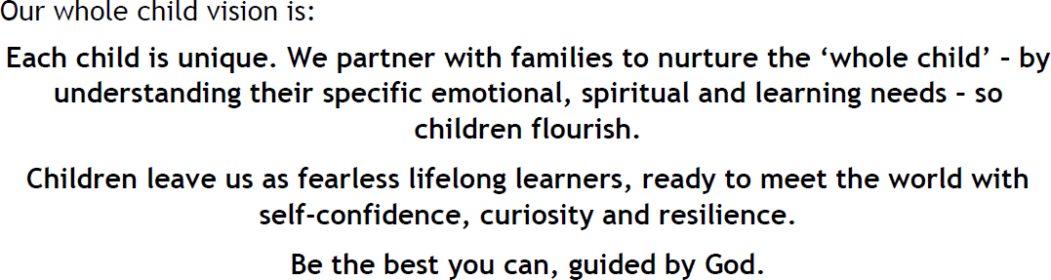

General Details
Title of Post:
Learning Support Assistant
Hours: TEMPORARY CONTRACT until 22nd July 2026 with a view to extend: Days negotiable - between two days and full time (8:30-3:30) term time only.
Start Date: ASAP
Salary Grade: 3 £24,796 pro rata TA

- Purpose of the Role

We are looking for a Learning Support Assistant with experience of SEND who believes in our vision and can support individual children and small groups to access the curriculum through adaptation in order that they can be the best that they can be.

General Duties Teaching and Learning:
  - Supervise and support pupils with special needs, including 1:1 work and the implementation of Educations Health Care Plans
  - Assist in the educational and social development of pupils under the direction and guidance of the headteacher and class teacher;
  - Provide support for individual pupils inside and outside the classroom to enable them to fully participate in activities;
  - Work with other professionals, such as speech therapists and occupational therapists, as necessary and liaise with parents/carers where appropriate;
  - Be familiar with the class teacher’s planning in order to successfully support the
pupils within their mainstream lessons;
  - Assist class teachers with maintaining pupil records by providing feedback of attainment and possible follow up activities;
  - Support pupils with emotional and behavioural problems and help develop their social skills;
  - Prepare and maintain relevant resources and equipment;
  - Deliver specific programmes of work such as nurture groups and social stories;
  - Regularly communicate with the SENDCo.

Standards and Quality Assurance:
  - Support the aims and ethos of the school as set out in the vision and values; Undertake professional duties that may be reasonably assigned by the head teacher or class teacher;
  - Be proactive in matters relating to health and safety;
  - Comply with policies and procedures relating to child protection, health, safety and security, confidentiality and data protection;

Other Duties and Responsibilities:
  - First aid if required.

Responsible to:
Headteacher

Bolney CE Primary School considers safeguarding to be of paramount importance.

Safeguarding Statement
This school and West Sussex County Council are committed to safeguarding and promoting the welfare of children and young people and expect all staff and volunteers to share this commitment. We will ensure that all our recruitment and selection practices reflect this commitment. All successful candidates will be subject to an appropriate Disclosure and Barring Service check along with

Closing date for applications – Please send completed applications to the school office ASAP
Interviews – tbc
Vacancy description correct at the time of advertising positions

Person Specification
Learning Support Assistant

 | ESSENTIAL | DESIRABLE
Key personal qualities and characteristics | - Enjoy working with children both inside and outside the classroom  - Ability to work as part of a team and demonstrate good interpersonal skills  - Good organisational skills and time management  - Demonstrate versatility, tact, commitment and the ability to use initiative  - Ability to communicate effectively both orally and in writing  - Self-motivated, flexible and hard working  - Able to provide intimate care for a child, if required  - Be patient and remain calm under pressure | - Experience of working with children with different special needs particularly Cognition and Learning  - Ability to use children’s own interests to  support progress and motivation  - Ability to use personalised strategies to support independence of pupils  - Experience of supporting children with challenging behaviour
Skills and Knowledge | - Ability to support a broad and rich primary curriculum which celebrates individuality  - Good ICT skills  - Committed to further personal/professional development | - Working knowledge of the National curriculum  - Can demonstrate an understanding of how children learn  - Effective use of ICT to support learning  - Experience of preparing for, and delivering, interventions such as Narrative therapy and Speech &  Language interventions
Qualifications and Experience | - Experience of working with children within the primary age range  - DBS clearance  - GCSEs including Maths and English (Grade D or above) | - NVQ level 2 or 3 (or equivalent)  - Qualifications relating to the role of TA (or evidence of study towards gaining such qualifications)  - First Aid qualifications

