18th December 2024

Dear Parents and Carers

Thank you for all your support this term. I wish you all a happy Christmas and a happy new year.

In January, we will be exploring the characteristics of Achievers and Creative thinkers and our project is all about the Anglo Saxons and Vikings.

We will be discussing big questions such as; ***What makes someone British? Were Saxon times really ‘Dark’ Ages? How did the Vikings try to take over the country and how close did they get? Alfred the Great. How great was he? Raiders or settlers: how should we remember the Vikings? What image do we have of the Vikings?***

In English and VIPERS, we will be using the brilliant book, ‘The London Eye Mystery’ by Siobhan Dowd. It would be great for each child to have access to this text as we will be using it for our daily VIPERS sessions and in English later in the term.

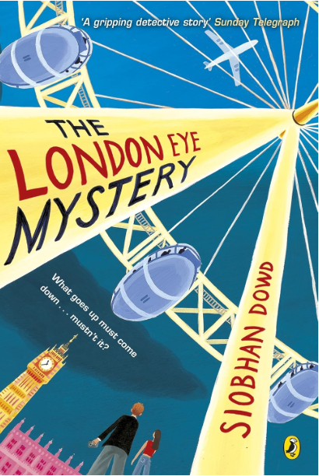As you are already aware, having copies of the text enables each child to not only follow the story being read aloud, but to be able to go back, re read, look deeper into the illustrations and highlight words they liked. We have found that the children love reading ahead too!

It can be found on Amazon for £3.54 but from 0.89p for a used copy. If you have any questions or need support with this, please email me cjames@bolneyprimary.school

Regards, Mrs James